**Y8 Science Assessment - insulation experiment**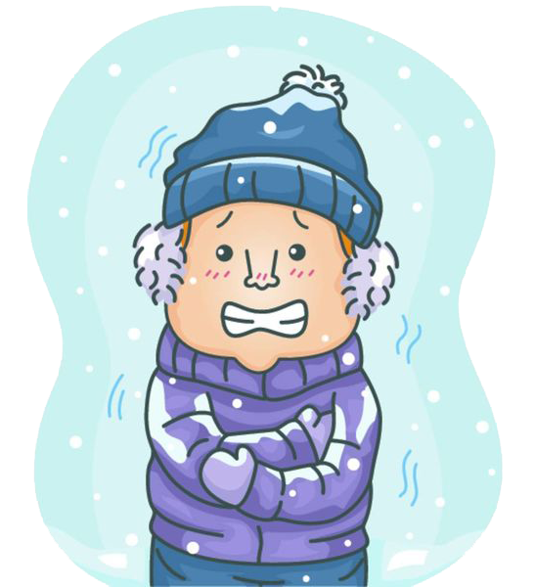

For this term’s context - Survival, year 8’s have been exploring the science behind survival in the wilderness. As part of this context, they have been learning how to stay warm, and will carry out an experiment *investigating which materials are good thermal insulators.*

**For this investigation, students are required to:**

Follow practical instructions carefully and safely, and write an *investigation report* based on this experiment, including an aim, hypothesis, variables, method, results (table + graph), conclusion and final survival questions.

(Note - the aim, hypothesis, variables, method and results can be completed as a group. **The conclusion and final survival question must be completed individually**)

**Assessment start date:** Week 7

**Assessment due date:** 8W1: Wednesday Week 8, 5pm

8W2: Thursday Week 8, 5pm

**Schedule for this assessment:**

Lesson 1 - Introduction to experiment and aim, hypothesis, variables, method

Lesson 2 - Carry out experiment and record results

Lesson 3 - Experiment catch-ups and results

Lesson 4 - Conclusion and final question

Lesson 5 - Conclusion and final question

**Report template:**

Complete your investigation report by filling in this template.

Pink parts = can be done as a group. Blue parts = must be done individually.

| Group members: |  |
| --- | --- |
| Aim:  (Group) | The purpose of this experiment is to determine…  Words to include: heat, insulate, material/fabric, |
| Hypothesis:  (Group) | I predict that….  Newspaper  Tin foil  Cotton cloth  Bubblewrap |
| Variables:  (Group) | **Independent variable (what are we changing?):**  **Dependent variable (what are we measuring?):**  **Control variables: What factors do we need to keep the same throughout the experiment to keep it fair? List them below** |
| Method:  (Group) | **List the sequence of steps here for carrying out the experiment.**  1.  2.  3.  4.  5.  ... |
| Results  (Group) | 1. **Fill in your table with your results below**  | **Material** | **Starting temp of water (oC)** | **Final temp of water (oC)** | **Temp change (oC)** | | --- | --- | --- | --- | |  |  |  |  | |  |  |  |  | |  |  |  |  | |  |  |  |  | |  |  |  |  |  1. **Insert your bar graph below (material vs temperature change)** |
| Conclusion (Individual)  Optional sentence starters | **What was the purpose of your experiment?**    The purpose of this experiment was to find out...  **What did your results show?**  My results showed that…  **Do your results therefore support or reject your hypothesis?**  I predicted that…(your hypothesis)  The results of the experiment (supported/did not support) my hypothesis because …. |
| Final survival questions | **In this practical experiment, we investigated heat and insulation. Write a paragraph explaining:**   1. ***What is* heat transfer, and *why* is it important to consider in a wilderness survival situation? *(At question)*** 2. **H*ow* would you use what you have learned in your experiment to make decisions in a survival situation? *(Above/Beyond question)***   Include in your answer:   * ***Why* some materials worked as better insulators than others** * ***How* you could use this in real life to stay as warm as possible** |

**Marking rubric:**

| **Investigation** | You have refined a scientific question. | You have refined a scientific question, developed a simple method. | You have refined a question to investigate and developed a simple method. | You have refined a question to investigate and developed a valid method. |
| --- | --- | --- | --- | --- |
| You have developed a simple method which allows you to gather data. | You have gathered and processed data. | You have gathered appropriate data. You have interpreted the data, drawing simple conclusions. | You have interpreted the data and drawn science based conclusions based on the data. |
| ***Heat transfer*** | You have explored and identified the nature of heat transfer | You have explored and described the nature of heat transfer | You have explored and described with examples, how to manipulate heat transfer | You have explored and accurately described in some detail, how to manipulate heat transfer |
| **Accuracy** | You have made errors in grammar, spelling and/or punctuation and these are intrusive at times, consequently the reader has to infer meaning | You have made some errors, but minimal reader inference is needed as meaning is mostly clear | You have carefully edited your writing to ensure you have few intrusive errors and meaning is consistently clear | You have carefully edited your writing to ensure you have no intrusive errors and meaning is consistently clear |
| **Time Management** | You have **yet** to complete and **submit** your assessment. | You **have** submitted your assessment **late**. | You **have** submitted your assessment **by the due date**. | You have submitted your assessment **before** the due date. |