Week 4 Lesson 1

Teenagers and the Power of the Group



Success Criteria
Group dynamics (peer influence) is one of the most powerful forces in human psychology. Students will gain an understanding of key findings from two key studies that look at the influence of peers on individual behaviour. Students will be be able to summarize the research conducted by Solomon Asch and Stanley Milgram. If you go to university and take a class in law, psychology or sociology – you will come across these studies.

Task 1: In your Red Books write down Week 4 Lesson 1 – The Power of the Group to Influence Teenagers.’ Next write down the 7 questions below in your books, then watch the clips and write out your responses. You may reword the question to make it shorter.

Task 2: Watch the clips: Go to https://www.youtube.com/watch?v=BOBhKR4MK3w (3:38 sec.) and watch the video clip, ‘Brain Games - Asch Line Study.’ In your Red Book, write down each question followed by the answer. You may reword the question to make it shorter.

Now watch the second clip:

https://www.youtube.com/watch?v=iRh5qy09nNw (1:57 sec.)

1. When a study subject was alone and asked to judge the length of the lines, how often did they get the answer wrong? (3:40 sec. mark)

2. How often did they get the answer wrong at least once? (3:50 sec. mark)

3. How often did they get the answer wrong every time the group did? (3:55 sec. mark)

4. In the study they made use of a confederate. What does this term refer to? (4:15 sec. mark)

5. When interviewed, what did most people who went along with the group, say why they had done it? (5-minute mark)

6. What is normative social influence? (5:30 sec. mark)

7. What is informational social influence? (6:50 sec.)

Class discussion: How do you think you would have responded? What does this study tell us about conformity?

Homework
Complete today’s tasks and make sure your Red Book is up to date.

Week 4 Lesson 2:

The Milgram Experiment:
How Far Would You Go to Please Someone?



Task 1: In your Red Books write down ‘Week 4 Lesson 2 – The Milgram Experiment.’ Next write down the 6 questions at the end of this lesson into your books, then watch the clips and write out your responses. You may reword the question to make it shorter.

Video Clip: Watch the video clip on the Stanley Milgram Experiment at:
https://www.youtube.com/watch?v=fCVlI-_4GZQ (9:53 Sec.)

This clip will give you a broad understanding of the Milgram experiment.

Class Discussion: How do you think you would have fared in the experiment? What does it tell us about conformity and the capacity for people to engage in what they believe to be dangerous acts?

Task 2: Reading. Read ‘What Was the Milgram Experiment?’ at: https://www.verywellmind.com/the-milgram-obedience-experiment-2795243

Based on the reading, answer the following questions –

1. Why did Milgram conduct his experiment?

2. How were the people who took part in the experiment recruited?

3. Summarize the results of the experiment.

4. What factors were found to influence obedience?

5. What ethical concerns do some people have with conducting the experiment?

6. Under the section, ‘Impact of the Milgram Experiment,’ write a summary of the key findings.

Homework
Complete today’s tasks and make sure your Red Book is up to date.

Current Event #8
The Coming Solar Tsunami
& the Kiwi Scientists Trying to Understand It

Success Criteria: By the end of the lesson students will be able to describe the Carrington Effect and why we need to prepare for it.

Class Discussion: How many students have ever seen the Northern or Southern Light? What did it look like? Has anyone ever heard of The Carrington Effect?

Task 1: Watch the video clip titled, “The Most Powerful Solar Storm in History and Why It Matters for Our Civilization” at: https://www.youtube.com/watch?v=CwUND3V74ew

Answer the following questions in your Red Book:

1. What is a solar storm?

2. How did scientists discover that a giant solar storm hit earth thousands of years ago – and what does Carbon 14 have to do with it?

3. What are the consequences of a solar Tsunami hitting earth?

4. What can be done to prepare for the next event?

5. What are the odds that a major event will happen in he next 50 years? To answer this question, read the article below from TV NZ:

Scientists Preparing New Zealand's Defences Against Solar Tsunami Threat
August 20, 2022 by Kaysha Brownlie NewsHub

A group of Dunedin scientists is already stepping up New Zealand's defence for when one happens.
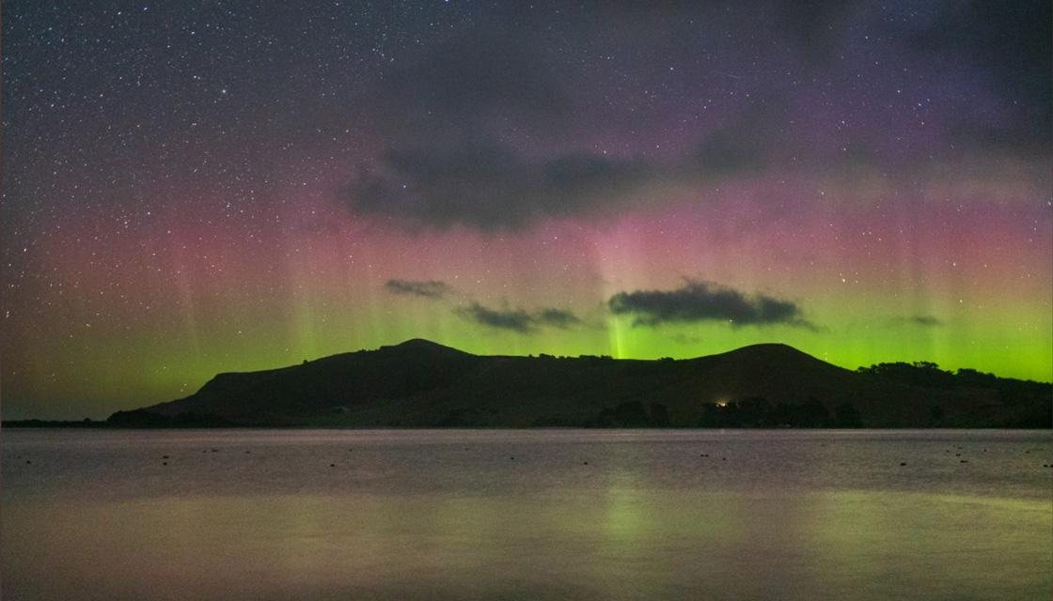
'A rather pretty display': Stunning Aurora Australis lights up New Zealand's skies
We see the sun every day but what most of us don't realise is it's currently moving into a phase of high activity. During this time it produces more solar flares, as well as solar tsunamis.
"Solar flares are the biggest explosion in the solar system inside the atmosphere. They throw billions of tonnes of material out into space and that's a solar tsunami," explained Professor Craig Rodger, from the Otago University physics department.
There's roughly a 25 percent chance of an extreme event reaching Earth in the next 50 years.
"That's pretty high, much higher than us winning Lotto even in 50 years," Prof Rodger warned. It could cause an electrical blackout which is why he will travel to the Chatham Islands as part of a team installing a magnetometer.
"We need to better understand how magnetic fields vary across the country," he told Newshub.
"We put a magnetic instrument up in Awarua near Invercargill, one in King Country, now we're putting one in the Chathams. That will give us good north, south, east, west coverage."
Unlike other natural disasters, we will know when a solar tsunami is coming. It takes 12 hours to reach Earth from the sun.
"If it's a very very big event, you could imagine the safest thing to do would be to turn the power grid off for a day or two and then we'd turn it back on - we'd have a power grid," Prof Rodger said.
A previous solar tsunami has proven planning is key.
"The Carrington event was the largest solar storm ever recorded in history in 1859, it affected electrical infrastructure everywhere around the world including New Zealand," warned Otago Museum science engagement co-ordinator Toni Hoeta.
There wasn't a lot of electricity back then but today the world relies on it. It's worth stopping at this point to think about the number of electrical devices you rely upon as do hospitals, schools, businesses, laptops and phones.
"It can even affect GPS so imagine you're in the sky on an aeroplane and the GPS goes out of whack," Hoeta said.
That being said, work is already underway to prepare for it.
"The good thing is that we're doing science with Transpower to prepare for this eventuality so we can mitigate and have contingency plans so it won't be as bad for New Zealand," Prof Rodger said.
"Don't prepare for it in the sense the world is ending, just know we might have limited power for a certain amount of time," added Hoeta.
So best keep those batteries to hand.

