Week 3 Lesson 1:

The Nestle Baby Formula Controversy

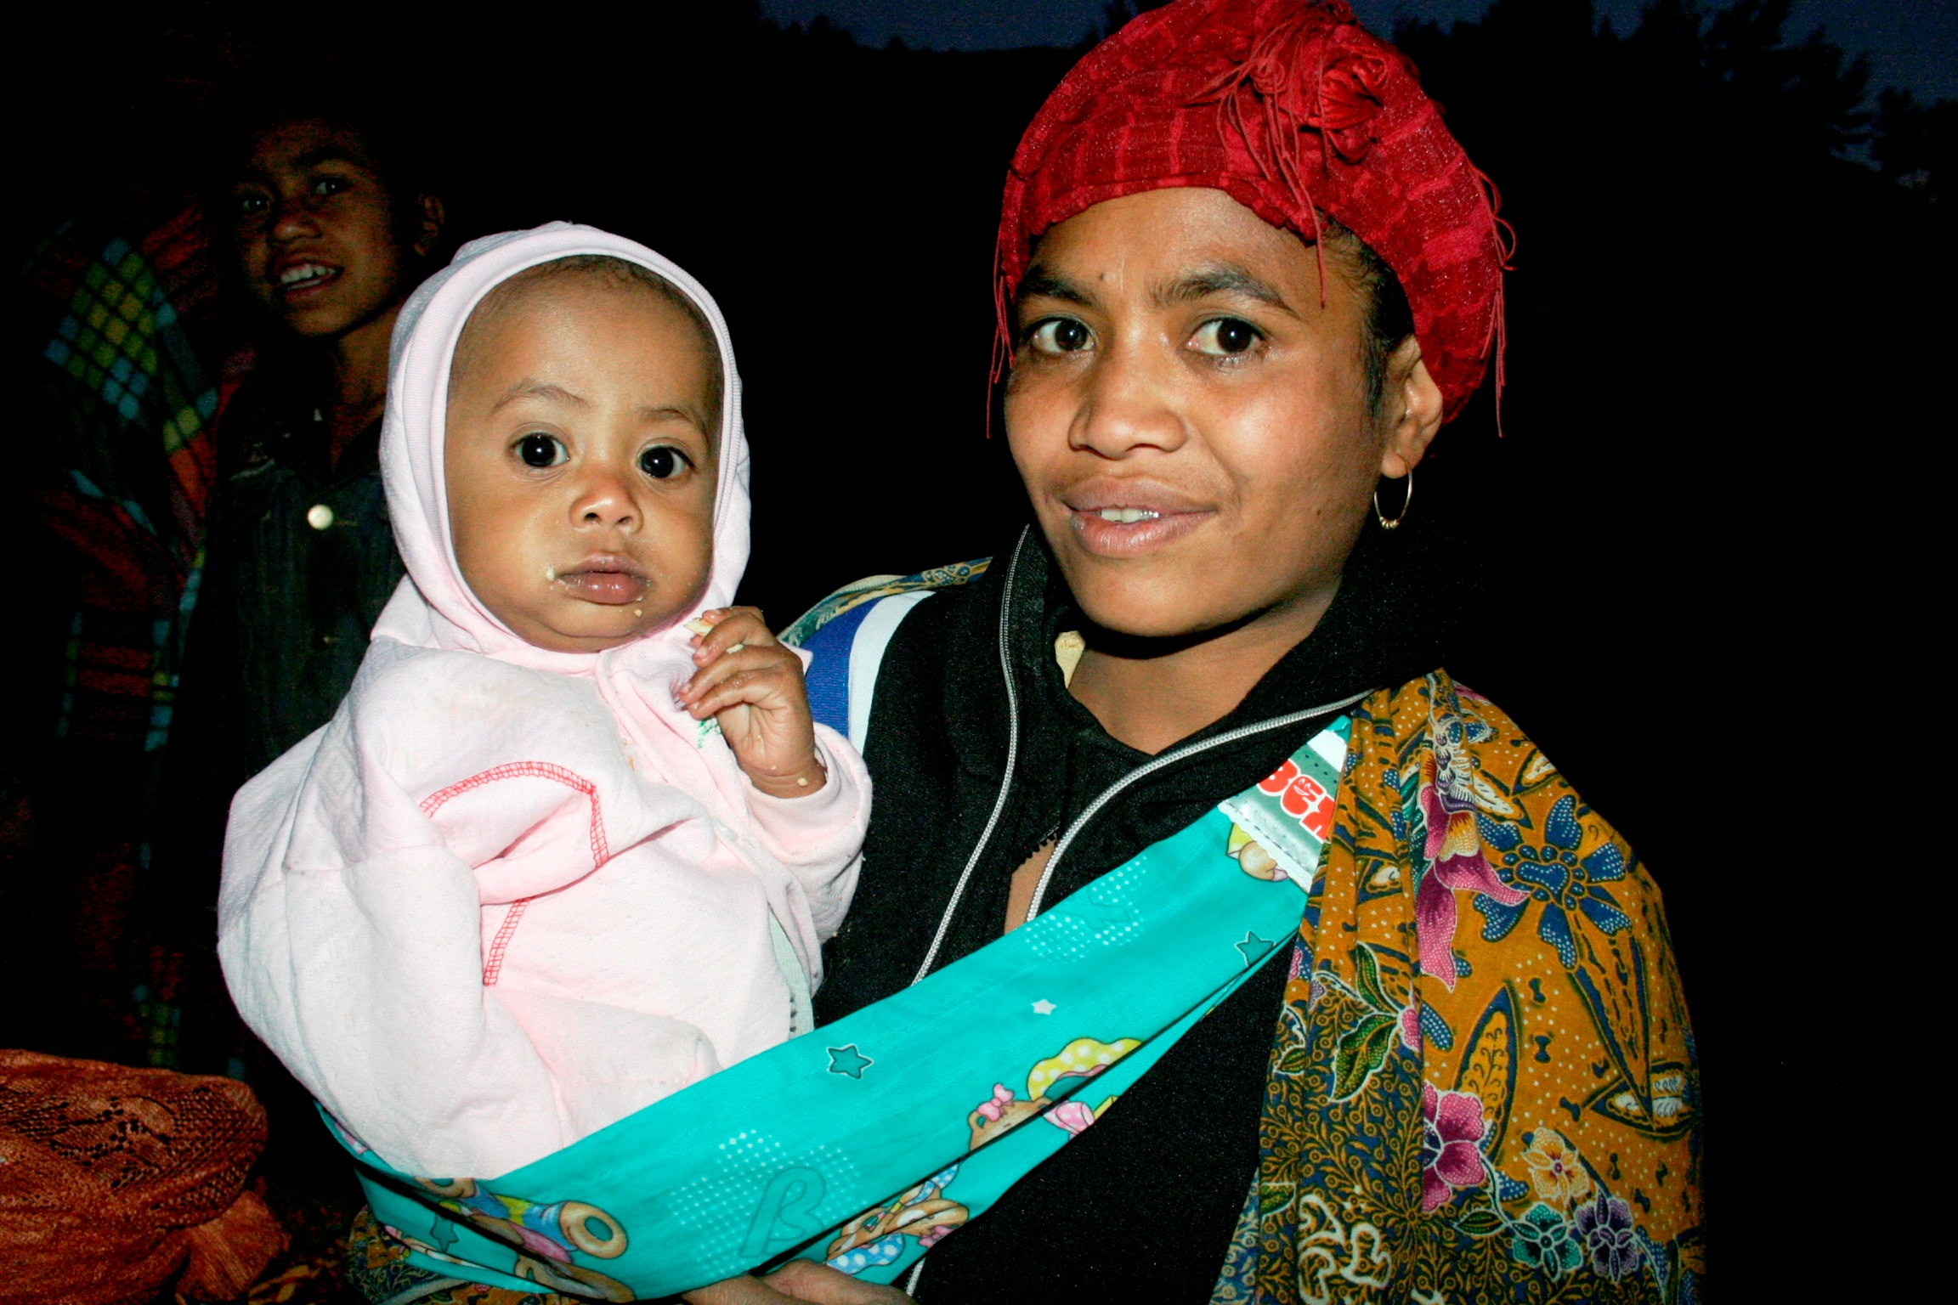

Success Criteria
Students will gain a thorough understanding of the controversy that surrounds the use of infant formula in low-income countries and be able to recount the pivotal role of clean drinking water – and the implications of what happens when formula is mixed with contaminated water.

For decades there has been a debate over the safety of infant formula being used to feed babies in poor countries around the world. This week we will examine this debate and the role that clean/dirty water plays in it.

Class discussion: How many students have heard of the Nestles Infant Formula Controversy? Which do you think is better – infant formula or breast-fed milk? Why?
At what age should babies stop breastfeeding?

The Breast Milk Debate
Task 1: Get into groups of between 2 and 5 and watch the video together, stopping and starting as needed and discussing what is being presented.
“Is Breast Milk Actually Better Than Formula? Science Explains” (12:55 sec).
https://www.youtube.com/watch?v=i1UMnKduosE

Each student will draw a line down the middle of a blank page in their Red Books and on one side write ‘The Benefits of Breast Milk” and on the other side write “Negative impacts of infant formula.”
The Benefits of Breast Milk Formula / Negative impacts of infant
/
/
/
/
/
/
/
/
/
/
/
/

Task 2: One the next page, write a one paragraph summary on the safety of using infant formula. *Infant formula is safe to use – but what is the catch?

Week 3 Lesson 2:
The Nestlé Baby Formula Scandal
that Rocked the 1970s

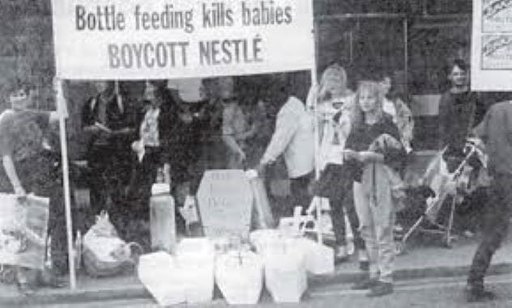

Task 1: Watch the short video clip as a class:
https://www.youtube.com/watch?v=Prz45n5Tlcw (5:38 sec.)
This will give students a big picture overview of the infant formula debate.

Task 2: Get back into your small groups and watch the following video, then answer the questions below in your Red Books.
https://www.youtube.com/watch?v=v-PcOVl1K2g (start at the 1:23 sec. mark)

Questions:
1. How many deaths are estimated to occur from the marketing of infant formula to poor countries? (answer can be found at the 2:06 sec. mark)

2. In the 1960s, why did companies like Nestlé's search for new customers in low income countries?

3. What percentage of women are unable to breastfeed?
4. On average, how much of a person’s income in these poor countries was being spent to buy infant formula (a product that most did not need)?

5. What was the formula for Nestlé's successfully marketing their infant formula in low income countries? (3:40 sec.).

6. How did Nestlé's advertisements create fear and anxiety in new mothers – and how did this affect their ability to produce milk or their self-image?

7. Explain ‘The Free Sample Trap.’

8. Who were mothercraft advisors and what did they do?

9. After the practice of mothercrafting (‘milk nurses’) was banned, how did they capture new customers in the following countries: (7:50 sec.)
a. Singapore
b. Jamica
c. the Philippines

10. What is Baby Bottle Disease? Explain in a paragraph.

11. What is Marasmus?

12. What is Kwashiorkor?

13. A bottle-fed baby living in unhygienic (dirty) conditions is ____ times more likely to die from _____________ and ________ times more likely to die of ____________ than a breast-fed baby.

14. What did Nestlé's say in their defence? Technically was their anything wrong with their product? If there was nothing wrong with the product – then why were so many babies dying? (10:30)

15. How did language play a role in baby deaths from infant formula? (11:00 sec.)

16. “Profits were being put before people.” Explain giving at least 2 examples.

17. During the court case what did the judge rule about Nestlé's publicity methods for promoting their infant formula?

18. In 1981, the World Health Organization approved what became known as ‘The Code.’ What did it require?

19. Was ‘The Code’ always followed?

20. Where does the debate over infant formula and poor countries stand today?

Week 3 Lesson 3: Nestles Continued
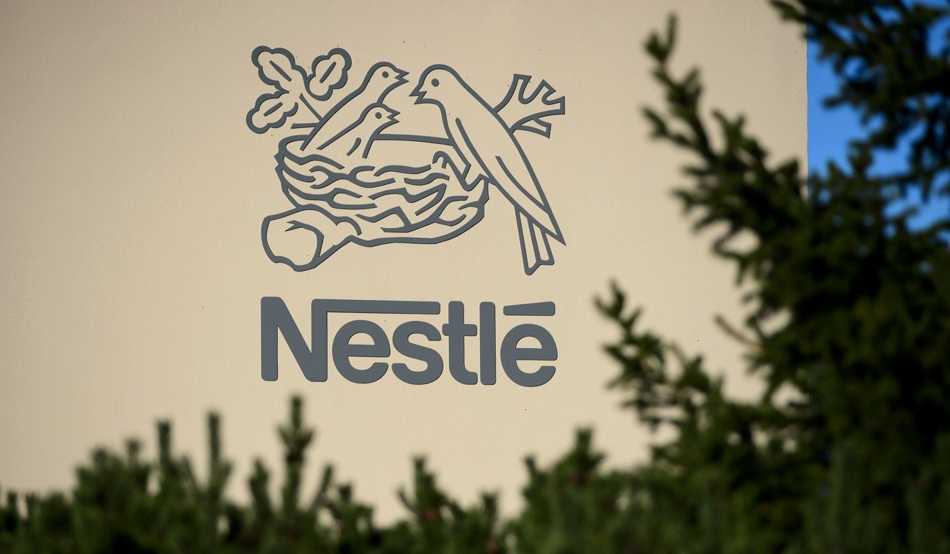
Above: the Nestle logo

In 2022, America’s National Public Radio carried an article that updated the Nestles infant formula controversy. Read the article below, then write a letter to Nestles advocating for change.

A Letter for Change

Task: Get back into your groups and come up with a plan to raise awareness of the issue of infants dying by drinking formula that is made with contaminated water.

Write a letter to Nestle that is intended to get them to change their current practices on how they market to poor countries. Can you offer an alternative way that they might be able take to make money without causing potential harm?

Infant formula promoted in 'aggressive' and 'misleading' ways, says new report
MARCH 1, 2022 by Fran Kritz

A new report from the United Nations and the World Health Organization documents what it calls "aggressive" and "misleading" marketing of infant formula. There's special concern about efforts in poor countries

"Advertisements will make me buy infant formula, if I see a beautiful and chubby baby on TV, well-fed and smiling."
That's the feedback from a mother in Lagos, Nigeria, one of 8,500 mothers and pregnant women in eight countries interviewed for a new report, How Marketing of Formula Milk Influences Our Decisions on Infant Feeding just released by the World Health Organization and UN. The report focuses on marketing practices employed by companies that make up the $55-billion-a-year global infant formula business.

The issue is far from new. In 1981, the World Health Assembly released the International Code of Marketing and Breast-Milk Substitutes, an agreement whose goal was to "stop the aggressive and inappropriate marketing of breast-milk substitutes," according to WHO. The Code was developed to ensure that mothers are not discouraged from breastfeeding and that substitutes are used safely if needed.
The report stresses that some babies do need formula because in rare instances, but not usually.
WHO says its position on breastfeeding is critical because of longstanding evidence that exclusive breastfeeding for six months after birth, if possible, and for up to two years or beyond protects against child malnutrition and many childhood illnesses and health issues. Yet according to WHO, only 44% of babies under 6 months are exclusively breast-fed.

Why past activism may not have produced results
In the new report, WHO notes that global breastfeeding rates have increased very little in the past two decades while sales of infant formula have more than doubled in roughly the same time period.
"This report shows very clearly that formula milk marketing remains common, misleading and aggressive," said Tedros Adhanom Ghebreyesus of WHO.
Dr. Ana Langer, professor of the Practice of Public Health at Harvard University, says the report shows that infant formula companies often give the impression that “formula as an equally good, if not better, alternative to breast milk."

How formula is marketed
While marketing by infant formula companies is common across the world, health experts are concerned about lower income countries, where the purchase of formula can often be a financial burden and can cause illness if it's prepared with contaminated water, a risk for millions who don't have easy access to clean, safe water.
Among the tactics the report details:
- Marketing techniques by formula companies include reading social media posts from women about nursing, then sending direct messages to those women about the benefits of infant formula.
- False and incomplete scientific claims that formula is close to, equivalent or better than breast milk.
- Incentives to health workers to promote formula through gifts and trips to conferences.
"The nature of the marketing [in the report] really sought to exploit emotions, the fears and the ambitions of, women and families at a time when they're potentially most vulnerable," said Dr. Nigel Rollins, research leader for the report at a press conference. Rollins is a scientist at WHO.

The report's survey questions included one about women's desire to breastfeed and found a strong desire to do so, ranging from 49% of the women in Morocco to 98% of the women from Bangladesh. But the marketing by infant formula companies can change their minds.
More than half of the 8,500 parents and pregnant women interviewed said they had received marketing information from formula companies. The report said these messages were often misleading and scientifically unproven.
The report also found that the companies have extended their reach by selling and promoting formula for older babies and even for mothers, marketed as "maternal milk."
Lost in the marketing, says WHO scientist Rollins, are the clear benefits of breast milk when mothers can nurse. In an overview published last year, for example, the American Academy of Pediatrics noted that children who are breastfed have improved dental health and brain developmental outcomes and a decreased risk of such conditions as ear infections, diarrhea, respiratory tract infection, sudden infant death, asthma, celiac disease, Crohn's disease, leukemia and childhood obesity.
Benefits to mothers of breastfeeding, according to the AAP overview, include a decreased risk of excessive menstrual blood loss, high blood pressure, type 2 diabetes, and rheumatoid arthritis.
*This article has been modified by Mr. Bartholomew to make it easier for students to read.

