Global Studies Unit Overview (Year 10 Term 2)

Why Teens do Foolish Things?
The Brain Science Behind Why Adolescents are Prone to Engaging in Risky Behaviours

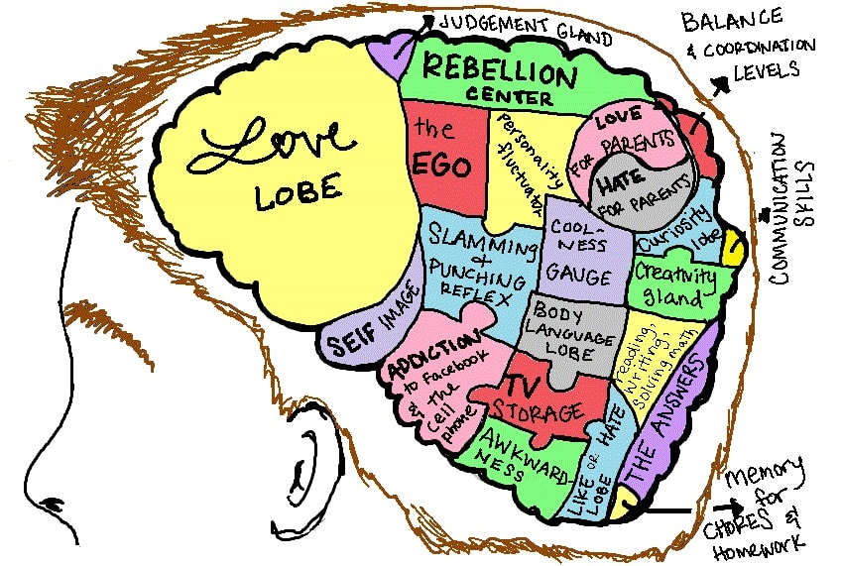

Studies show that teenagers are much more likely than adults, to engage in highly risky behaviors that could endanger their lives and the lives of those around them. Whether it is racing in cars, experimenting with drugs, engaging in crime, binge drinking, smoking, vaping, or diving off a cliff into a pool of water, teens are notorious for doing risky things. Yes, we all take risks, but it is important to balance the potential risks versus the possible rewards. We will explore why this is, and the brain science behind it. As part of the assessment, students will be asked to create an advertisement that highlights a particular risky behaviour and what can be done to modify the risks.

Week 2 Lesson 1:

Why Teens are at Risk for Risky Behaviours



Success Criteria
Students will gain a thorough understanding why teenagers are so prone to engaging in dangerous behaviours and be able to identify the part of the brain that is still developing and significantly influences their risk (the lateral prefrontal cortex).

Activities
1. Reading & Writing
2. View and respond to a video clips from a study on risk-taking

Homework
Complete all lessons by Friday at 3 pm.

It’s true – teens are at the highest risk for injury and death from a variety of acts that they engage in with their own free will. But why? What is different in teenagers that places them at such a high risk?

Task 1: In your Red Book, go about one-third of the way down the page and draw a line across the page. In the top section write the Title of this unit. Underneath the line, write ‘Lesson 1: ‘How Risk-taking Changes a Teenager’s Brain.’

Task 2: Watch the video by Kashfia Rahman on ‘How Risk-taking Changes a Teenager’s Brain.’ WATCH IT FROM START TO FINISH. DO NOT think about writing down answers – just watch it for pleasure at:
https://www.youtube.com/watch?v=VLDwh4ivNf4

This is an amazing video; it is about a high school student who conducted a study on teen risk-taking. As a result of her study, she ended up winning one of the world’s biggest science awards for teenagers and being accepted into one of the best schools in the world – Harvard University.

While many scientists blame teen risk-taking on the undeveloped teen brain, Ms. Rahman found that while that may be true, something else was driving the risky behaviours. When she uses the word ‘habituation,’ all this means is becoming used to something.

Task 3: In Paragraph #1, write a summary of the study she conducted at her school (this starts at around the 5:30 second mark).

Task 4: Next, list in key dot-points, what she found.

Week 2 Lesson 2: The Risky Teen Brain
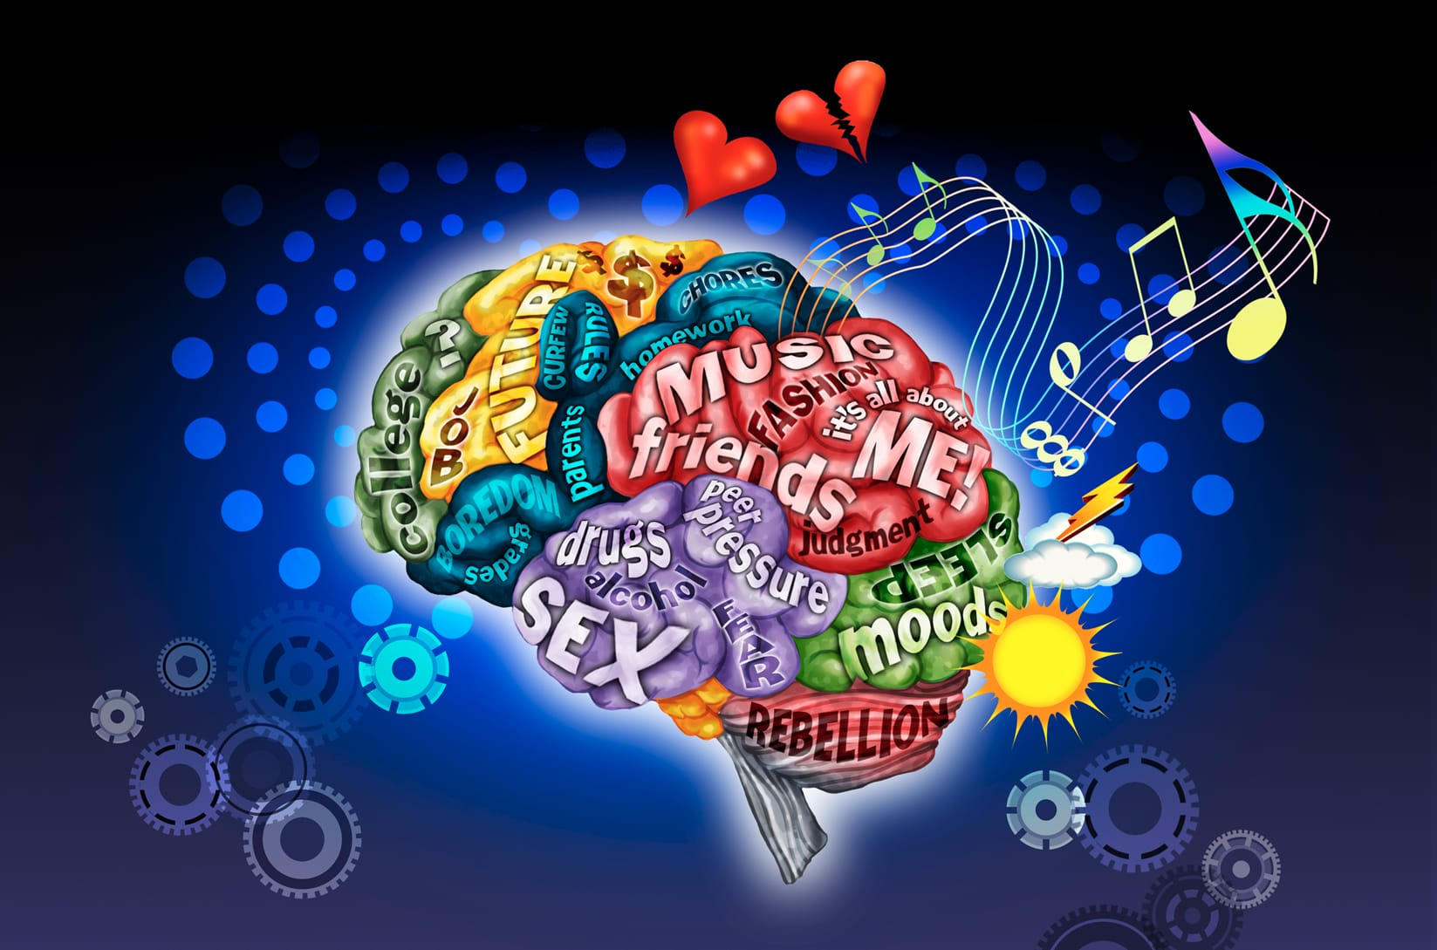

Task 1: Read the article from Psychology Today Magazine, ‘Why Are Teen Brains Designed for Risk-taking?’ by Psychologist Joe Magliano at: https://www.psychologytoday.com/nz/blog/the-wide-wide-world-psychology/201506/why-are-teen-brains-designed-risk-taking. I have re-written the article and targeted to a Year 10 reading level.

Task 2: Write the following questions and answers in your Red Books.

1. Define the word ‘adolescence.’
2. Define the word ‘puberty.’
3. Write a letter to your friend who has been driving his car in an unsafe manner and who is binge drinking. A) Explain to him why the teenage brain is more prone to doing risky things, and 2) what he can do to try to be more sensible.

Reading appears below:

Reading for Lesson 2

The Wide Wide World of Psychology

Why Are Teen Brains Designed for Risk-taking?
Nina Mounts is a professor of psychology at Northern Illinois University

Here are several ways parents can reduce the danger

Adolescents and young adults take more risks than any other age group This risk-taking includes dangerous driving (for example, texting), drug use, binge drinking, and risky sexual behavior. Despite educational efforts to provide teens with information about risky behavior, many teens continue to engage in risky behavior.

A teenager engaging in risky behaviour - smoking

People often believe that teens engage in risky behavior because they are not very good at evaluating risk. But research in this area demonstrated that teens are just as good as adults at evaluating risks. across a broad range of risky behavior. Teens know that the behaviors are risky, but they still engage in them. Why?
Research on how teens interact with their friends as well as their brain development at this age, may provide an answer.
In recent years, there has been an increase in the availability of magnetic resonance imaging (MRI) – devices which scan the brain. Using MRI scans of teen brains, researchers have found several changes take place in the brain during puberty that are important in explaining risky behavior.
#1. First, during the teenage years young people become very prone to peer pressure, which peaks at about the age of 14. At the same time, MRI scans of the brain show that teen brains are more sensitive to the rewards of peer relationships than adults. As a result they are more likely to do risky or silly things around their friends in order to fit in and feel liked and wanted.
#2. While teens become more interested in their peers (friend who are about their same age) and can become very unhappy and upset when they are excluded by their peers. Research shows that it is less developed in teens than adults so adolescents may not be as effective at controlling distress during peer social exclusion. This likely contributes to engaging in risky behaviors to prevent being excluded by their peers. They may engage in silly or risky actions to become accepted into a group.
#3. Third, another area of the brain (the lateral prefrontal cortex), regulates how we control ourselves and our emotions. In one study, early teens, late teens, and adults behaved similarly on a computerized driving task when they were by themselves. However, when they were paired with two same-aged friends, clear differences emerged. Early teens were more likely to engage in risky driving when friends were present. Late teens were somewhat more risky in their driving when they were with friends. The presence of friends had no impact on adults’ driving.
If talking about the dangers of risky behaviors isn’t as effective in preventing them as parents would like, what can parents do?

