

# **Name:** **Class:** 9C1 / 9C2

**Inquiry Plan Due Date:**

# **Tombstone/Evaluations Due Date:**



**Instructions:**

1. **Working individually**, you will follow the Inquiry Process sheet completing the Inquiry Plan and Evaluation sheets as you work through the assessment.

2. You will have approximately **three** periods and homework time to research and create your tombstone.

3. **Information:**

Although Pol Pot is now dead, his dictatorship in Cambodia during the 1970s has had a massive affect on the development of that country.

You are to research the websites indicated, and other resources to find out more about this.

In particular, you are to find out the following information

| Pol Pot:  * A photo * Date and place of birth * Date and place of death * Cause and circumstances surrounding his death * Paragraph (**approx. 150 words**) describing Pol Pot’s actions and beliefs as a dictator that have made him so infamous.   ***Use the websites bookmarked at:*** in powerpoint, MHOL and Google Classroom | **\*Present this on THE FRONT of the tombstone** |
| --- | --- |
| Statistics Comparison Chart: Complete the attached chart comparing statistics for Cambodia and New Zealand today.  ***This website is useful:***  [**http://www.cia.gov/cia/publications/factbook/**](http://www.cia.gov/cia/publications/factbook/) | **\*Present this on** **THE BACK of the tombstone** |
| The Effects of Pol Pot’s Dictatorship on Cambodia Today: Cambodia is still recovering from Pol Pot’s dictatorship today.  Write paragraphs (**approx. 200 words**) which describe some of the ways that Cambodia is still affected today as a result of Pol Pot’s dictatorship in the 1970s.  You must describe at least THREE effects on Cambodia today.  ***Use these websites to help you:***  [**http://cambodia.worldvision.org.nz/**](http://cambodia.worldvision.org.nz/)  [**http://frontline.worldvision.org.nz/ourstories_Cambodia_story.asp**](http://frontline.worldvision.org.nz/ourstories_Cambodia_story.asp) | **\*Present this on** **THE BACK of the Tombstone** |

4. **Presentation:**

Create a model of Pol Pot’s tombstone. Make this as authentic looking as possible.

Display the information you have researched on either the front or back of the tombstone

You MUST display a Bibliography on your Tombstone.

(*see above).

5. Also hand in any notes / drafts you have used.

6. You will complete a Website Evaluation, Self Evaluation in class upon the completion of your assignment

### 

### **WHO’S THE BOSS: PROCESS OF INQUIRY**

Mission Heights Rubric

| **Criteria** | **WORKING TOWARDS Curriculum expectation** | **Working AT curriculum expectation** | **Working ABOVE curriculum expectation** | **Working BEYOND curriculum expectation** |
| --- | --- | --- | --- | --- |
| **Useful sources** | You have used a research plan provided | You have attempted to define the scope of your research and/or attempted to develop focus questions in your research plan | You have defined aspects of your research scope in your research plan and attempted developed focus questions | You have defined the scope of your research in your research plan and developed open focus questions |
| **Reliable sources** | You have used more than one useful and reliable source | You have used several useful and reliable sources | You have used a range of useful and reliable source | You have used a range of sources and demonstrated their usefulness and reliability |
| **Gathering of relevant information/evidence** | You have gathered relevant information from a source provided to you | You have gathered relevant information and attempted to note take in your own words using multiple self identified sources | You have gathered relevant information and have taken notes in your own words using a range of self identified sources | You have gathered relevant information and have taken effective notes in your own words using a wide range of source types |
| **Accuracy in Writing** | You have made errors in grammar, spelling and/or punctuation and these are intrusive at times, consequently the reader has to infer meaning | You have made some errors, but minimal reader inference is needed as meaning is mostly clear | You have carefully edited your writing to ensure you have few intrusive errors and meaning is consistently clear | You have carefully edited your writing to ensure you have no intrusive errors and meaning is consistently clear |
| **Time Management** | You have yet to complete and submit your assessment.. | You have submitted your assessment late. | You have submitted your assessment by the date …... | You have submitted your assessment by the date ……. |
| **Overall Grade** | **WORKING TOWARDS Curriculum expectation** | **Working AT curriculum expectation** | **Working ABOVE curriculum expectation** | **Working BEYOND curriculum expectation** |

| **Task:** | **For Achieved:** | **For Achieved for Merit:** | **For Achieved with Excellence:** |
| --- | --- | --- | --- |
| **1.** | Some of the Inquiry process has been completed with either clear planning or evaluation. | A well completed piece of research that is carried out with care and is well planned with a clear self evaluation and website evaluation included. | Thorough research that is well planned, with a range of sources of information used; one website is carefully evaluated; the self evaluation is completed in detail. Confident use of the Inquiry process |
| **2.** | Appropriate presentation of the tombstone, most of the expected content is displayed. | An appropriate presentation of the tombstone, mostly authentic-looking. Most of the expected content is displayed as required. | A high standard of presentation. The tombstone model is authentic-looking and has impact. All required content is completed and displayed as required on the tombstone |
| **3.** | Most required written content is completed but some is either too brief, inaccurate and / or poorly written. | Most required written content is completed, clearly written and is accurate. | All required written content is completed, clearly written, and is accurate. |

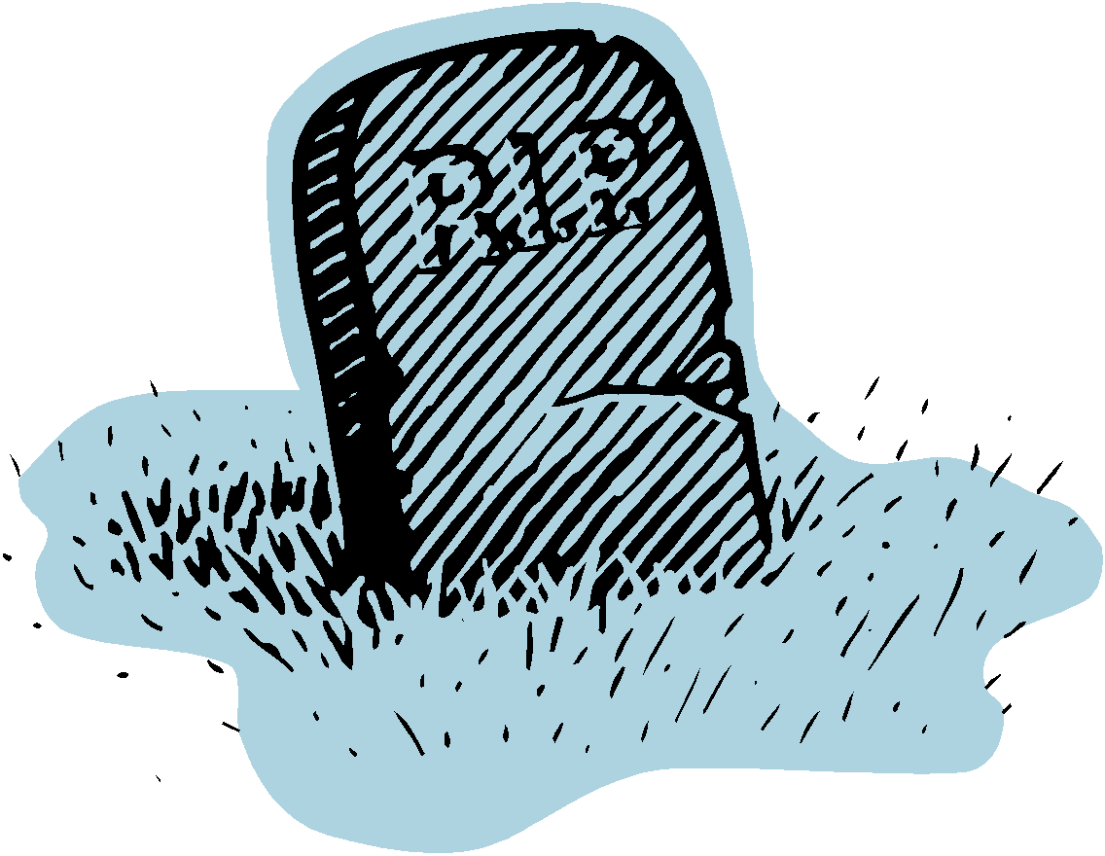

The five steps you will follow in doing this assignment are outlined below.

# **DECIDING**

* What am I expected to do/produce?
* What do I know already?
* What do I need to find out?
* What sort of questions do I need to get answered?
* Where could I go to get this sort of information?
* Can I find this information using the library books and files, the school’s network reference collection, CD Roms, text books, local library?

COMPLETE THE INQUIRY PLANNING SHEET AND HAND IN ON _______________________

# **RECORDING THE INFORMATION**

* What do I need to make a note of?
* How can I organise my notes?
* Have I kept a record of where I got my information from?

KEEP ALL MATERIAL PRINTED OUT AND DRAFT WORK TO HAND IN WITH MY ASSIGNMENT

# **USING THE INFORMATION**

* What do these resources tell me?
* Do they answer the questions that I need to answer?
* Do I have the skills to extract the information from the resources or do I need something simpler?

# **PRESENTING MY INFORMATION**

* What do my assignment instructions tell me to do?
* Have I read the marking schedule carefully? Have I missed anything out?

# **EVALUATING MY WORK**

* How well do I think I have done?
* Am I satisfied with my assignment?
* What could I do better next time?
* What have I done really well and am proud of?

COMPLETE THE WEBSITE EVALUATION SHEET, SELF EVALUATION SHEET AND HAND IN WITH MY TOMBSTONE ON _____________________________



**NAME:____________________________________**

Before you begin the process of Inquiry you need to think carefully about how you are going to approach the

task you have been given. Complete this sheet to show evidence of planning and preparation for the Inquiry process.

| **The question:**  what do you need to know/find out before you can do this assignment? What are you actually going to research? What questions will you ask yourself as you investigate this topic? |
| --- |
| **Sources of information:** what sources are available to use? What kinds of information will each source give you (current, dated, opinion, fact, statistics) will some be better sources of information than others? Why? |
| **Processing the information:**  what do you think you will need to do with your information before you use it as a part of your research? |
| **Presentation of your findings:**  How will you present your information? What is expected for this Inquiry? How will you make your presentation effective? |
| **Deadlines:** when are you expected to complete this sheet? When is the assignment due in? When should you have completed your research and have started on your presentation? Are there other deadlines you have for this assignment? |

Comments:

**Self Assessment**

**NAME:_________________________________**

At the end of the Inquiry process it is important to evaluate the sources of information used and consider how carefully you have followed the process of inquiry and completed the assessment activities. Complete this evaluation sheet and hand it in. Write thorough answers and critically evaluate your work. If you can pinpoint weaknesses yourself you are more likely to make improvements next time. Recognising where you have done something particularly well is also to be encouraged.

1. I planned my research well:



Poor planning Thorough planning

Comments to explain your placement:

1. I used a variety of sources for my information:



Not enough sources used A wide range of sources used

Comments to explain placement:

1. My information was appropriate and relevant:



Not very relevant Highly relevant information

Comments to explain placement:

1. I processed and then linked the information I collected to the task carefully:



Not processed or well linked to the activity Well processed and linked

Comments to explain placement:

1. My presentation shows care and attention to the marking schedule:



Poor presentation Excellent presentation

Comments to explain placement:

**Website Evaluation**

1. Choose one of the web sites that you have used in your research.

Write the web address below:

2. State the author or company, organisation, university that produced this web page:

(If you are unable to find it state this below)

3. When was this web page last updated? (If this information is not available, state

this below)

4. Does the information in this web site seem to factual or written as though it is

someone's opinion? Quote below some evidence from the web site that supports

your answer.

5. Which age group / groups of people would you recommend this web site to?

6. Was the page layout clear and easy to use. Circle the appropriate number on the

scale below.

**Not clear, Clear layout,**

**confusing layout. 1 2 3 4 5 easy to use.**

1. Was the web site presented in an appealing, eye-catching way? Circle the appropriate

number on the scale below.

**Not appealing, Appealing,**

**boring presentation**. **1 2 3 4 5 eye-catching.**

1. On the scale below give the web site an overall rating in terms of its usefulness:



**Not**  **1 2 3 4 5 6 7 8 9 10 Very**

**useful useful**

1. Why did you choose this web page to use? Comment on the overall usefulness.

**Fact File**

Useful website: [**http://www.cia.gov/cia/publications/factbook/**](http://www.cia.gov/cia/publications/factbook/)

|  | *CAMBODIA TODAY* | *NEW ZEALAND TODAY* |
| --- | --- | --- |
| **FLAG** |  |  |
| **CAPITAL CITY** |  |  |
| **TOTAL AREA** |  |  |
| **POPULATION** |  |  |
| **\*LIFE EXPECTANCY AT BIRTH** |  |  |
| **LANGUAGES** |  |  |
| **\*LITERACY RATE**  **(TOTAL POPULATION)** |  |  |
| **GOVERNMENT TYPE (TODAY)** |  |  |
| **CURRENCY**  **(Name of their money)** |  |  |

