NCEA RESOURCES:

What Are Human Rights? Human Rights Commission
https://www.hrc.co.nz/your-rights/human-rights/what-are-human-rights/

OHCHR | What are Human Rights
www.ohchr.org/EN/Issues/Pages/WhatareHumanRights.aspx

Human Rights | United Nations
www.un.org/en/sections/issues-depth/human-rights/

What are human rights? | Equality and Human Rights Commission
https://www.equalityhumanrights.com/en/human-rights/what-are-human-rights

WHAT ARE HUMAN RIGHTS? Video - Human Rights Definition ...
www.youthforhumanrights.org/what-are-human-rights.html

What is the Universal Declaration of Human Rights? | Australian ...
https://www.humanrights.gov.au/publications/what-universal-declaration-human-rights

What are human rights? | Amnesty International NZ
https://www.amnesty.org.nz/what-are-human-rights

Human rights and freedoms | NZ Government - Govt.nz
https://www.govt.nz/browse/law-crime.../human-rights.../human-rights-and-freedoms/

WHO | Human rights
www.who.int/topics/human_rights/en/

Human Rights Violations - United for Human Rights
www.humanrights.com/what-are-human-rights/violations-of-human-rights/

United for Human Rights: Violation & Abuses of the Universal UN ...
www.humanrights.com › ... › HUMAN RIGHTS VIOLATIONS

Definition and Examples of Human Rights Violation and Harassment ...
https://www.icu.ac.jp/en/campuslife/health/Examples.html

What are examples of violations of economic, social and cultural rights?
www.ohchr.org › OHCHR › English › Your Human Rights › ESCR

Human Rights Violations - Human Rights Commission
https://www.hrc.co.nz/your-rights/human-rights/our-work/

Human Rights Atlas
www.humanrightsatlas.org/

Human Rights Risk Index 2016 - Q4 - World | ReliefWeb
https://reliefweb.int/report/world/human-rights-risk-index-2016-q4

Human Rights Violations Around the World, in One Map. | elephant ...
www.elephantjournal.com/.../human-rights-violations-around-the-world-in-one-map/

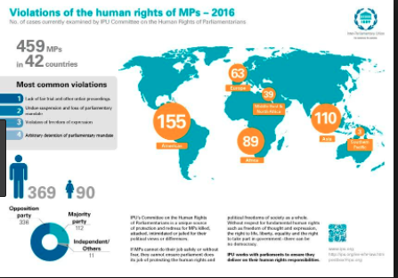

Is poverty a violation of human rights? - - Cetim
https://www.cetim.ch/is-poverty-a-violation-of-human-rights/

Poverty and Human Rights: is poverty a violation of human rights ...
www.cesr.org/poverty-and-human-rights-poverty-violation-human-rights

OHCHR | Human rights dimension of poverty
www.ohchr.org › OHCHR › English › Your Human Rights › Poverty

Poverty is a Human Rights Issue - Amnesty International
https://blog.amnestyusa.org/escr/poverty-is-a-human-rights-issue/

[Lecture] "Human Right to be Free From Poverty" - Prof. Thomas ...
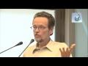▶ 39:32
https://www.youtube.com/watch?v=AWGeKkSBZAw

The Ethics of Wealth, Poverty, and Inequality - Human Rights and ...
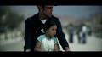▶ 21:50
https://www.coursera.org/.../the-ethics-of-wealth-poverty-and-ineq…

United Nations
www.un.org/en/

Human Rights | United Nations
www.un.org/en/sections/issues-depth/human-rights/

human rights | World Vision International
https://www.wvi.org/topics/human-rights

Who's Hungry? - World Vision New Zealand
www.worldvision.org.nz/whos-hungry

Search Results

GoodnessTv - World Vision Child Sponsorship
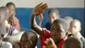▶
https://www.goodnesstv.org/en/videos/voir/47854/1/

What does it mean if the rains don't come? | World Vision Australia ...
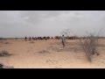▶ 2:17
https://www.youtube.com/watch?v=UDrOWFeCkuI

NEW ZEALAND 2017/2018 | Amnesty International
https://www.amnesty.org/en/countries/asia-and-the-pacific/.../report-new-zealand/

Human Rights Education | Amnesty International
https://www.amnesty.org/en/human-rights-education/

Human Rights: The Rights of Refugees | edX
https://www.edx.org/.../human-rights-rights-refugees-amnesty-internationalx-rights2x

