**‘BOX PLAN’ for Essay Writing**

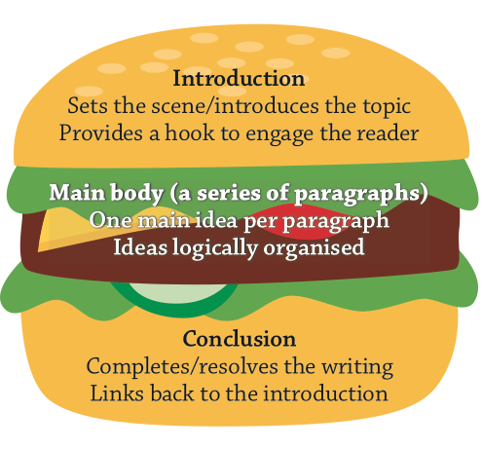

|  |
| --- |
| **INTRODUCTION:**   * What is topic of your writing? USE KEYWORDS FROM THE Q/TASK * What is your argument? * How are you going to hook the reader? |

|  |
| --- |
| **BODY PARAGRAPHS:**  BP1   * Point * Explain * Evidence   BP2   * Point * Explain * Evidence   BP3   * Point * Explain * Evidence   **STOP:**   * Have you re-read the question/task to ensure you have addressed all the criteria? * Do you have enough information to explain your point and provide a relevant example * in each BP? If not you will need to conduct more research! * Do you have too much information? Discard the things that are not entirely relevant * Are the above paragraphs arranged in the correct order? If not rearrange them * YOU WILL STILL NEED TO WRITE YOUR PARAGRAPHS IN **SEXY** OR **TEXAS** the above is just a plan |

|  |
| --- |
| **CONCLUSION:**   * Summary of key points * Provides resolution for the reader * Links back to the introduction = KEYWORDS |