Inkscape Guide
Follow these guidance notes to complete a drawing file using the CAD (Computer Aided Design) programme Inkscape, the file can then be used by the laser cutter to cut a profile from acrylic plastic, wood and other materials. To save your drawings, make a new folder called Inkscape Drawings, save your drawings with a title you can easily recognise.

- Download a copy of Inkscape, if you are using a chromebook you will need to use an app (Rollapp) to access Inkscape.
- Open a new inscape drawing – file – new – enter – you will see a blank A4 outline on the screen
- Set the screen size to the laser cutter bed size which is 900mm wide x 60mm high
- File – document properties – click on the units box, choose the mm unit
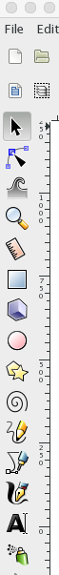
- Click inside the width box, enter 900, click in the height box, enter 600. This is the size of the laser cutter bed, centre the outline on the page by using the side and bottom sliders.

The tool bars at the side and top of the page contains all of the drawing and editing tools used in Inkscape, by selecting these tool icons you are able to draw virtually any shape and edit your drawing. The main tools you will need to begin with are;

- Select - use this to make a shape active, then it can be moved, resized, deleted or copied, a shape needs to be active in order for it to be worked with.
- Rectangle – draw any 4 sided shape
- Circle – circle or elliptical shape
- Stars and polygons – any shape with points or multi sides

- Select a shape by clicking on the shape in the left toolbar
- to change the size of a shape first select it using the select tool (arrow)
- in the top toolbar, change the units to mm
                - Enter the width W and height H of the shape in the boxes
- For a circle, the width and height must be the same size
- For a star or polygon you can enter the number of points or sides by entering these in the units box.
Practice finding all of these tools, you need to know where they are located
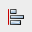
Along the top toolbar there are some very useful editing tool icons you will need, these are (left to right) zoom, group/ungroup, text edit and align. Group and Ungroup are also regularly used.

File, Edit, View, Object, Path will be used regularly, click on them to see their drop down menus

Importing a photo or drawing into Inkscape
A really useful feature of Inkscape is to import a photo or image which can then be laser cut and engraved. It is important to understand that a photo/image cannot be laser cut or engraved without first editing it as laser cut files must be in the SVG format which is the only format that a laser cutter can read. Photos/images will be in other formats such as JPG (Joint Photographic Group) PDF (Portable Document Format) or DXF (Document Exchange Format)
A photo/image is made up of layers of colours and lines, the laser cutter software cannot ‘read’ colours, it needs to ‘read’ the outlines of the image, so the image must be edited so that the outlines are not hidden.

To import and edit a photo/image follow these steps:
- Find an image by using google search
- Change the image into a line drawing, click ‘tools’ - click ‘type’ - click ‘line drawing’
- Copy the image and paste it into the Inkscape drawing area.
Next step is to define the outline of the shape so the laser can cut/engrave the outline so we need to separate the solid shape layer from the outline.
- Select the shape using the ‘select tool’
- On the top toolbar, click on ‘path’
- On the drop down menu click on ‘trace bitmap’ (a bitmap is an image made up of dots/bits)
- Click on the ‘edge detection’ box
- Click on ‘update’ then OK, the outline of the shape will appear in the drawing box (if it does not appear then the image cannot be edited for use as a laser cut file

The next step is to delete the solid shape leaving the outline which can be edited in the inkscape drawing box
- Select the imported image which has been traced using ‘trace bitmap’
- Click on the shape and drag it away from the outline which you will now appear behind
- Delete the solid shape to leave only the outline
- The image that is left can be tested to make sure the correct outline has been deleted.
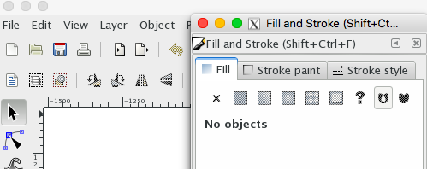
- Select the image
- Click on ‘object, then click on ‘fill and stroke’ (a pop up box will appear)
- Click on Fill, click on the black X below the Fill icon (this removes the colour fill)
- Click on the ‘stroke paint’ icon, click on the shaded square to the right of the black X
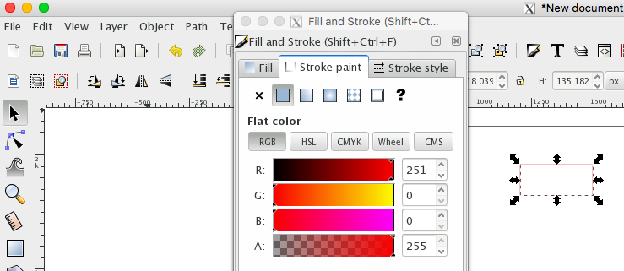

- Three coloured sliders will appear
- Click on the top slider R, hold your mouse over the small triangle on the slider
- Move the slider triangle to the far right side, the selected outlines on the selected image should change to RED colour (there may be a delay in the slider moving)

- If the colours do not change then the the wrong outline has been deleted, go back and repeat the process with the other outline that was deleted

Set the width of the laser beam cutter by using ‘stroke style’
- Click on ‘stroke style’ a pop up box will appear with a number
- Make sure the units box is set to mm
- Overtype the number to 0.3 mm
- The number may show as 0.282, if so then leave it set, this the Inkscape default stroke style

The laser can cut an outline and also engrave patterns and text on to a surface. To do this the lines on the image need to be changed to different colours, RED lines will be cut and BLACK lines will be engraved. The laser machine operator can also control the speed and laser power settings.
Usually the outer edges will be cut and the inner lines will be engraved, the same ‘fill and stroke’ process is used to do this.

To laser cut:
- This is done using the same ‘fill and stroke’ process
- Select the outlines to be laser cut
- Follow the process as detailed above in points 1 to 11
- The lines to be laser cut must be RED

To laser engrave:
- Follow the process as detailed above in points 1 to 11 for cutting but leave the slider on BLACK so that all lines to be engraved are BLACK
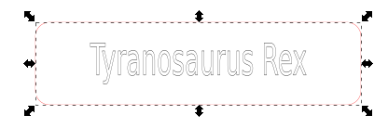

In this screenshot the outline has been set to red so will cut and the text has been set to black so will engrave

How to edit an image that has two outlines:
Some images that have been converted to an SVG file have two outlines but they may not be able to be seen unless the image is zoomed, then they can be seen, so you should always zoom in on an image to check the outlines.
The problem with having two outlines is that the laser cutter will cut all lines and as well as taking more time to cut it will leave many very thin cut parts, the outlines can be edited to leave only the outline that needs to be cut, follow this process;
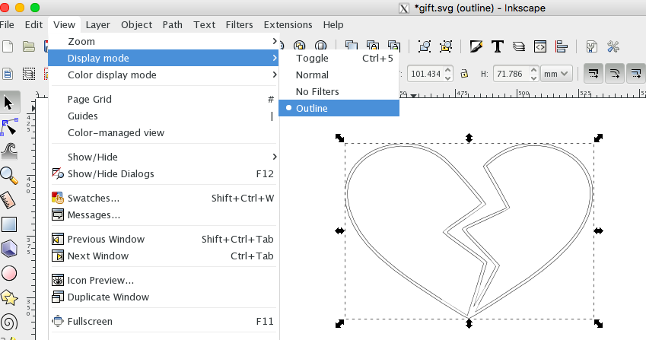
- Zoom in using the max zoom icon (the left magnifying glass of the three zoom buttons on the toolbar)
- Click on the ‘view’ button on the toolbar
- Click on ‘outline’ in the drop down menu
- You can now see the outlines of the image in black lines
- Use the zoom % up/down buttons at the bottom right of the screen to adjust the zoom so the whole image can be seen
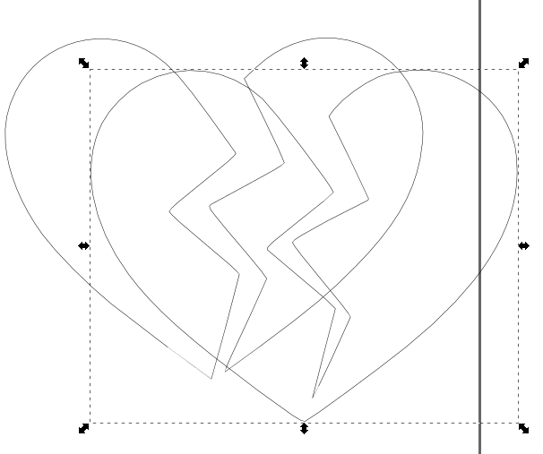
Separating the outlines:
- Click on ‘path’ then click on ‘break apart’ on the drop down menu, the image will split into all of its separate parts
- Click on the outermost line of the drawing and the whole of the outline should be selected, if it is not then you have not clicked on the outline, try to select the outline and repeat

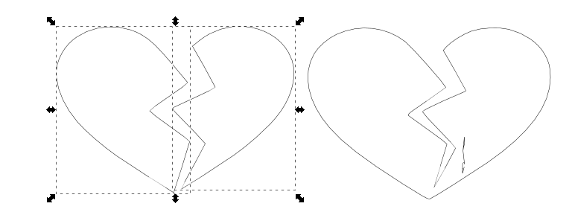

- When the outline has been selected, drag it to one side so it is separated from the lines that are left
- Select and then delete the inner lines that are left
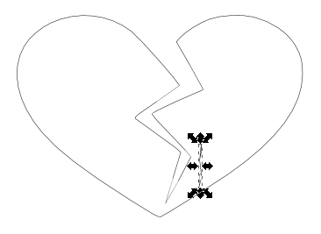

- There may be other lines that are left over after the outline has been traced, these must be found, selected and deleted.
- The screenshot shows one of these lines selected and ready to delete

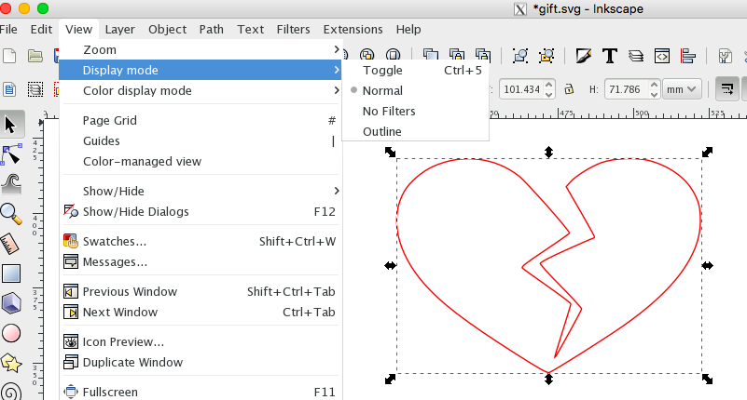

The last thing to do after editing the outline is to go back to ‘normal’ view,
Only when in ‘normal’ view can lines be changed colour and edits be made, lines will show as the colour that they were before ‘outline’ view was selected.
The outline of the drawing is now ready to laser cut

