Last Match | A | B | C
 | Explain why the play focuses on survival and if it reminds you of anything else important like that. | Definition finder:  - Kindling  - Perish  - Fathoms | Write about the personalities of all the different characters throughout the play.
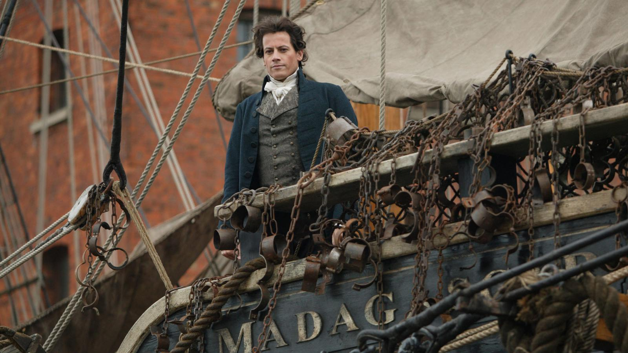 | Describe what William Sanguily, James Teer, Joseph Jewell, Bartholomew Brown and Mary Ann Jewell do throughout the play. | Compare and contrast where the characters are and what they do with where you are now and what you do. | What is an example of sibilance in the play?
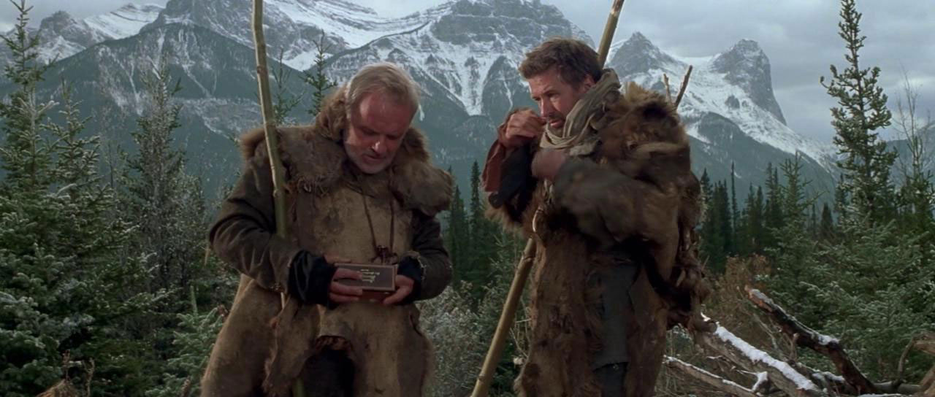 | Draw, design and label your own survival kit. | Describe what you would have done if you were in the same situation as William Sanguily, James Teer, Joseph Jewell, Bartholomew Brown and Mary Ann Jewell. | List the ways that the author prepares us for the ending of the play.

