**Current Event #1**

**Are Ultra-processed Foods Really that Bad?**

**“A grocery store that has a health food section should**

**make you wonder about the rest of the store.”**

**– Anonymous**

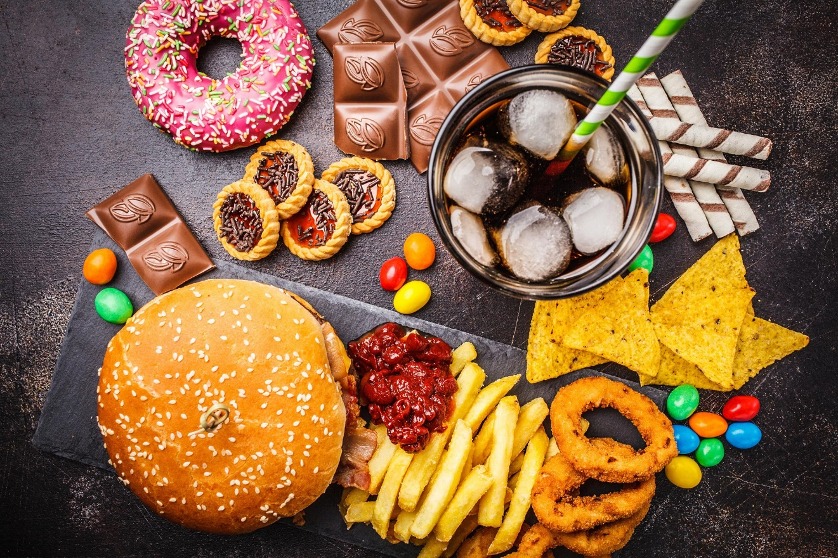

**Success Criteria:** By the end of the lesson students will be able to describe at least three reasons why ultra-processed foods are harmful to human health, if vaccines cause autism, and how a flipping of the magnetic poles is expected to impact life on earth.

**Task 1:** Watch the video on ultra-processed foods and answer the following questions:

<https://www.youtube.com/watch?v=r03hB_xk5xs>

**1. What are some of the ingredients commonly found in ultra-processed foods? List five.**

a.

b.

c.

d.

e.

2. What percentage of the United States food supply is made up of ultra-processed foods?

3. Provide an example of a minimally processed food. (5:20 sec.)

4. Give an example of a highly processed food. (5:50 sec.)

5. What processed candy was only sold to the U.S. military during World War 2 because it would not easily melt? (6:20 sec.)

6. List 5 health problems that have been linked to eating ultra-processed foods. (7:50 sec.)

7. Go to the Mayo Clinic webpage and write down the definition of pre-diabetes. Here is the link:

<https://www.mayoclinic.org/diseases-conditions/prediabetes/symptoms-causes/syc-20355278>

8. High school student Tiara Channer was pre-diabetic then stopped eating ultra-processed foods. What happened? (8:00 sec.)

9. How many American children are classified as being pre-diabetic?

10. What is the opinion of Benie Sanders on big corporations inducing people to eat ultra-processed foods? (10:00 sec.)

11. What does G-R-A-S stand for?

12. Of nearly 800 food chemicals introduced between 2000 and 2012, what percentage avoided having to get approval from the Food and Drug Administration?

13. Dr. Kevin Hall works for the US Government and was involved in a study of 20 people who were fed ultra-processed foods for 2 weeks, then minimally processed foods for the next 2 weeks. Write a summary below (or key dot-points of what happened):

14. Name two things that Bernie Sanders wants Congress to do to make foods safer from ultra-processing? (19:00 sec.)

**15. Go to the 21:00 sec. mark and play the video to the end. Summarize what happened. How does this make you feel? *note – the ending will shock you!**

**Current Event #2**

**The Myth that Vaccinations Cause Autism**

**They Don’t**

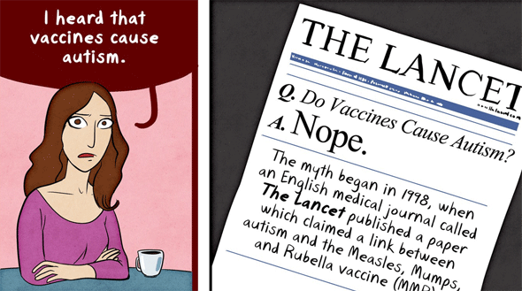

**Success Criteria: By the end of the lesson students will be able to describe the evidence that vaccinations do not cause autism.**

**Autism is a condition that affects how a person’s brain works, especially with things like talking, understanding feelings, or making friends. Their brain processes the world differently than most people. Some people think that autism is caused by vaccines. The man that Donald Trump has nominated to head the United States Health Department – ‘RFK’ or Robert F. Kennedy Jr. has said he believes that vaccinations cause autism. This has caused worry among Doctors in the U.S. because the man who may become the head of health for the entire country – has made a claim that is not supported by the science.**

**Task 1: Watch the video clip from CNN on vaccines causing autism:**

[**https://www.youtube.com/watch?v=Ut4Br9oTJgo**](https://www.youtube.com/watch?v=Ut4Br9oTJgo)

**Answer the following questions:**

**1. What happened in Samoa recently when people stopped getting their children vaccinated for measles? (3:00 sec. mark)**

**2. Robert Kennedy says just show him the data that vaccines are safe and he will be fine with vaccinations. What is wrong with this statement? (5:00 sec.)**

**3. If vaccinations are reduced, what are the likely diseases that will make a comeback?**

**4. In the past 50 years, how many lives are vaccines believed to have saved? (9:00 sec.)**

**Task 2: Read the following article about vaccinations and autism at:**

[**https://raisingchildren.net.au/autism/learning-about-autism/about-autism/vaccinations-asd**](https://raisingchildren.net.au/autism/learning-about-autism/about-autism/vaccinations-asd)

**Based on this article, create a poster designed to educate parents that vaccines do not cause autism. Include:**

1. **A catchy title designed to attract interest**
2. **At least one image that is relevant to the topic**
3. **Make the case that vaccines do not cause autism – what does the science say?**
4. **Cite studies, facts and figures to support your case.**

**Current Event #3**

**What is Pole Shift?**

**It WILL Happen Again – What can we Expect**

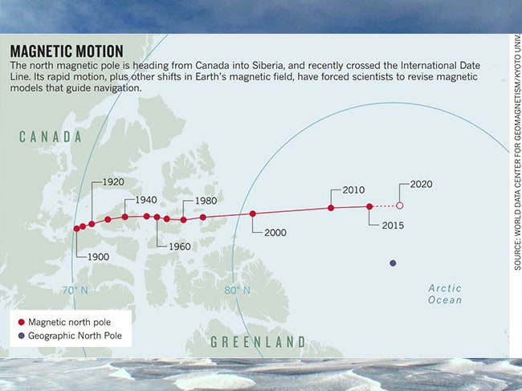

Earth's magnetic field is what protects our planet from harmful space radiation. However,

our protective shield might soon go into a transformation that could threaten lives on Earth. This video shows what will happen when Earth's magnetic poles flip.

**Task 1:** Watch the clip on pole shift. Answer the following questions.

<https://www.youtube.com/watch?v=I6Ggs7nUjxA> (5:18 sec.)

1. There are two north poles. What are they?

2. The next time the earth’s magnetic poles shift, what is expected to happen?

3. List at least 4 different things that the earth’s magnetic field shield’s humans from.

4. What could happen to animals? Airplanes? Satellites? Humans Living in space?

4a.

4b.

4c.

4d.

1. What is a sign that we may be on the brink of a solar flip?
2. When is that last time the earth’s magnetic field did a flip? How many years ago?
3. What are the different things sciebtists can do to try to help us deal with he next pole flip?

**Task 2:** Listen to the National Public Radio clip on Pole Shift and its relation to New Zealand.

<https://www.npr.org/2021/02/18/969063568/ancient-trees-show-when-the-earths-magnetic-field-last-flipped-out> (3:00 sec.)

After listening to this clip, list the different impacts from a magnetic shift on earth:

*

*

*

*

*

**Add additional dot-points from the reading below:**

READING

**Magnetic Pole Shift – The New Zealand Link**

**Ancient Trees Show When the Earth's**

**Magnetic Field Last Flipped Out**

February 18, 2021 National Public Radio

An ancient, well-preserved tree that was alive the last time the Earth's magnetic poles flipped has helped scientists pin down more precise timing of that event, which occurred about 42,000 years ago. This new information has led them to link the flipping of the poles to key moments in the prehistoric record, like the sudden appearance of cave art and the mysterious extinction of large mammals and the Neanderthals. They argue that the weakening of the Earth's magnetic field would have briefly transformed the world by altering its climate and allowing far more ultraviolet light to pour in.

Their provocative [analysis](https://science.sciencemag.org/cgi/doi/10.1126/science.abb8677), in the journal *Science*, is sure to get researchers talking. Until now, scientists have mostly assumed that magnetic field reversals didn't matter much for life on Earth — although some geologists have [noted](https://agupubs.onlinelibrary.wiley.com/doi/10.1029/2018RG000629) that die-offs of large mammals seemed to occur in periods when the Earth's magnetic field was weak.

The Earth is a giant magnet because its core is solid iron, and swirling around it is an ocean of molten metal. This churning creates a huge magnetic field, one that wraps around the planet and protects it from charged cosmic rays coming in from outer space.

Sometimes, for reasons scientists do not fully understand, the magnetic field becomes unstable and its north and south poles can flip. The last major reversal, though it was short-lived, happened around 42,000 years ago.

**What Science Says**

This reversal is called the Laschamp excursion, after lava flows in France that contain bits of iron that are basically pointed the wrong way. Volcanic activity back then, during the flip, produced this distinctive iron signature as the molten lava cooled and locked the iron into place. Iron molecules embedded in sediments around the world also captured a record of this magnetic wobble, which unfolded over about a thousand years. "Even though it was short, the North Pole did wander across North America, right out towards New York, actually, and then back again across to Oregon," says [Alan Cooper](https://www.researchgate.net/profile/Alan_Cooper11), an evolutionary biologist with Blue Sky Genetics and the South Australian Museum. He explains that it "then zoomed down through the Pacific really fast to Antarctica and hung out there for about 400 years and then shot back up through the Indian Ocean to the North Pole again."

These changes were accompanied by a weakening in the magnetic field, he says, to as low as about 6% of its strength today. He and colleague [Chris Turney](https://research.unsw.edu.au/people/professor-chris-turney), an earth scientist at the University of New South Wales, found a new way to study the exact timing of all this, using unusual trees in New Zealand. Giant [kauri](https://www.doc.govt.nz/nature/native-plants/kauri/) trees can live for thousands of years and can end up well preserved in bogs. "The trees themselves are quite unique," says Cooper. "They're a time capsule in a way that you don't really get anywhere else in the world." Inside [trees](https://www.stuff.co.nz/science/113954687/ancient-northland-kauri-tree-reveals-secrets-of-earths-polar-reversal) that lived during the last magnetic flip, the researchers and their colleagues looked for a form of carbon created when cosmic rays hit the upper atmosphere. More of these rays come in when the magnetic field is weak, so levels of this carbon go up. The trees, with their calendar-like set of rings, took in this kind of carbon and laid it down as wood. That let the researchers see exactly when levels rose and peaked and then fell again. One tree in particular had a 1,700-year record that spanned the period of the greatest changes.

By creating a precise timeline, the research team was able to compare the magnetic field's weakening to other well-established timelines in the archaeological and climate records.

"We really think actually there's quite considerable impacts going on here," says Cooper.

They also turned to advanced climate modeling to try to understand how the magnetic changes would have affected conditions on the planet. The ozone layer, in particular, would have taken a beating. "If you damage the ozone layer, as we've found out, you change the way in which the sun's heat actually impacts the Earth," says Cooper. "And as soon as you start doing that, you change weather patterns because wind directions and heating goes AWOL, goes all over the place."

If the sun went through one of its periodic conniptions when the strength of the Earth's magnetic field was turned way down, he says, a solar flare or storm would have sent a burst of radiation that could have had massive consequences for people living back then. "This is what we think actually drove them into caves," says Cooper. "You would not want to be outside during daylight hours." He admits that it's difficult to draw clear links among all these various events "at this stage. But I think that's always true when you're putting forward such a radical new theory." He notes that the idea of an asteroid killing off the dinosaurs once seemed far-fetched as well.

Other researchers say they're really struck by the fact that the scientists were able to construct such a detailed record of the timing of magnetic changes by looking at these trees. "That high-resolution temporal record is, I think, pretty impressive," says [Brad Singer](http://geoscience.wisc.edu/geoscience/people/faculty/brad-singer/), a geologist at the University of Wisconsin-Madison who studies the history of the Earth's magnetic field but was not part of the research team. "This is only a small number of specimens that they measured, but the results look fairly reproducible in the different trees, and I think that's a pretty impressive set of data."

He thinks this report will steer people's attention to do work that could test this proposal that reversals of the Earth's magnetic field could disturb its life. [James Channell](https://people.clas.ufl.edu/jetc/), a geologist at the University of Florida, questioned whether other kinds of historical records, like ice cores, support the idea of a global climate crisis around 42,000 years ago. He works mostly on the North Atlantic, he says, and isn't aware of anything very dramatic going on there at that time.

Still, he has previously [written](https://agupubs.onlinelibrary.wiley.com/doi/10.1029/2018RG000629) about the possibility that magnetic field weakening was linked to die-offs of large mammals, so he was "thrilled" to see someone else connecting those two things. Large mammals, he notes, are long-lived and susceptible to damage from prolonged exposure to the ultraviolet radiation that would increase during periods when the magnetic field was weak.