Global Studies, Term 1, 2023 Mission Heights Junior College

**Can you Solve the Mystery?**

**Week 5:**

**Did Māori Ancestors Really Voyage to South America and Bring back the Kumara?**

**In week 3, the man in the documentary clip (Ian Taylor) said that it appears that the early Polynesians who would eventually discover New Zealand, came from Asia and eventually reached as far as South America by using the double-hulled canoe. He says that we know this because the Kūmara is native to South American and it is the only place it could have come from. *The Encyclopedia of New Zealand* online also supports this view and states that “The Polynesian ancestors of Māori brought kūmara (sweet potato) with them as a food plant when they arrived in New Zealand in the 13th century. It is believed that early Polynesians had voyaged to South America and took kūmara from there to Polynesia.”**

**If you look closely at this passage, it does not state as fact that it came from South America through contact with Polynesians, only that it is “believed” to have happened when it was thought they voyaged to South America. What these sources fail to mention is that there is a debate among scientists over how the kumara spread across Polynesia. No one knows for sure. There are other explanations for how Polynesians and later Māori in what is now New Zealand, got Kūmara, that do not involve them traveling to South America.**

**Task 2: Access ‘Reading 1 & 2 on the Kumara.’ List five different explanations for how the kumara got to Polynesia.**

**1.**

**2.**

**3.**

**4.**

**5.**

**Writing Exercise: Which theory for the kumara reaching New Zealand do you think is most likely? Explain the theory, give your opinion, then provide information to support your view.**

**Week 5 Readings 1 & 2 on the Kumara Mystery**

# From the journal Nature **18 May 2007, and modified by Mr Bartholomew for language.**

# Drifters could Explain Sweet-Potato Travel

**An unsteered ship may have delivered crop to Polynesia.**

Brendan Borrell

Where did these come from?

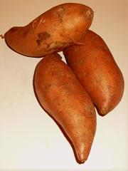

How did the South American sweet potato wind up in Polynesia? New research suggests that the crop could have simply floated there on a ship.

The origin of the sweet potato in the South Pacific has long been a mystery. The food crop undisputedly has its roots in the Andes. It was once thought to have been spread by Spanish and Portuguese sailors in the sixteenth century, but archaeological evidence indicates that Polynesians were cultivating the orange-fleshed plant much earlier than that, by at least AD 1000. However, there's no hard evidence of people travelling between South America and the South Pacific so early in history. Most Polynesian crops have their origins in Asia, where the people are thought to have migrated from.

Some scientists have suggested that sweet-potato seeds were carried in the stomachs of itinerant birds. Others suggest that Polynesians once voyaged to the Ecuadorian coast, and — foregoing such South American staples such as maize and *Phaseolus*beans — they brought back a root that reminded them of Asian yams. Still others proposed that the sweet potato floated 8,000 kms across open ocean, either in its spherical seed pod or in a drifting vessel.

## An unlikely journey

Álvaro Montenegro at the University of Victoria, British Columbia, says that when he ran simulations, sweet-potato seed pods that started off in American waters could reasonably hit seven different island groups, and had the best chance of landing on the Marquesas. But the trip took at least four months. Even coconuts can't survive in salt water that long.

More likely, he says, a loaded vessel was blown out to sea and landed on the islands — which could take as little as 90 days. Montenegro notes that seed pods are transported by currents alone, but a drifting vessel gains momentum from the wind.

With 2,000 years between sweet-potato use in South America and its arrival in Polynesia, there have probably been numerous such drift events. But did people survive the trip, along with the crops?

Montenegro says language similarities between the Quechua word for the tuber, *cumal*, and the Polynesian one, *kumala*, suggest that humans must have been along for the ride. Patrick Kirch, an archaeologist at the University of California, Berkeley, who has worked on the issue, thinks that more extensive and deliberate contact must have taken place. "In my view, the most probable mechanism of transport was Polynesians sailing to South America," he says. But the evidence is still unclear.

The simulations, Montenegro says, simply demonstrate the feasibility of the drift theory, but a final verdict will depend on future archaeological findings. This approach may also help us understand how other plants, such as the bottle gourd, have drifted to the distant islands. And vessel drift is not just a thing of the past either. Montenegro points out that in 2005-2006, a fishing boat from Mexico was swept to the Marshall Islands — just as his model predicts.

**Reading #2:** “Floating the sweet potato to Polynesia: Considering the feasibility of oceanic drift for the prehistoric introduction of the sweet potato…to Pacific Islands.” [Quaternary Science Reviews](https://www.sciencedirect.com/journal/quaternary-science-reviews), [Volume 295](https://www.sciencedirect.com/journal/quaternary-science-reviews/vol/295/suppl/C), 1 November 2022.

*Modified by Mr Bartholomew

Sweet potatoes can reproduce via seeds or through cuttings or pieces of plant matter from the potato of a parent plant. Once fertilized, sweet potato flowers create a seed capsule containing between one and four seeds. Seed capsules are round and contain a thick black shell that can still produce new shoots years later, even after exposure to saltwater. In one study, after being immersed for 120 days, all of the kumara seeds were still good. This raises the possibility that capsules and seeds may have floated from the coast of South America to Polynesia after drifting in the ocean on a buoyant (something that floats) structure such as a clump of vegetation floating on the water.

**Week 5, Lesson 2**

Accident or by Design:

How Māori Found Aotearoa New Zealand

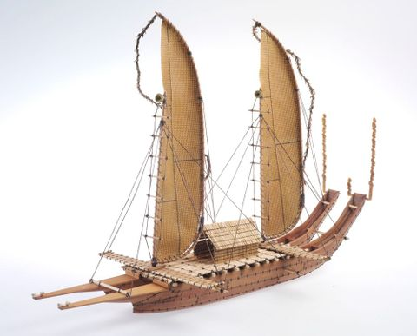

A double-hulled canoe

**Class Discussion:**

Name some common beliefs about how Māori discovered New Zealand. Was it an accident? Were they blown off course? Was it by design? If so, how did they know there was large southern land masses (the North and South Islands)?

**Task 1:** Watch the clip, “Birds and Navigation’ at: <https://www.thevoyage.co.nz/en/landing#Voyage%20Stories> (1:55 sec.)

1. Many experts believe that Māori discovered New Zealand after of watching birds. Explain.

**Task 2:** We are going to watch the **Breakup into groups of 4-5.**

Until relatively recently, many non-Māori looked at the first Māori settlers as arriving here by accident and barely surviving the voyage.

**Watch the video clip** on the myth of the first Māori to arrive in Aotearoa New Zealand at:

<https://www.thevoyage.co.nz/en/landing#Voyage%20Stories> (2:34 sec.)

Below is the famous painting that was mentioned in the clip. Have a close look at it. How are the Māori sailors portrayed. Look at the different facial expression, their physical features (do they look strong, weak, think, starving, muscular, etc.). The painting referred to in the video, appears below.

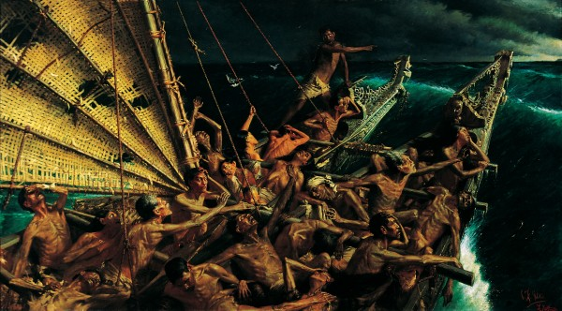

List the different negative images of Māori that are being conveyed by this painting from 1898. As a group, discuss the painting and come up with 10. List them below in your books – each person needs to write in their own book.

1.

2.

3.

4.

5.

6.

7.

8.

9.

10.

**Week 5, Lesson 3**

**A Polynesian Mystery**



A double-hulled canoe

During the 1940s, a Man from Norway named Thor Heyerdahl built a primitive ship and sailed from South America to Polynesia. His ship was called the Kon-Tiki and he proposedthat the Pacific islands were settled by people from North and South America. At the time, there was great excitement over his voyage as many people believed he had proved that the first people to settle in the Pacific Islands were from the Americas. Let’s look at the evidence.

**Task 1: Read** **‘The Polynesian Mystery,’ pp. 4-7.** Create a series of dot-points below that make the case that the first people to settle Polynesia, were South Americans.

**Task 2: Read** **‘The Case for Asia’ pp. 7-9.** List six types of evidence that support the theory that Māori and other Polynesian people originated in South America. List the type of evidence and a summary explaining it in 1 to 3 sentences. The first heading has been completed as an example.

**1. Language:** There is strong evidence that the Polynesians originated from Asia. Many of the words spoken in the islands across Polynesia are exactly the same as Asian words or are very similar. For instance, the Samoan word for 5 is lima – which is the same in Malaysian, while the Māori word for 5 is ‘rima’ – very similar.

**2. Food**

**3. Tools**

**4. Pottery**

**5. Religious Beliefs**

**6. Experimental Voyages**