How to use the BBC Micro:Bit with a prototype board (bread board)

* The Micro:bit can be connected to a prototype board (called a breadboard) by using a circuit board called an Edge Connector Board, circuits are built on the breadboard
* The breadboard is connected to the Micro:bit via the Edge Board using jumper wires
* The Micro:bit has three pins that can be used as output or input pins, they are P0, P1 and P2. There are many other pins on the Edge Board but this guide uses only pins 0, 1 and 2, on the Edge Connector Board
* Do not remove the Micro:bit from the Edge Connector board
* Connect the Micro:bit to your computer by using the long USB lead, this powers the Edge Board with 3 volts via the USB connection.
* The diagram below shows the connection pins on the Edge Board and how they are linked to the Micro:bit, the main pins used are;
* 0 (from the left side, pin 2 on the Edge Board)
* 1 (from the left side, pin 7 on the Edge Board)
* 2 (from the left side, pin 13 on the Edge Board)

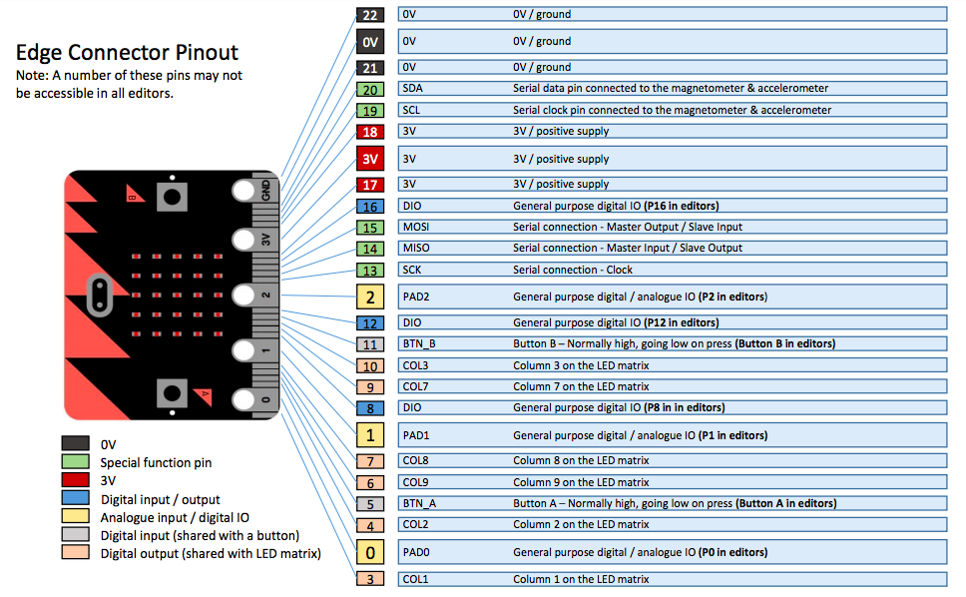

The first things you need to do before using the Micro:bit prototype board is to understand the Edge Connector board and the location of its pins and then to understand the breadboard and how the separate rows of points are linked in rows and columns.

The Breadboard:

* A breadboard usually has two rows running down each side which are **positive (+ve) red** colour and **negative (- ve) black** (can be blue on some breadboards)
* The +ve and -ve rows may be switched on some boards so be aware that you connect to the correct row
* These +ve and -ve rows are called ‘rails’ (because they resemble train tracks)
* All circuits must have a connection to the breadboard negative rail (the black row) then from the negative rail to a OV (0 volt) pin on the Edge Board, using this method enables multiple components to be connected from the breadboard to the Edge Board/Micro:bit
* Components like LED’s have a +VE lead (the long lead) and a -VE lead (the shorter lead
* The +ve lead must connect to the micro;bit pin that is being used to control it, in the first experiment you will learn how to flash an led which is controlled by pin 0
* See the photo below which shows a breadboard with a single led and its connections to pin 0 and -VE. A metal staple has been used to connect from the breadboard area to the -VE row and then a white hook-up wire connects the +VE led lead to pin 0 on the Edge Board
* All led’s use the same connection methods except to different pins (0, 1 or 2)

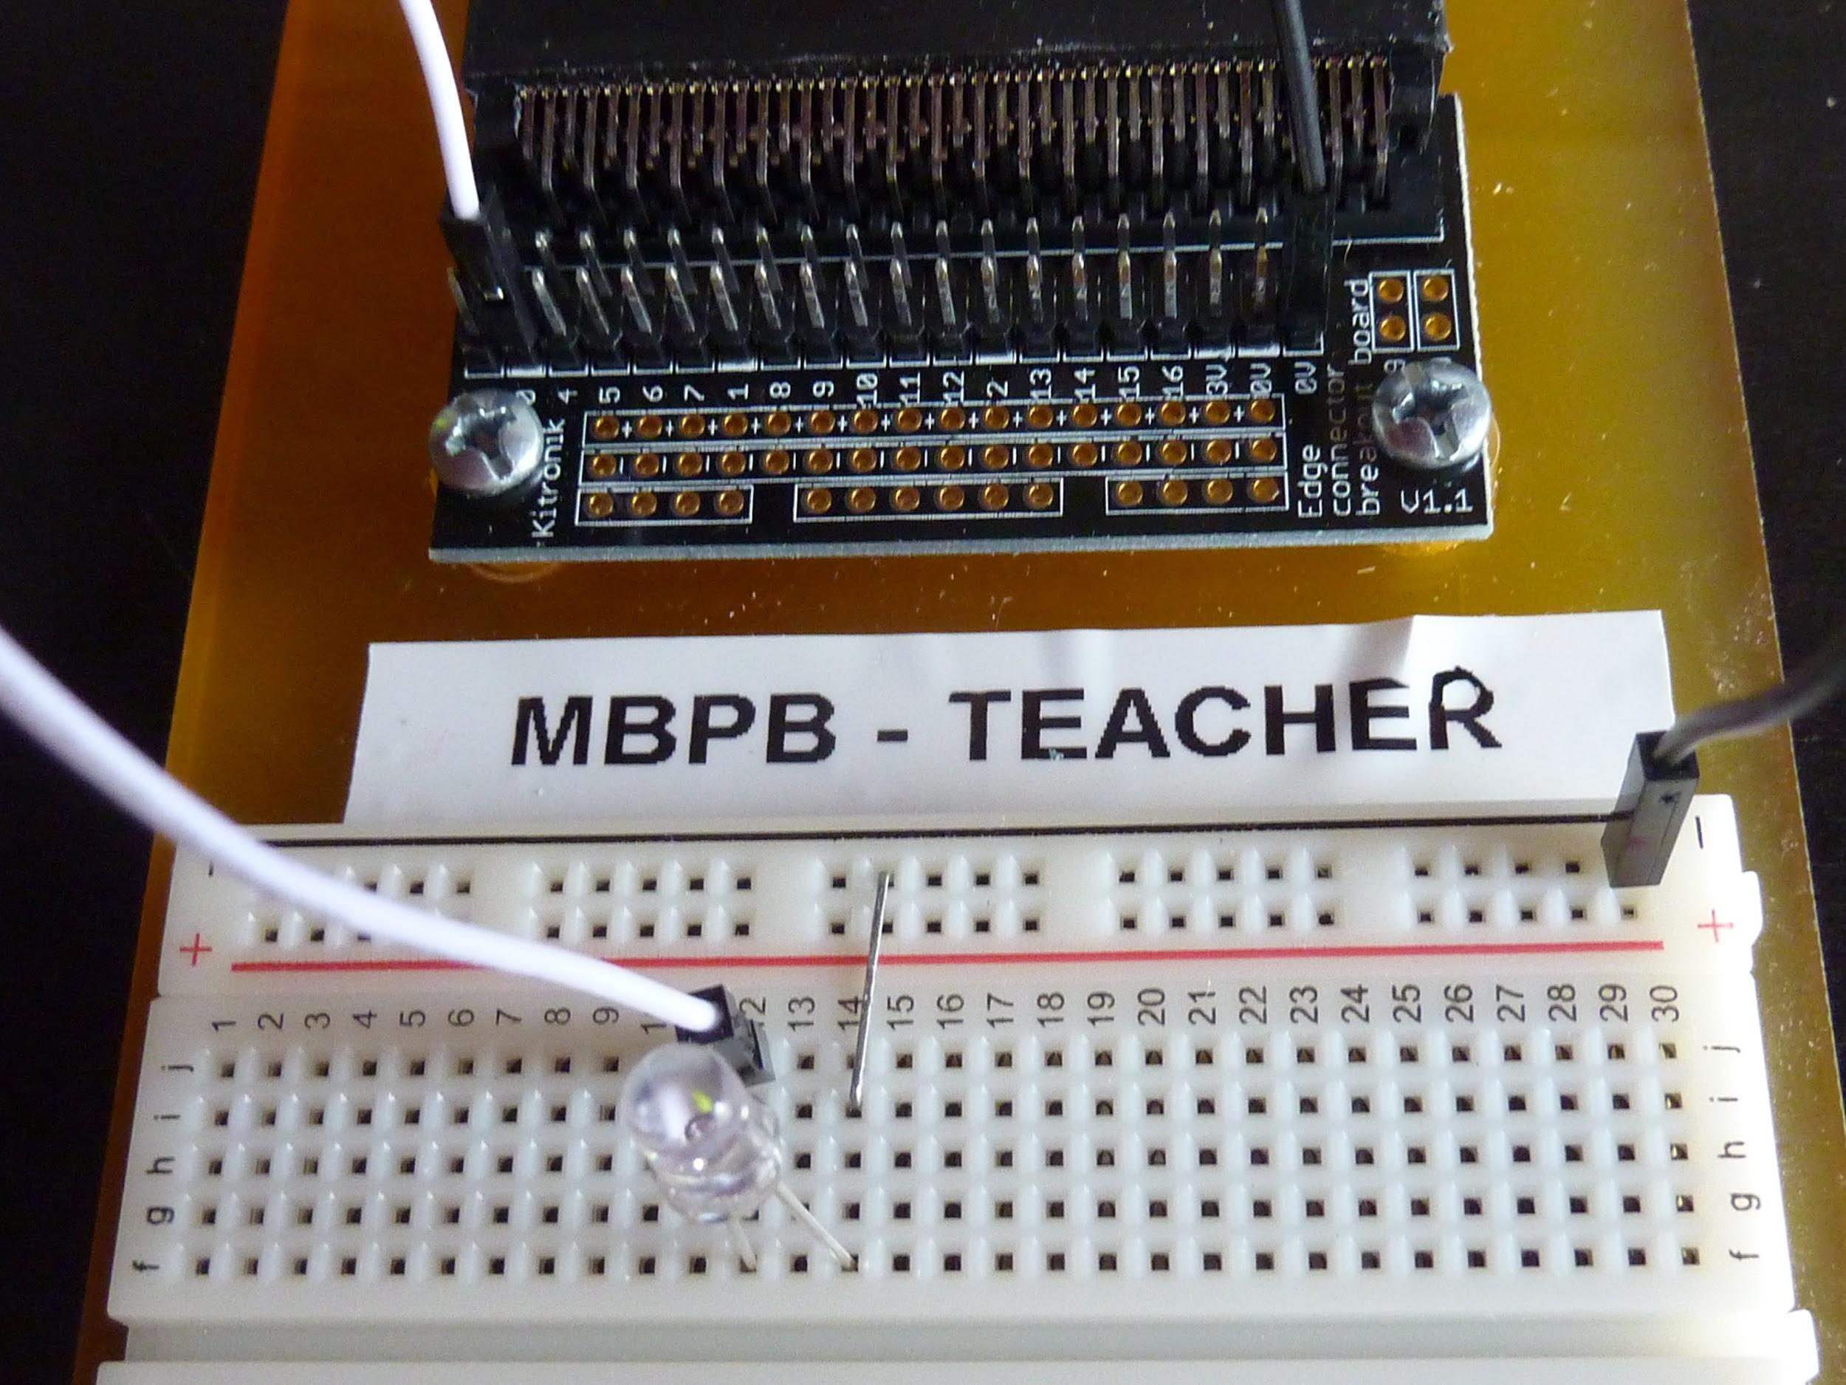

We will use the prototype board to build a series of circuits using electronic components such as Light Emitting Diodes (LED’s) and Light Dependant Resistors (LDR’s) along with jumper wires, jumper wires can also be made by using ordinary paper staples.

You will need a pair of long nose pliers which will be used to insert the components and jumper wires.

The circuits we will construct will be:

1. Flash an LED on and off using digital input pins
2. Flash two led’s alternatively
3. Turn on and off led’s using the Micro:bit switches A and B
4. Make a set of traffic lights using red, blue and green led’s
5. Turn on/off the traffic lights using switches A or B to represent two traffic directions at a road junction
6. Use a Light Dependant Resistor as a sensor to turn led’s on and off depending on the light level, without using switch inputs (the same system as some street lights use)

An LDR uses an Analogue input value so you will begin to learn the difference between Analogue and Digital inputs

**Experiment #1 - Flash a single led**

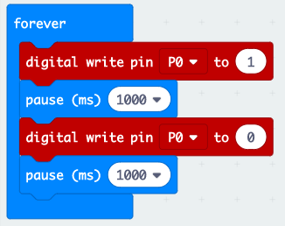

Write this programme which will flash a single green led LED, + ve lead connected to pin 0

‘forever’ controls the length of time the programme will run

‘digital write pin’ sets the pin number to be controlled (0, 1, 2) and whether it is turned ON (1) or OFF (0)

‘pause’ is a time delay that sets the time the pin is ON or OFF in milliseconds or seconds (1000 milliseconds = 1 second)

See the first photo above which shows the connection points on the breadboard

**Experiment #2 - Flash two led’s alternatively**

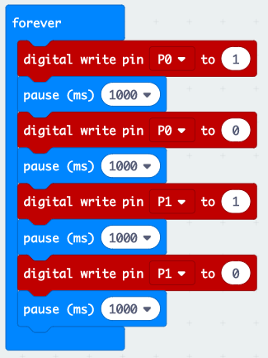

Write this programme which

will flash two led’s, one green, one red.

Green led, +ve lead connected to pin 0

Red led, +ve lead connected to pin 1

You can change the time they are on/off by editing the pause times

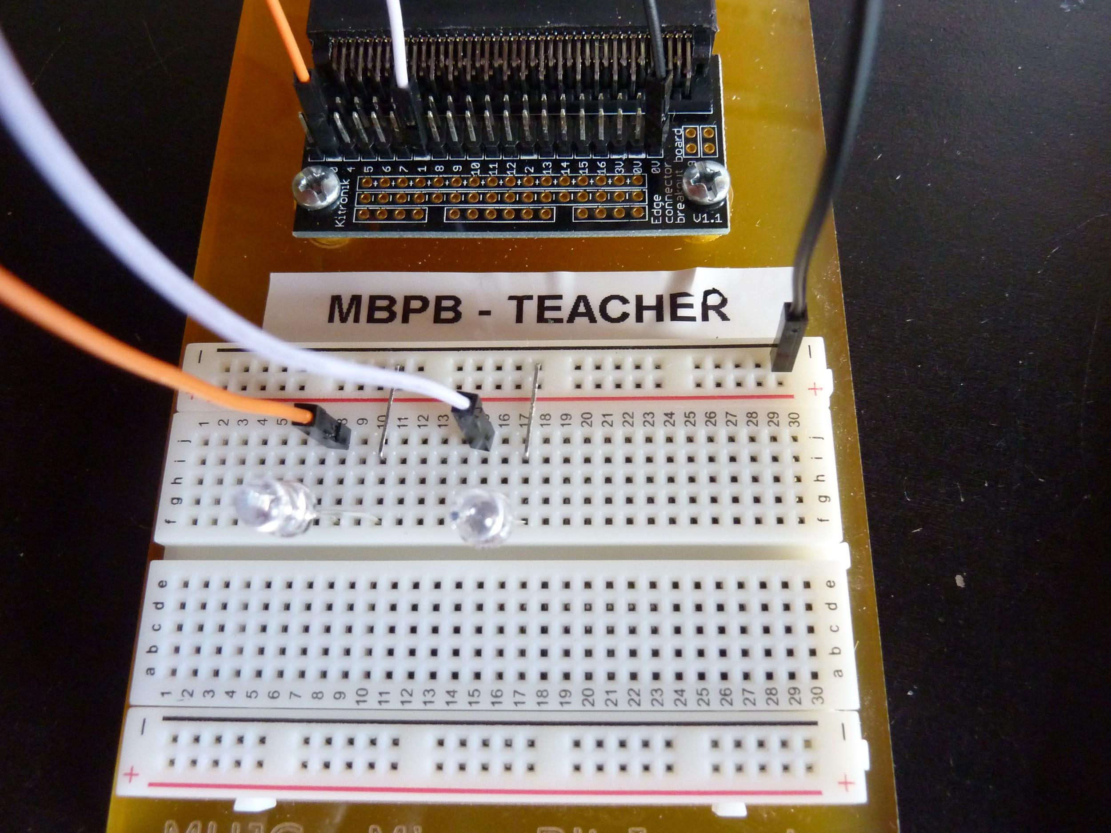

This photo shows the breadboard connections for experiment #2 - 2 x led’s, green led on the left, red led on the right.

**Experiment #3 - Switch input with LED output**

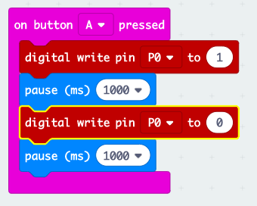

Write this programme which will flash an led when switch button A is pressed

Usethe same breadboard connections as experiment #1 the green led connected to pin 0 should light when button A is pressed

**Experiment #4 and #5 - traffic lights**

(you will figure out this programme without an example but is a combination of the previous circuit experiments) the breadboard connections are shown below, the +ve led leads are in line with the hook-up wires to pins 0, 1 and 2

Green = left, blue = centre, red = right

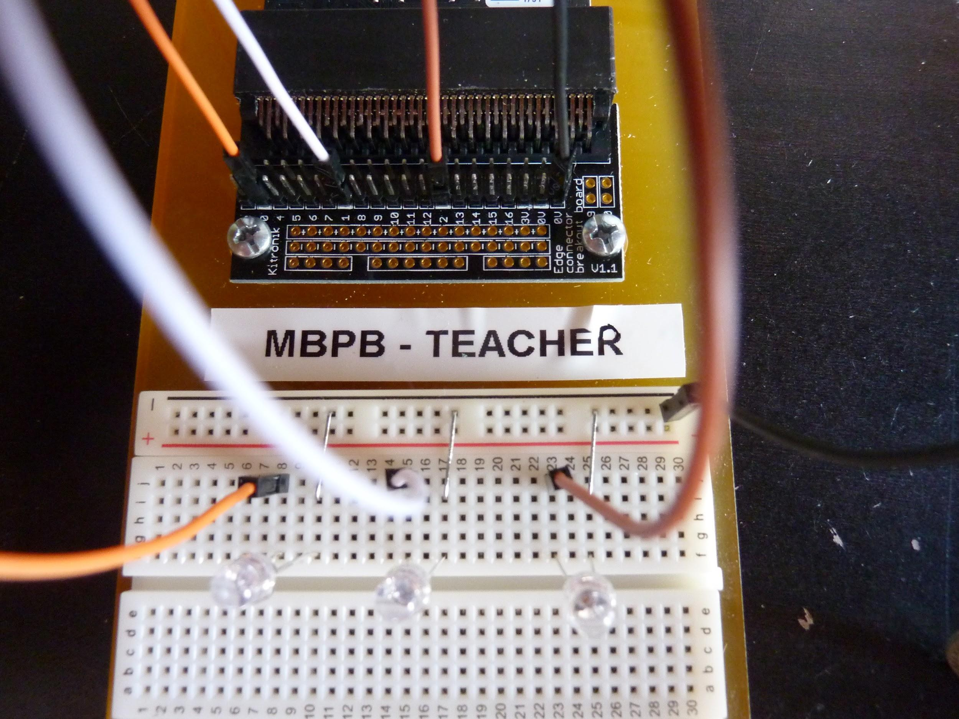

Write a programme to turn on a set of traffic lights with a green, blue and red led, then add a switch button A or B into the programme to control the traffic lights, button A will represent traffic from one direction at a crossroad junction. You will need a duplicate programme for button B as the makecode screen cannot activate buttons A and B on the same programme.

You will need these components;

* 1 x green led
* 1 x red led
* 1 x blue or yellow led
* 1 female/male jumper connected from the green led +ve lead to pin 0
* 1 female/male jumper connected from the blue led +ve lead to pin 1
* 1 female/male jumper connected from the red led +ve lead to pin 2
* 1 female/male jumper connected from the -ve rail to pin 0V
* 3 connector links from the led -ve leads to the -ve rail

When the circuit is completed it must follow this sequence:

1. Sequence the green, blue and red led’s on when a switch button A or B is pressed
2. When a switch button is pressed the green led must go off
3. There must be a 1 second pause, the red goes on then off
4. Then the blue led must come on for 1 second before going off
5. There must be a 1 second pause then the green led must stay on

**Experiment #6 - Light Dependant Resistor Experiment**

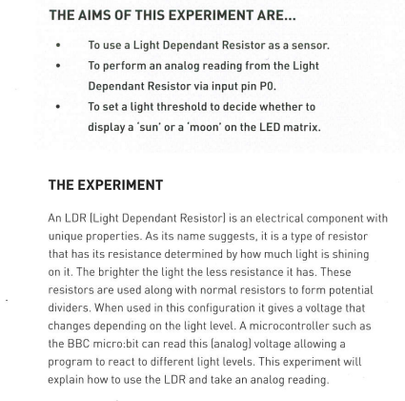

Before we build the ldr circuit we will learn some basic knowledge and understanding of light dependant resistors

For this circuit you will need:

1 x ldr (light dependant resistor)

1 x 10K fixed value resistor

3 x male to female jumper wires

Use the blocks shown to create the programme shown below. Drag all of the blocks on to the programming screen the assemble the blocks in order.

The photo shows the breadboard connections

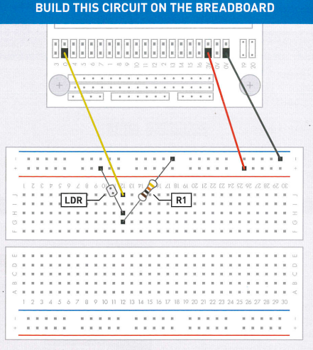

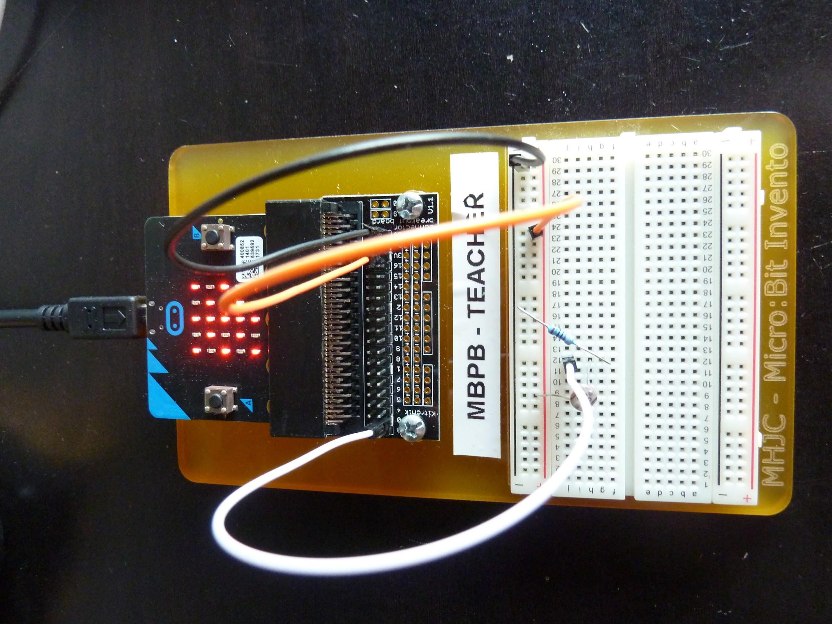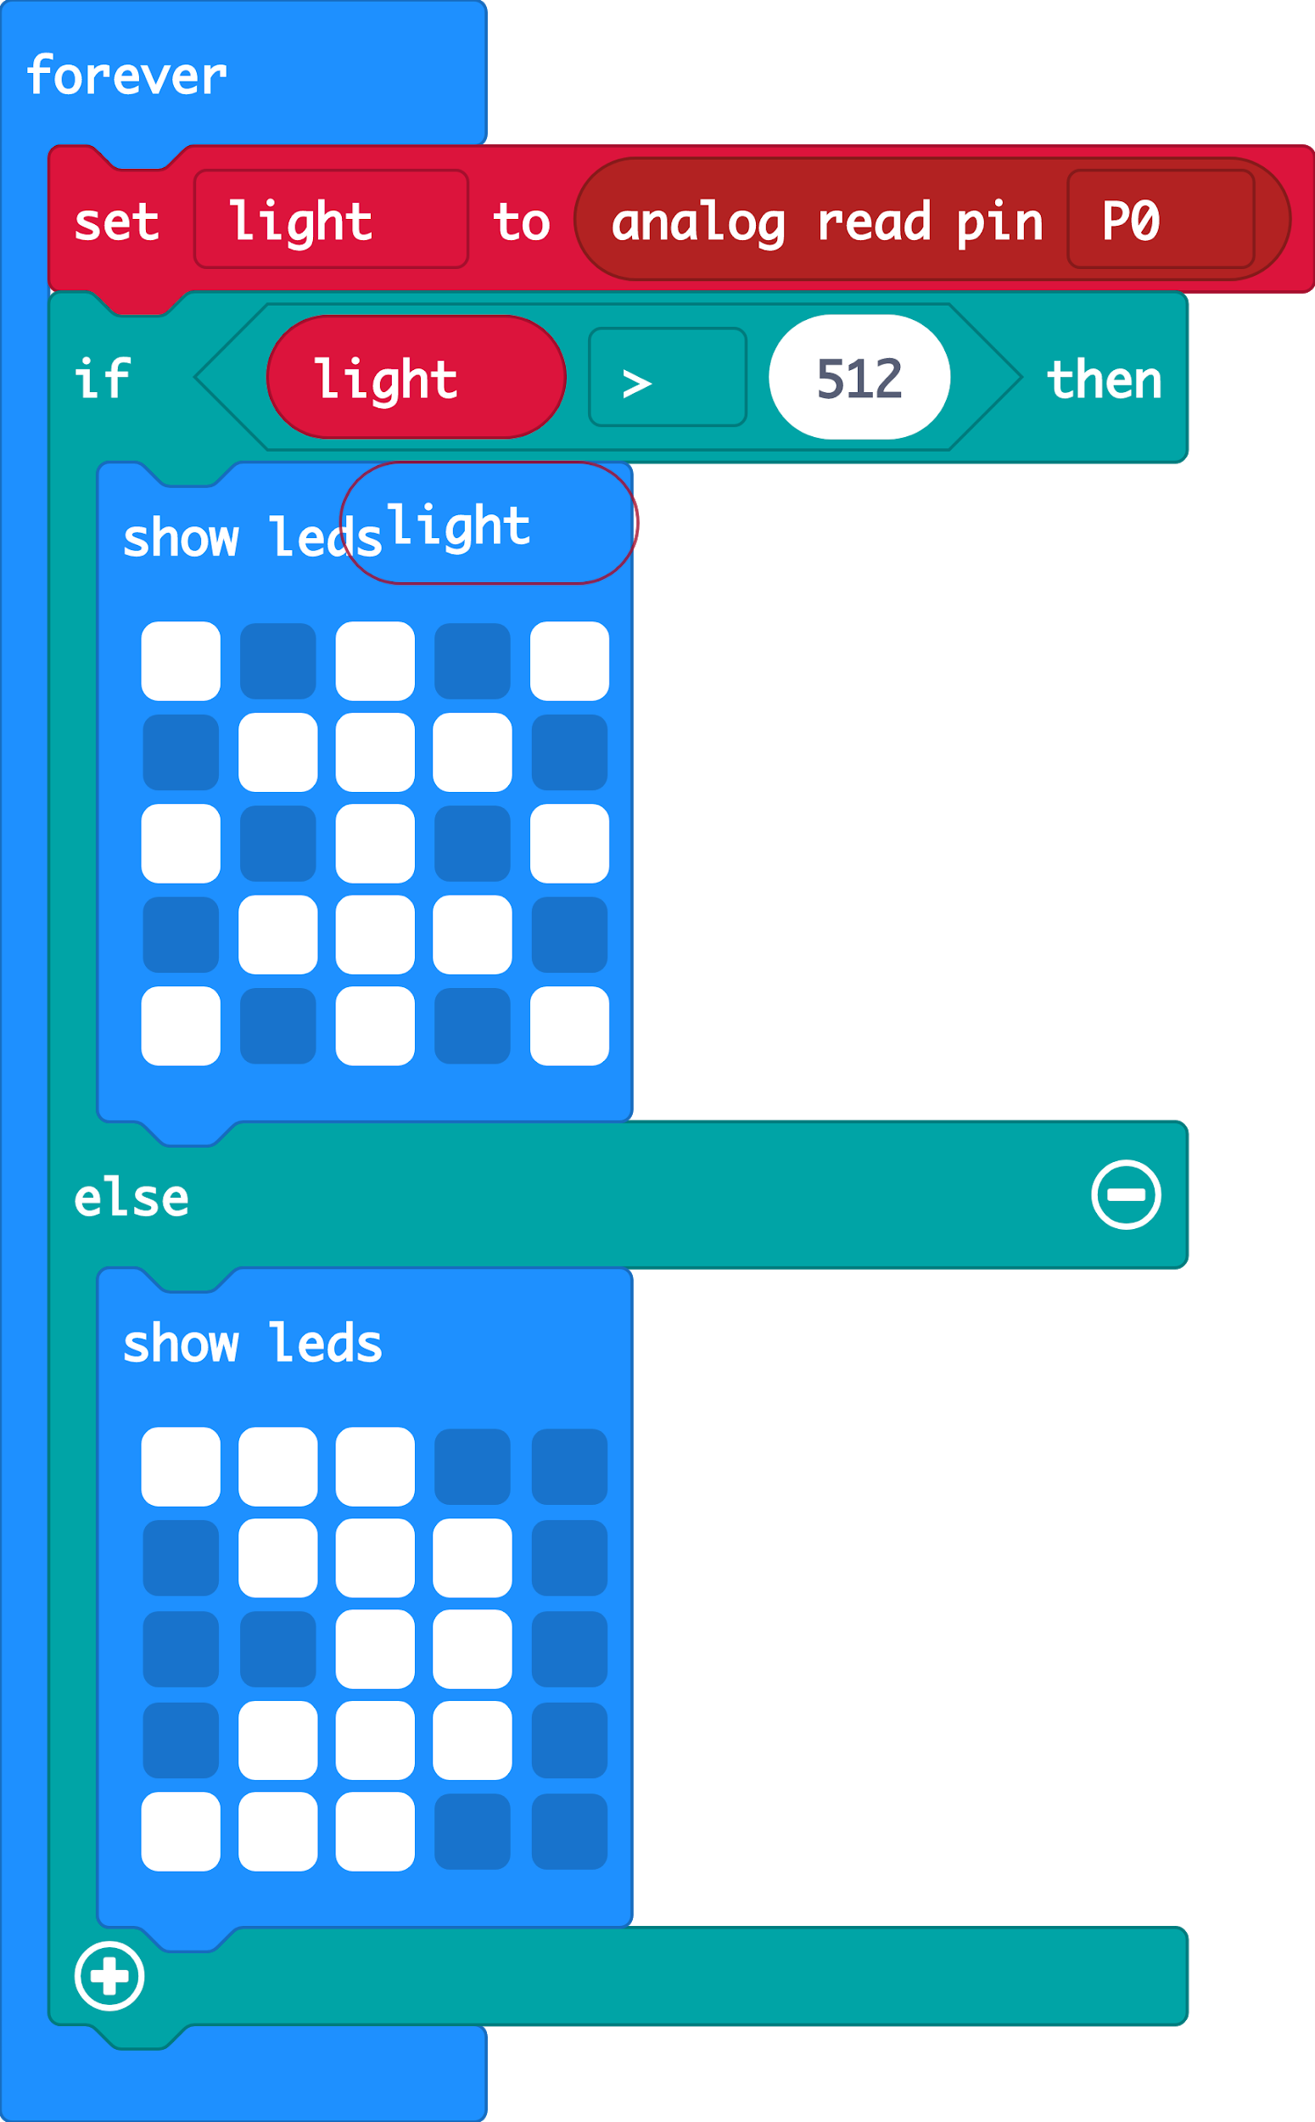

The breadboard photo shows the connections to build the ldr circuit.

* The ldr connects one lead to the +ve rail the other lead to row 12 (it does not matter which lead as both leads are the same)
* The 10K connects one lead to the -ve rail the other lead to row 12 (it does not matter which lead as both leads are the same)
* The white jumper wire connects row 12 to pin 0
* The orange jumper wire connects the +ve rail to the 3V pin (pin 18 from the left side of the Edge Board)

When the ldr is shaded by placing a finger on its surface the ‘sun’ display should be replaced by the ‘moon’ display

**Extension activity:**

Use the ldr to turn on/off one or more led’s