**Victims of the Holocaust**  
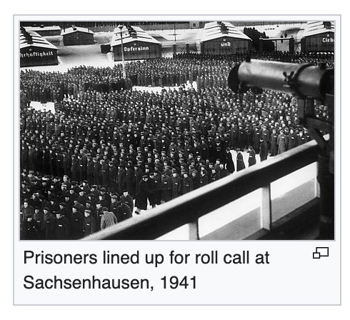

**Paragraph One:**

A major reason why Germany lost the war was that the Nazi Party was so focused on killing Jews that their army shifted from fighting a war to fighting an extermination campaign. They were driven by the thought of extermination, especially as the war dragged on and the Germans realised they would lose. They ramped up the Holocaust to kill more and more Jews as this became clear.

Jews had the highest number of victims in the Holocaust, but they were not the only group of victims of the Holocaust. Germany was a country driven to madness by its all-white policy and acceptance of eugenics, and this madness touched more than the Jewish population. There were many different types of people that the Nazis targeted for extermination due to their ‘undesirable’ status within Nazi Germany, because they were either seen as racially inferior (Black people, the Roma), genetically unacceptable (disabled individuals) or otherwise deplorable and not fitting for German society, such as the Nazi targeting of LGBT people during this time.

**Activity 1 - Holocaust Victims**

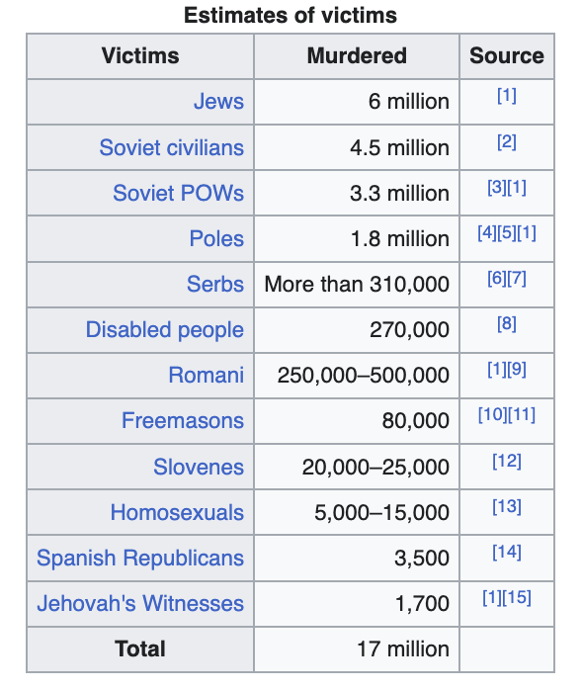

| 1. Black people were despised by the Nazis and were killed when possible. However the **Romani (or Roma)** people were the only other ethnic group specifically targeted for extermination during the Holocaust. **What are other names the Roma people were known by, and why did the Nazis try to kill them?** You will have to do research on Google for this one.   Answer here:   1. How many different **groups** of victims are labelled in this photo? And why do you think that Soviets & the Polish (Poles) make up such a large number of victims?   Answer here: |
| --- |

**Paragraph Two:**

It is a matter of debate whether the term ‘holocaust’ should singularly refer to Jewish people, and the term genocide should encompass all others purposefully targeted by the Nazi regime. This is due to the word ‘holocaust’ being increasingly associated with Jewish people in the decades since it happened.

However, Nobel laureate and Jewish Holocaust survivor Elie Wiesel considered non-Jewish victims to be Holocaust victims, declaring to President Jimmy Carter, "Not all the victims of the Holocaust were Jews, but all Jews were victims," when he asked for Carter’s support for a national Holocaust museum in Washington. British historian Michael Burleigh and German historian Wolfgang Wippermann maintain that although all Jews were victims, the Holocaust transcended the Jewish community – other people shared the tragic fate of victimhood.

At the time of writing, it is currently accepted that the Holocaust, capital H, an event, refers to all people who were relentlessly exterminated by Nazi Germany. The term *Shoah* (Show-ahh) is a Hebrew word that specifically refers to the suffering and genocide inflicted on Jews during this time - the destruction of Jewish society in Europe, and the journey to new lands during World War II and afterwards.

**Activity 2 - Concentration Camp Numbers**

|  | **Title:** *“Number of prisoners in the Nazi concentration camp system”* |
| --- | --- |

| **Question 1:** Based on what you have picked up from the slideshow & this reading, why does the number of prisoners rapidly increase from 1942 onwards?  **Question 2:** Based on the previous activity, what are the largest three groups you could expect to find in the concentration camps? |
| --- |
| Answer 1:  Answer 2: |