Mini murder mystery
Coordinates
Who
One of the four characters below has committed a murder. Analyse the statements from each suspect. The 3 innocent characters make at least 2 truthful statements. The guilty person makes 3 errors.
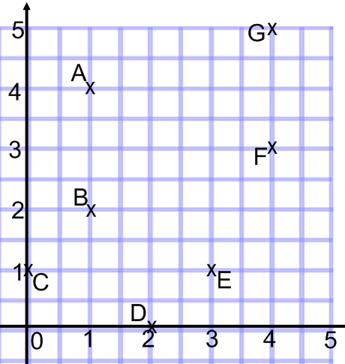
The mad scientist said the following  - A is (1,4)  - E is (3,1)  - The x coordinate of G is more than the x coordinate for F  - A and B make a vertical line |  |  | The silly boy said  - F is (3,4)  - C and E are on the same horizontal line  - The y coordinate of B is less than the y coord of A  - D is (0,2)
The chef said the following  - G is (5,4)  - F is (4,3)  - C is (1,0)  - B is (2,1) |  |  | The artist said  - C and E are on the same vertical line  - A is (4,1)  - D is (2,0)  - C, B and G are on the same diagonal line
Where
The murder was committed within this grid. Following the clues below, you have to mark “x” at the right spot.
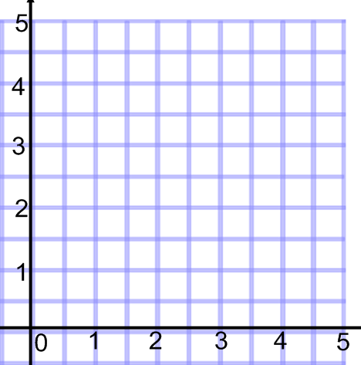 |  | - The x and y coordinates add up to an even number  - The x coordinate is more than the y coordinate  - Both of the coordinates are odd numbers  - The difference between the x and y coordinate is a square number
When
The time and day of the murder can be decoded from the grid below.
(2,2) (1,1) (1,5) (3,2) (5,2) (5,5) (3,2) (5,2) (5,3) (4,2) (4,4) (4,1) (1,2) (3,3)  (5,3) (4,3) (5,2) (1,1) (5,5) (4,2) (4,5) (1,5) (5,1) | 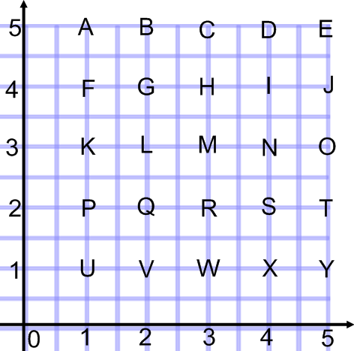
Final Accusation
The murderer is
The coordinates of the place the murder happened are ( , )
The time and day are

