**Year 10 Global Studies CAT Study Guide 2024**

**CAT Overview - 1.5 hours**

* 45 mins - Resource Interpretation on a current events issue
* 45 mins - Mapping Skills

**What to bring to the CAT: P**ens, ruler, colour pencils, highlighter.

**Section A: Resource Interpretation on a Current Events Issue**

**This section may include:**

* Written source analysis (news article excerpts, quotes, opinion piece excerpts)
* Image analysis (cartoons, memes, photos)
* Graph analysis (bar graphs, pie charts, etc)
* Short written answers
* Discussion questions - long written answer

**Study Tasks**

* Complete Past CAT papers:
  + [Yr10 Practice CAT Questions](https://drive.google.com/file/d/1BF0NG6OBqqnjvhwmOWXoDQt7-wLx_onE/view?usp=sharing)
  + [Year 10 PRACTICE CAT - Resource Book](https://drive.google.com/file/d/1OBpeotJuOhuo7JbYVFhDbbI1kZ5KSegS/view?usp=sharing)
* Read news articles - analyse the current events issue and consider the following questions.
  + *What are the core facts? (who, what, when, where, why, how?)*
  + *What are the different perspectives on the issue? What evidence supports these viewpoints?*
  + *What global studies concepts are relevant and/or discussed? (e.g. sustainability, human rights, culture & identity, changes over time, inequality, economic impacts, etc.)*
  + *What is your opinion or perspective on the issue? What evidence supports your viewpoint?*
* Assigned [Education Perfect](https://app.educationperfect.com/app/dashboard/homework/7229097) tasks
* Make a mindmap (see how in study tasks for Section B)
* Practise cartoon analyse using the resources below:
  + [Exam Prep: Cartoon Analysis](https://docs.google.com/presentation/d/1CjS6fOBSA6acpNttYG7Muzo6jsyeWJ3lWGhhXnDGNcI/edit#slide=id.p1)
  + [How to Analyze a Political Cartoon](https://www.youtube.com/watch?v=BNkJNNuxsuQ&ab_channel=JohnNoffke)
  + [Analysing Cartoons - The RISK Method](https://www.youtube.com/watch?v=s8MHy1nIZjk&ab_channel=TKentEducation)
  + [How To Analyze Political Cartoons](https://www.youtube.com/watch?v=pCp2RHCn76g&ab_channel=KarenWisheu)

**Cartoon analysis steps**

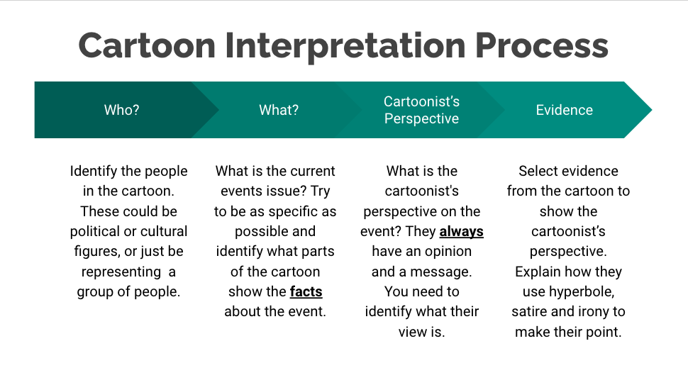

A political cartoon is an illustration containing a commentary that usually relates to current events or personalities.

They typically combine artistic skill, hyperbole and satire in order to question authority and draw attention to corruption and other social ills.

* **Hyperbole** – exaggerated statement or claims
* **Satire** - the use of humour, irony, exaggeration, or ridicule to expose and criticize people's stupidity, particularly in the context of contemporary politics and other topical issues.
* **Irony** - the expression of one's meaning by using language that normally signifies the opposite, typically for humorous or emphatic effect.

**How to write an extended answer for cartoon interpretation:**

|  | **Examples of what to include:** |
| --- | --- |
| **P** | * Use key words from the question in your topic sentence * Outline the message in the cartoon - i.e. the point the cartoonist is making |
| **E** | * Explain the topic sentence in further detail |
| **D** | * Describe something in the cartoon which shows your idea from the topic sentence |
| **A** | * Explain how the cartoon links into the historical or current issue |
| **L** | * Summarise the main point of your paragraph (the topic sentence) |

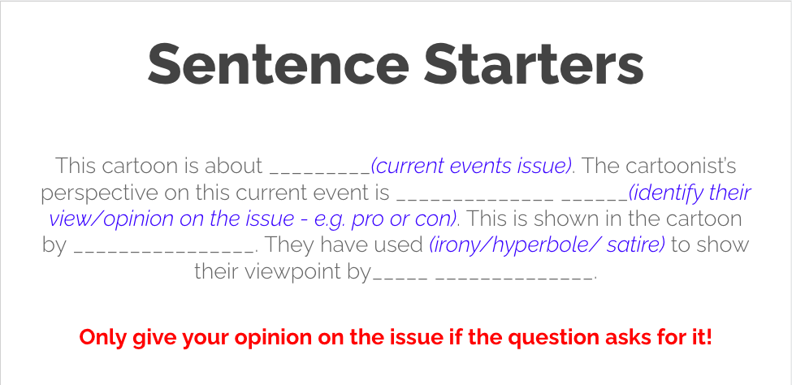

**Section B: Mapping Skills**

**Key Skills:**

* Identifying different kinds of maps and their uses
* Reading and interpreting a key
* Using grid references
* Reading contour lines
* Drawing maps
* Using scale
* Latitude and longitude
* Compass directions
* Geographical descriptions
* Compare and contrast

**Study Tasks**

* Complete Past CAT papers:
  + [Year 10 CAT PRACTICE Questions](https://drive.google.com/file/d/1BF0NG6OBqqnjvhwmOWXoDQt7-wLx_onE/view?usp=sharing)
  + [Year 10 Global Studies PRACTICE CAT Resource Booklet 2024](https://drive.google.com/file/d/1OBpeotJuOhuo7JbYVFhDbbI1kZ5KSegS/view?usp=sharing)
* Assigned [Education Perfect](https://app.educationperfect.com/app/dashboard/homework/10389505) tasks
* Complete tasks on [Geography Skills Worksheets](https://drive.google.com/file/d/1t1V8WS8PB4khun8A6lbrCGm0i_H70LoW/view?usp=sharing)
* Making mind maps are a hugely effective way of studying - MUCH more effective than just reading notes or answering questions.

[How to Make Mindmaps | Study Effectively!!](https://www.youtube.com/watch?v=bYtzNofLfpw&ab_channel=Imaginfinity) [How to Make MINDMAPS to Study // 2 minute study tips #3](https://www.youtube.com/watch?v=slb1ip3UyFg&ab_channel=Imaginfinity)

* Creating flashcards is also a great way to study if you are trying to memorise key information.

|  |  |
| --- | --- |