**Title: Let’s Unpack Your Book**

**Lesson 2: Vocabulary & Introduction to Plot Diagram**

**Learner Name: …………………………………**

**Learner Surname: …………………………………..**

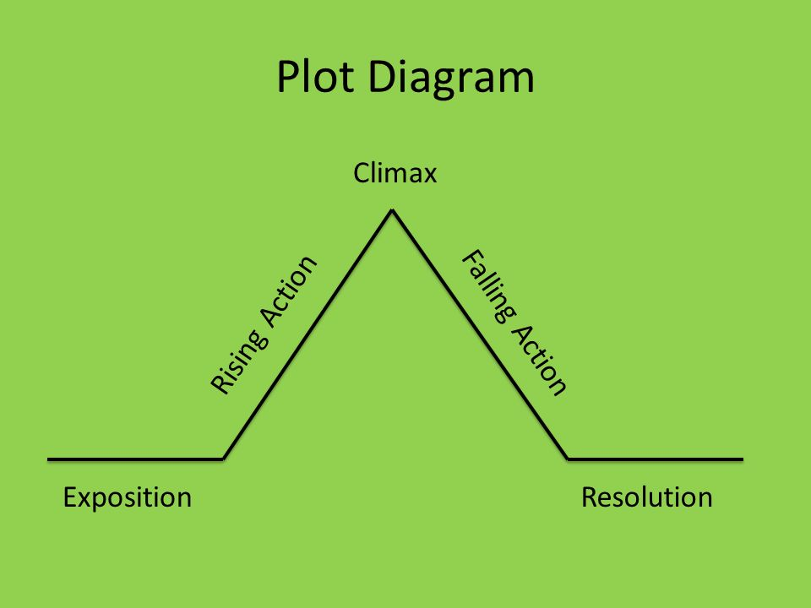

Exercise 1

|  |  |  |
| --- | --- | --- |
| **WORDS** | **ANSWER** | **DEFINITION** |
| 1. Protagonist |  | A The character that actively opposes or is hostile to the lead character. |
| 1. Plot |  | B. Linked events that make up the main parts of the story. |
| 1. Climax |  | C. Loose ends are tied up and story will end soon |
| 1. Rising action |  | D. The leading character in a novel. Film or play. |
| 1. Exposition |  | E. Events or conflict get resolved. |
| 1. Antagonist |  | F. The part of the story where the tension and action is at it’s highest suspense. |
| 1. Falling action |  | G. The first part of a story ‘s plot that describes the location, characters and initial problems in the story. |
| 1. Resolution |  | H. Contains events that add tension to the story and increases until the story’s climax. |

Well Done!!!