**Week 4 – Year 10**

**Vaping – the Big Picture**

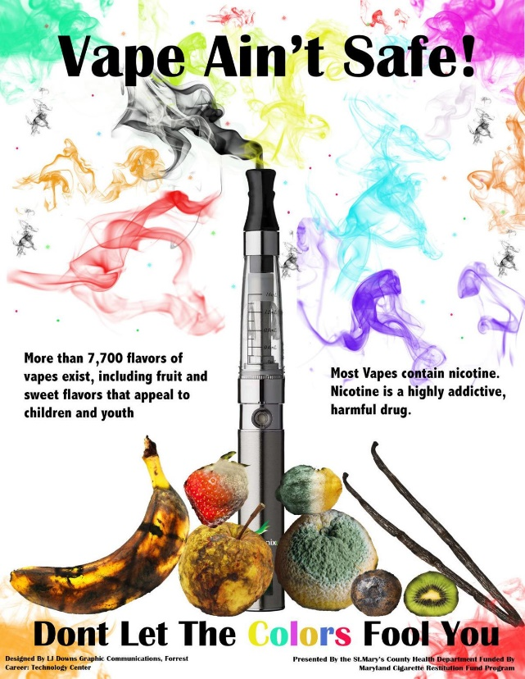

**This week we are going to look at the controversy surrounding vaping.**

# Success criteria: By the end of the week students will be about to recount at least four major adverse health consequences from vaping and be able to identify which students are at the highest risk for vaping in New Zealand schools.

# Lessons 1 & 2

# Task 1: Break up into groups of between 2 to 6 and watch the video – ‘Unmasking the VAPING Crisis’ which talks about what is now considered to be a crisis in Australia – and is a growing problem here in New Zealand. Later in the week we will look at the situation here in New Zealand. Here is the link: <https://www.youtube.com/watch?v=l3WaMVm5II8>

# 1. Vapers are _____ times more likely to take up smoking cigarettes later in life (2:50 sec. mark)

# 2. The number 1 target of vaping customers is _____? (3:00 sec.)

# 3. What was considered a pathway out ____ of smoking cigarettes has become a pathway _____ smoking…

# 4. How do the 3 students know that they are addicted to vaping and the nicotine from the smoke? List all of the symptoms vaping thar are mentioned (5:00 sec.)

# 5. According to Dr. Becky Freeman, what are the chemicals in vapes that cause harm?

# 6. Describe the experience when people vape for the first time. (6:30 sec.)

# 7. Some people aren’t concerned about vaping “because it’s just water vapor with a sprinkling of nicotine in it.” Why is this incorrect? (7:20 sec.)

# 8. One vaping cartridge contains the equivalent of smoking how many packs of cigarettes? (8:00 sec.)

# 9. In what ways are the vape companies targeting young people? (9:30 sec.)

# 10. In Australia, you cannot buy vapes if you are under 18 and without a doctor’s prescription. So, how easy was it for kids to get their hands on vapes? (10:30 sec.)

# 11. There have been 50 cases of children under the age of ____ being poisoned by vapes.

# 12. What happened to Peter Hanson who quit smoking using vapes? (17:00 sec.)

# 13. People who have vaped have died of EVALI – what does it stand for?

# 14. How long did it take Rosie to become sick from vaping? When did she start and when did she die?

# 15. Of the 43 different vapes analyzed at the University of Wollongong, only one included the ingredient ________ on the label. (23:00 sec.)

# 16. Of all of the vapes looked at ____percent of them were found to have _______ ?

# 17. Where were all of the vapes found to have come from?

# 

# 18. What is the solution proposed by the Australian Health Department to get the vaping epidemic under control (34:00 sec.)

# Lesson 3: Vaping in New Zealand Students

# Read the article on the shocking new finding that vaping is more of a problem in Kiwi primary schools than it is in secondary schools.

# <https://www.newshub.co.nz/home/new-zealand/2024/01/vaping-smoking-bigger-issue-in-primary-schools-than-secondary-new-figures.html>

# Task: Create a poster in your Red Books that is designed to raise awareness in young children about the dangers of vaping. What strategies would you use to get people so young to pay attention to your message and either quit vaping or never start?