**Weeks 6 & 7**

**Wanted Posters Pest Project**

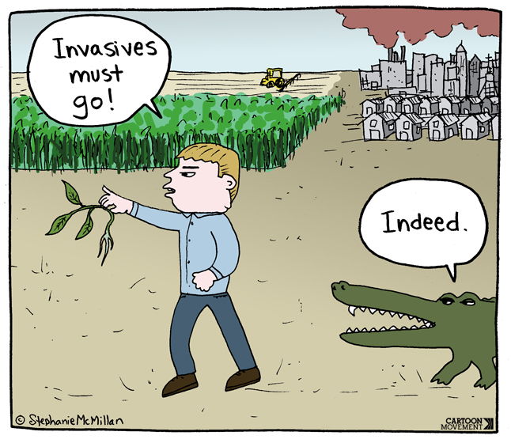

**Success Criteria:**  By the end of week seven students will become familiar with a specific invasive species that is considered a major threat to New Zealand’s biosecurity and recount it’s origin, the harms that it poses to the ecosystem, and actions that are being taken to reduce or eliminate its presence.

**Wanted Posters**

Students will create wanted posters for invasive species that threaten New Zealand. It can be either a plant or animal (*creatures like frogs and toads are classified as animals!). You will complete your posters by the end of Lesson 1 Week 7, followed by class presentations.

Your Posters will be in the following format: Students may work in pairs.

**1. Title**

a. Include phrases like, “Wanted Dead or Alive…” or “Most Wanted” and the name of the organism.

b. The title must be eye-catch, informative, and grab the reader’s attention.

**2. Picture**

a. Color print out or drawing of the species

b. Must be large enough to be one of the central features of the poster

**3. Identification (This heading should appear on poster)**

a. include both the common name and scientific name

b. how could use to identify the species

**4. Crimes Committed (This heading should appear on poster)**

a. What allows it to thrive in its new environment (life history traits and other characteristics that help it to succeed and dominate the new habitat)

b. How does it harm native species or alter the ecosystem and biological community it was introduced into

**5. Fun Facts**

**Possible Animal Pests in New Zealand**

– Choose one and have it approved by your teacher. Here is a list of 20 invasive animal species in New Zealand (why do you need approval? Because I don’t want 20 students doing the same species!).

**• Possums:** Australian brushtail possums are a significant invasive species in New Zealand, causing damage to native forests and competing with native wildlife for food.

**• Rats:** Both the ship rat (Rattus rattus) and the Norway rat (Rattus norvegicus) have negatively impacted native bird populations by preying on eggs and chicks.

**• Stoats:** These predators were introduced to control rabbits but have since become a major threat to native birds, particularly ground-nesting species.

**• Feral Cats:** Cats prey on native birds, insects, and reptiles, contributing to the decline of several native species.

**• Ferrets:** Similar to stoats, ferrets were introduced to control rabbits and have become predators of native wildlife.

**• Weasels:** Another introduced predator, weasels, pose a threat to small native birds and insects.

**• Wild Pigs:** Feral pigs cause damage to native vegetation and can disturb ecosystems by rooting in the soil.

**• Australian Magpie:** Introduced for their song, these birds can sometimes become aggressive during breeding season, posing a risk to people.

**• Rainbow Trout:** While prized by anglers, introduced trout can negatively impact native fish species and aquatic ecosystems.

**• Australian Brush-tailed Rock Wallaby:** An introduced species that competes with native wildlife for food and habitat.

**• European Hedgehog:** Predatory hedgehogs threaten native insects, snails, and ground-nesting birds.

**• Australian Common Skink:** Introduced reptiles that compete with native lizards for resources.

**• European Starling:** These birds outcompete native species for nesting sites and food resources.

**• European Rabbit:** Introduced for hunting, rabbits cause damage to native vegetation through grazing.

**• Common Myna:** These birds compete with native birds for food and nesting sites.

**• House Mouse:** While small, mice can have significant impacts on native insects and seeds, affecting the food chain.

**Possible Plant Pests in New Zealand**

Here are 20 invasive plant species that have become problems in New Zealand:

**Gorse (Ulex europaeus):** Forms dense, spiny thickets, displacing native vegetation.

**Old Man's Beard (Clematis vitalba):** A vine that can smother trees and shrubs in forests.

**Japanese Knotweed (Fallopia japonica):** Known for its aggressive growth, forming dense stands and impacting native vegetation.

**Wild Ginger (Hedychium gardnerianum):** Forms dense thickets and inhibits native plant regeneration.

**Tradescantia (Tradescantia fluminensis):** Also called wandering Jew, it forms dense mats, especially in damp areas, suppressing native plants.

**African Clubmoss (Selaginella kraussiana):** An invasive ground cover that can outcompete native species.

**Cotoneaster (Cotoneaster spp.):** A shrub that can invade native habitats and compete with indigenous plants.

**Darwin's Barberry (Berberis darwinii):** Forms dense thickets, impacting native ecosystems.

**Purple Loosestrife (Lythrum salicaria):** An aggressive invader of wetlands, displacing native vegetation.

**Woolly Nightshade (Solanum mauritianum):** Forms dense thickets and suppresses native plant growth.

**Himalayan Honeysuckle (Leycesteria formosa):** Escapes gardens and can invade natural areas, altering ecosystems.

**Wandering Dew (Commelina diffusa):** Spreads rapidly and forms dense mats in open areas, affecting native plants.

**Japanese Honeysuckle (Lonicera japonica):** A vigorous vine that smothers and shades out native vegetation.

**Periwinkle (Vinca major and Vinca minor):** Escapes gardens and can spread rapidly, outcompeting native ground cover.

**Pampas Grass (Cortaderia selloana):** An ornamental grass that invades grasslands, reducing biodiversity.

**Yellow Flag Iris (Iris pseudacorus)**: Invasive in wetlands, crowding out native aquatic plants.

**African Feather Grass (Pennisetum macrourum):** An aggressive grass species that displaces

native vegetation.

**Himalayan Strawberry (Fragaria nilgerrensis):** Forms dense mats, impacting native flora.

**Climbing Asparagus (Asparagus scandens):** A climbing plant that can smother trees and shrubs.

**Pittosporum (Pittosporum undulatum):** Escapes cultivation and invades forests, affecting native vegetation.

**Examples of what I am looking for in your Posters – but be sure to include all of the criteria.**

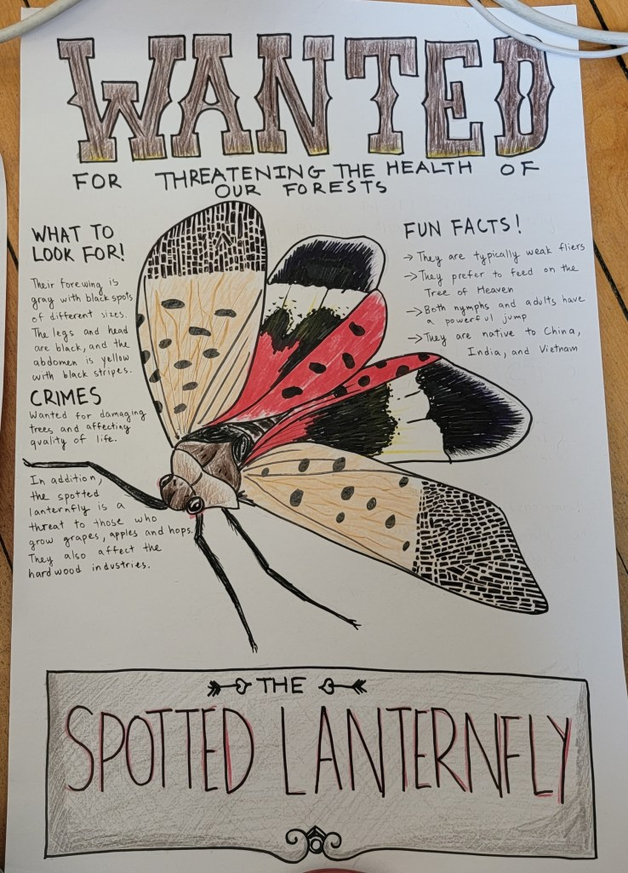

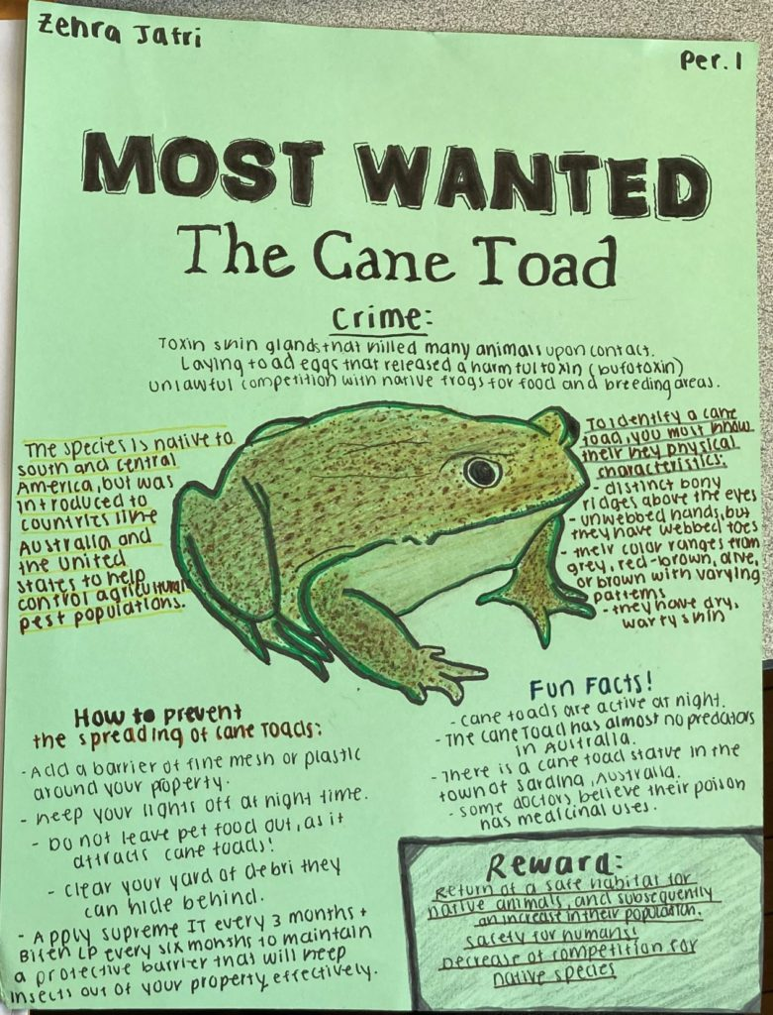

**Basic Poster**

**Only to be done with teacher permission**

World’s Most Unwanted!

[Name of organism both common & scientific name]

An invasive non-native [plant, animal, fungus, or pathogen]

[Draw picture here]

Hometown: [native habitat – where did it originally come from before getting to New Zealand?

For the crime of: problems resulting from its invasion?

Fun Facts

**Week 7**

**Poster Project Continued**

**Lesson 1: Students are to complete their posters and print them out. If they finish early, they can practice their presentations.**

**Lessons 2 & 3: Students will give their presentations in class by holding up and discussing their posters. NO Powerpoints.**