**Week 7: Current Event Analysis #1**

**Do we really eat a credit card's worth of**

**microplastic each week?**

**A look at the calculations behind the widely reported statistic that we eat over five grams of microplastics each week**

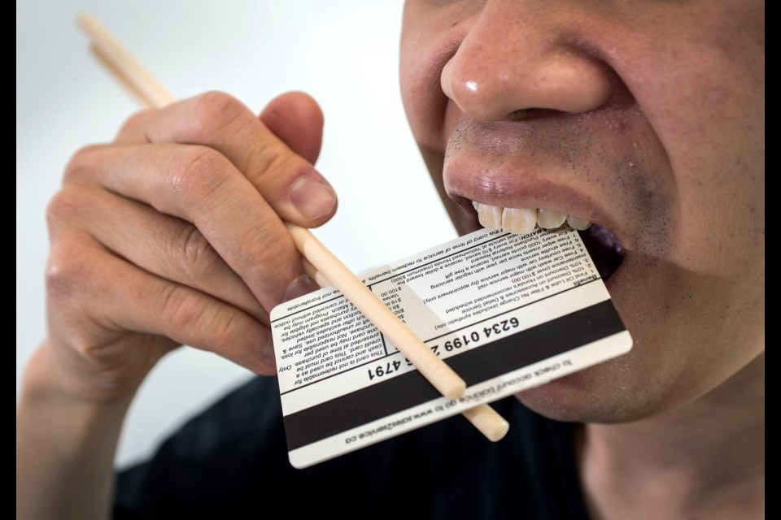

During an earlier lesson we looked at the researcher who concluded that people eat a credit card’s worth of microplastics each week. This is an update on that research. Listen to the Podcast and answer the following questions –

Podcast:

<https://www.bbc.co.uk/programmes/w3ct5tqj?at_medium=social&at_link_type=web_link&at_campaign_type=owned&at_link_id=B32EC24A-61EB-11EF-AECD-ADAF6BE4F952&at_link_origin=BBC_World_Service&at_ptr_name=facebook_page&at_bbc_team=editorial&at_format=image&at_campaign=Social_Flow> (7:41 sec.).

**Task 1:** After listening to the article, write a paragraph summarizing the new research on microplastics and health. Do we really eat a credit card’s worth of microplastics each week – and if not, how much are we likely eating?

**Task 2:** Let’s investigate the latest research into ultra-processed foods and why they are bad for your health. Listen to the following podcast by Radio New Zealand (August 20, 2024)

<https://www.rnz.co.nz/audio/player?audio_id=2018952912>

and answer the following questions:

1. Define ultra-processed foods? Look up the definition online.
2. Why do some companies use ultra-processed foods? What is their purpose? (1:16 sec.)
3. List some common ultra-processed foods?
4. What percent of the food supply is ultra-processed?
5. What is the impact on human health from ultra-processed foods? (2:40 sec.)
6. Listen to the description of the study that was done in 2019 when people were given an ultra-processed diet. What was the big finding over the 2 week period? (5:00 to 6:30 sec.).
7. How can people stop eating so much ultra-processed foods?
8. Describe the different theories as to why eating ultra-processed foods make you want to eat more? (9:00 sec. mark)
9. One theory has to do with how ultra-processed foods affect your stomach – explain (11:28 sec. mark).

**Current Event Analysis #2**

**Auckland’s Volcanic Hazards – What would you did in the event of an Eruption?**

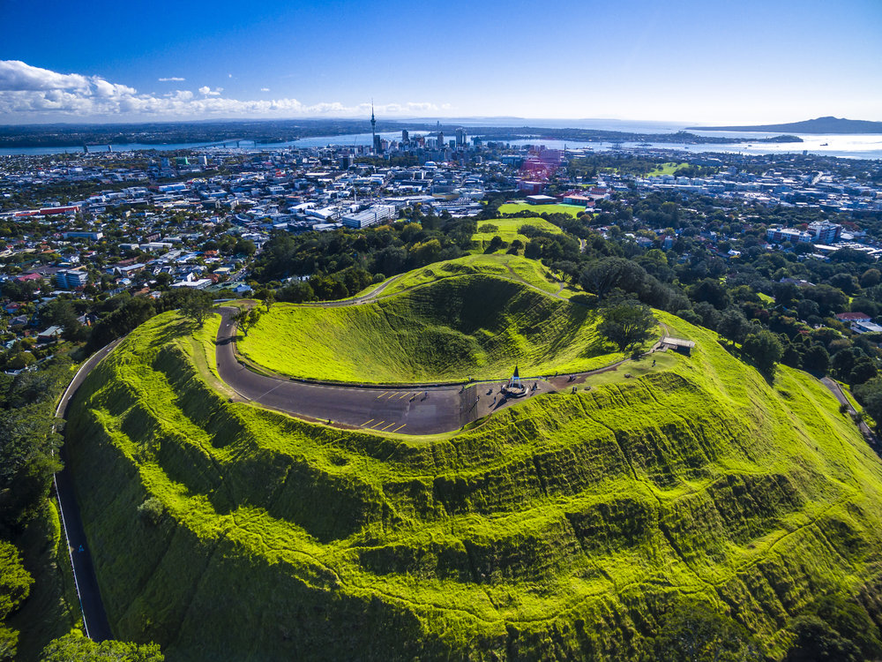

Just 600 years ago there was a major volcanic eruption in Auckland. What would happen if a similar event occurred today? The Emergency Services branch of the New Zealand Government has created a video explain what actions we can do and how we can prepare for such an event.

**Task 1:**  Watch the video ‘Auckland’s Volcanic Hazards.’ <https://www.youtube.com/watch?v=wRVvYsg33yg&t=473s> (10:42 sec.)

Based on the video, answer the following questions:

1. At least how many volcanic cones have been identified in the Auckland volcanic field ober the past 200,000 years?

2. Auckland is the only large city in the world that is built directly on a ________ ______.

3. What is the name of the largest volcanic cone in Auckland? How long ago did it eript?

4. Auckland’s volcanos produce a very fluid form of magma (hot melted rock) called _______.

5. If there is another volcanic eruption in Auckland, how will scientists know days or weeks ahead of time?

6. In the event of an Auckland eruption, what would be the exclusion zone where people have to be evacuated from?

7. How hot is volcanic magma?

8. What problems are caused by volcanic ash. List each of the problems caused by volcanic ash?

a.

b.

c

d.

e.

f.

g.

9. How long could a volcanic eruption last in Auckland?

10. What can you do to prepare for a volcanic eruption in Auckland. List each of the things you need to do to be ready – as listed in the clip.

**Current Event Analysis # 3**

**The Havana Syndrome Mystery Solved**

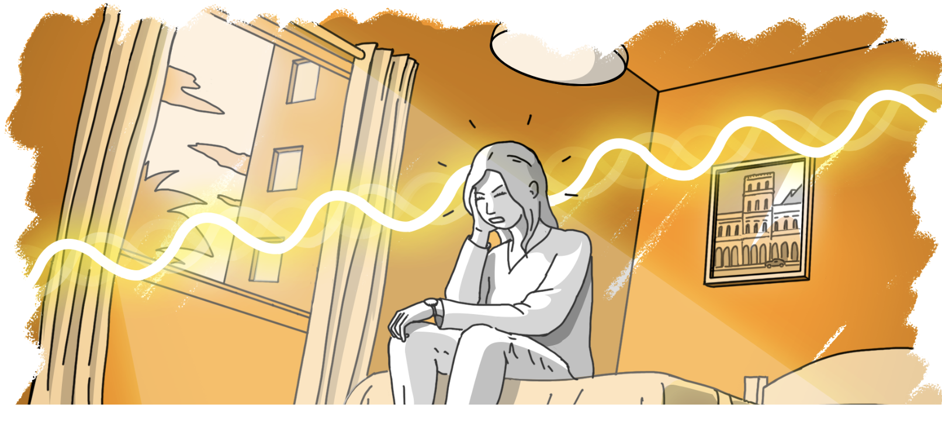

In late 2016 several American and Canadian Embassy staff reported feeling unwell after hearing mysterious sounds while they were stationed in Havana, Cuba. Some people have suggested that they were targeted with a Russian secret weapon. While we explored this Current Event last year – new information has since come to light.

**Task 1:**  Watch the new 60 Minutes report on Havana Syndrome. https://www.youtube.com/watch?v=DYDDxfpV-WE

Write a half-page summary of the position held by the skeptical scientist from the University of Auckland. Why is he reluctant to believe in Havana Syndrome?

**Task 2:** Read the article ‘Havana Syndrome: The Story that Refuses to Die’ at: <https://www.psychologytoday.com/nz/blog/its-catching/202404/havana-syndrome-a-story-that-refuses-to-die>

Answer the following questions:

1. What has the United States intelligence community (the CIA & FBI) concluded about Havana Syndrome?

2. List the 5 different reasons why the author of the article believes is keeping the Havana Syndrome myth alive. Write a summary of each reason in at leats 3 sentences – and in your own words – DO NOT COPY word for word from the article.

1. Current Fears & the Power of Moral Panics

2. Ego

3. The Prevalence of AHIs

4. Excitement

5. The Search for Confirmation