**Seahorse and the Reef**

**Understanding ideas in the text.**

In the story the narrator tells us about an experience they had when they were younger.

1) Describe what the narrator remembers?

2) What was the special place called?

3) Google the word "industrial". What does it mean? How is it relevant to the story?

4) Explain what kai moana is and why it is important to Māori.

5) What does the father tell his children about the ocean?

6) According to the story, what was the sea boiling with? What does this mean?

8) How did the narrator ’ s father convince his mother to go to the reef?

9) Do you agree with Dad and how he believes people should treat the sea? Explain your answer.

10) Explain why you think Ihimaera uses a seahorse in the story. You may wish to read the article [here](https://drive.google.com/file/d/1j3AlvIZGTw4WxdJ_5lNaOYOiD5hjDfOJ/view?usp=sharing) (Image below is from this article)

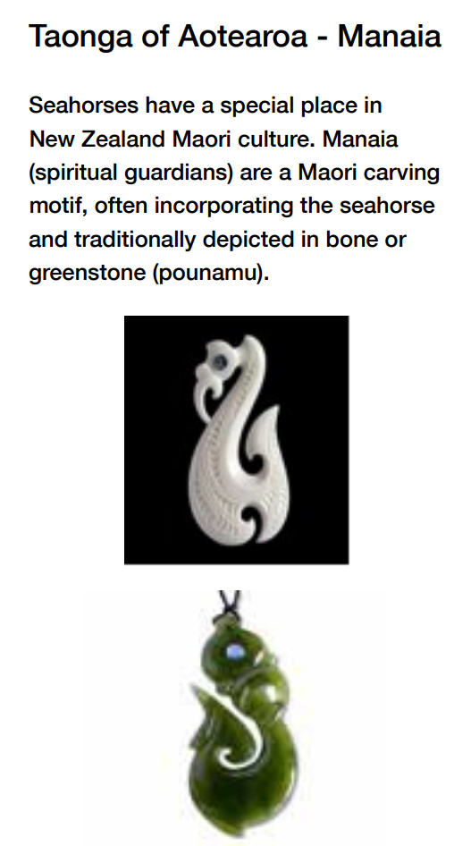

**Language feature 1**:

*His fists unclenched and his eyes became sad. ‘It says that it is dangerous to take seafood from the reef, son.’*

*‘Why,Dad?’*

*‘The sea is polluted, son. If we eat the seafood, we may get sick.’*

Look at the underlined sentence above.

1. How is Dad feeling?
2. What words are used to show us how Dad is feeling?
3. How does this help the reader understand the importance of the reef to this iwi?

**Language feature 2:**

*With the rest of the iwi, we bowed our heads. While she was singing, the sea boiled yellow with effluent issuing from a pipe in the seabed.The stain curled like fingers around the reef*.

Look at the sentence underlined.

1. What is this language feature called?
2. What two things are being compared?
3. What does it tell us about the effect of the effluent (sewage) on the reef?

**Structure:**

The author uses imagery at the end of the story:

*In my mind I caught a sudden vision of many pupu crawling among polluted rocks. I saw a starfish encrusted with ugliness. And flashing through dead waving seaweed was a beautiful seahorse, fragile and dream-like, searching frantically for clean and crystal waters.*

1. What mood/feeling/understanding do these sentences create for the reader?
2. Why do you think the author wanted to end the story with the reader feeling this way?
3. Do you think it is an effective way to end the story? Why or why not?