**Animal Survey**

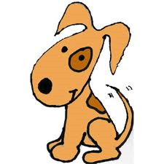Nǐ yǒu gǒu ma?

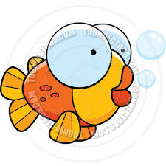

Nǐ yǒu yú ma?

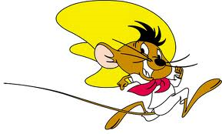

Nǐ yǒu lǎoshǔ ma?

 Nǐ yǒu māo ma?

 Nǐ yǒu tùzi ma?

 Nǐ yǒu niǎo ma?

Other

**Yǒu 有**

**Méiyǒu 没有**

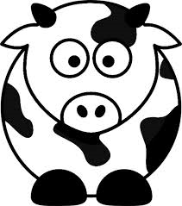

Nǐ xiǎng yào niú ma?

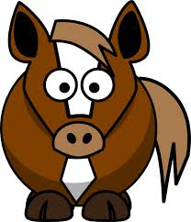

Nǐ xiǎng yào mǎ ma?

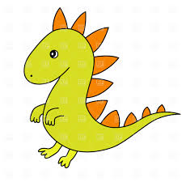

Nǐ xiǎng yào lóng ma?

 Nǐ xiǎng yào lǎohǔ ma?



Nǐ xiǎng yào zhū ma?

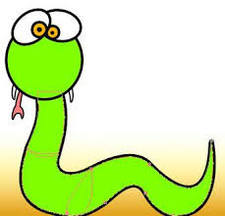 Nǐ xiǎng yào shé ma?

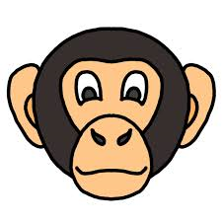 Nǐ xiǎng yào hóuzi ma?

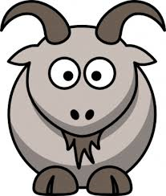

Nǐ xiǎng yào yáng ma?

**Xiǎng 想**

**Bù xiǎng 不想**