Work Done and Power calculations

Equations: Work done (J) = Force (N) x distance (m)

Power (W) = Work done (J) / time (s)

Weight (N) = mass (g) x gravitational field strength (N/kg)

Take g = 9.8 N/kg

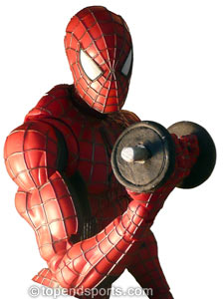**Core**

1. Joe is pumping iron in the gym and he raises a 150 N weight 0.5 metre – how much work does he do?
2. Saleh uses hair straighteners which transfer 1200 J of internal energy in 20 seconds – what is the power of the straighteners?
3. 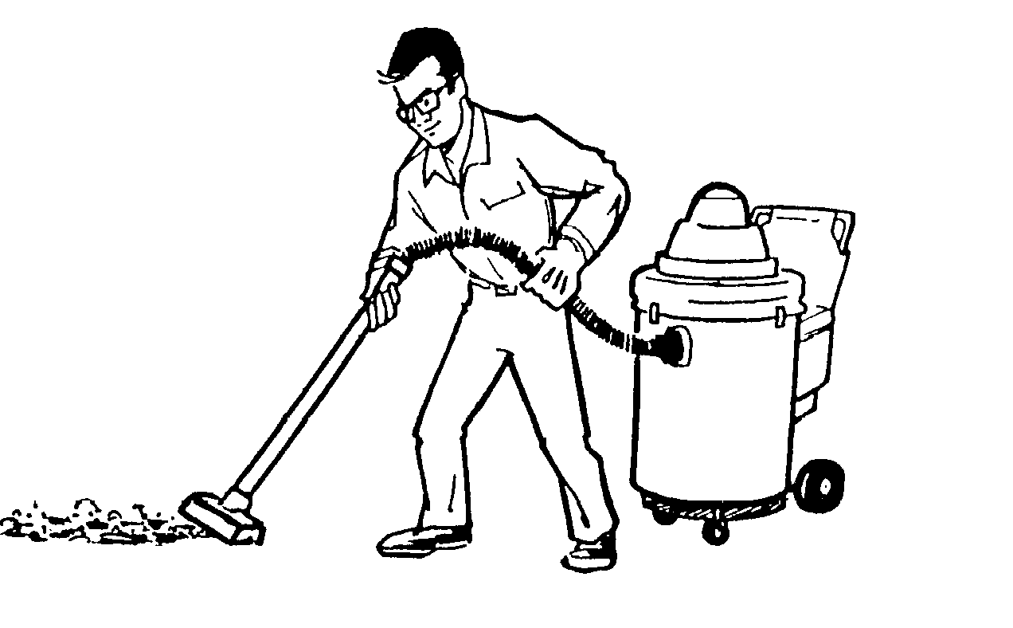Riley is cleaning his room (a once a year activity) and pulls the hoover with a force of 8 N a total distance of 20 metres. How much work does he do? Where does this energy end up?
4. Climbing up a tree Charlotte and her lunchbox have a weight of 650 N and she climbs a height of 22 m – how much work does she do in climbing the tree?

**Challenge**

1. Alex does 3,500 J of work pushing Jack in a shopping trolley down the high street. If he has to push with a force of 20 N how far does he go before the police stop him?
2. 3.6 kJ are transferred when Marcus is singing ‘One Dance’ by Drake on his karaoke machine. If the song is 3 minutes long what is the power of the karaoke machine?
3. Charlie is trying to impress Tutku with his electronic flute which transfers 0.5 kJ of chemical energy to internal over a performance of 10 minutes. What is the power of the flute?
4. Danny is testing out his new golf driver and hits his sister’s hamster with a large force doing 600 J of work over a distance of 20 cm. What is the size of the force in kN?

**Super Challenge**

1. 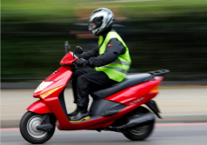Lucy fires her catapult at Miss Padfield’s face by mistake. The projectile knocks her face back 30 cm over a time of 0.2 s. If the force is 25 N what is the power of the catapult? Lucy is suspended.
2. Beth has bought a moped to help with her paper round. It has a power of 3.5 KW and over 10 minutes of riding she travels 2.5 km. What is the force of the moped?
3. Josh flies his drone over the sports hall for no reason at all. It weighs 60 N and travels vertically up 20 m. If it has a power of 0.1 kW how long does it take to get to the top?

Work Done and Power calculations

Equations: Work done (J) = Force (N) x distance (m)

Power (W) = Work done (J) / time (s)

Weight (N) = mass (g) x gravitational field strength (N/kg)

Take g = 9.8 N/kg

**Core**

1. Joe is pumping iron in the gym and he raises a 150 N weight 0.5 metre – how much work does he do?
2. Saleh uses hair straighteners which transfer 1200 J of internal energy in 20 seconds – what is the power of the straighteners?
3. Riley is cleaning his room (a once a year activity) and pulls the hoover with a force of 8 N a total distance of 20 metres. How much work does he do? Where does this energy end up?
4. Climbing up a tree Charlotte and her lunchbox have a weight of 650 N and she climbs a height of 22 m – how much work does she do in climbing the tree?

**Challenge**

1. Alex does 3,500 J of work pushing Jack in a shopping trolley down the high street. If he has to push with a force of 20 N how far does he go before the police stop him?
2. 3.6 kJ are transferred when Marcus is singing ‘One Dance’ by Drake on his karaoke machine. If the song is 3 minutes long what is the power of the karaoke machine?
3. Charlie is trying to impress Tutku with his electronic flute which transfers 0.5 kJ of chemical energy to internal over a performance of 10 minutes. What is the power of the flute?
4. Danny is testing out his new golf driver and hits his sister’s hamster with a large force doing 600 J of work over a distance of 20 cm. What is the size of the force in kN?

**Super Challenge**

1. Lucy fires her catapult at Miss Padfield’s face by mistake. The projectile knocks her face back 30 cm over a time of 0.2 s. If the force is 25 N what is the power of the catapult? Lucy is suspended.
2. Beth has bought a moped to help with her paper round. It has a power of 3.5 KW and over 10 minutes of riding she travels 2.5 km. What is the force of the moped?
3. Josh flies his drone over the sports hall for no reason at all. It weighs 60 N and travels vertically up 20 m. If it has a power of 0.1 kW how long does it take to get to the top?

Work Done and Power calculations

Equations: Work done (J) = Force (N) x distance (m)

Power (W) = Work done (J) / time (s)

Weight (N) = mass (g) x gravitational field strength (N/kg)

Take g = 9.8 N/kg

**Core**

1. Finn is pumping iron in the gym and he raises a 150 N weight 0.5 metre – how much work does he do?
2. Jade uses hair straighteners which transfer 1200 J of internal energy in 20 seconds – what is the power of the straighteners?
3. Pele is cleaning his room (a once a year activity) and pulls the hoover with a force of 8 N a total distance of 20 metres. How much work does he do? Where does this energy end up?
4. Climbing up a tree Sam and his lunchbox have a weight of 650 N and he climbs a height of 22 m – how much work does he do in climbing the tree?

**Challenge**

1. Tom does 3,500 J of work pushing Joe in a shopping trolley down the high street. If he has to push with a force of 20 N how far does he go before the police stop him?
2. 3.6 kJ are transferred when Abuzar is singing ‘One Dance’ by Drake on his karaoke machine. If the song is 3 minutes long what is the power of the karaoke machine?
3. Luke is trying to impress Hannah with his electronic flute which transfers 0.5 kJ of chemical energy to internal over a performance of 10 minutes. What is the power of the flute?
4. Matt is testing out his new golf driver and hits his sister’s hamster with a large force doing 600 J of work over a distance of 20 cm. What is the size of the force in kN?

**Super Challenge**

1. Jessica fires her catapult at Mr Coyle’s face by mistake. The projectile knocks his face back 30 cm over a time of 0.2 s. If the force is 25 N what is the power of the catapult? Jenna is suspended.
2. Daniel has bought a moped to help with his paper round. It has a power of 3.5 KW and over 10 minutes of riding she travels 2.5 km. What is the force of the moped?
3. Connor flies his drone over the sports hall for no reason at all. It weighs 60 N and travels vertically up 20 m. If it has a power of 0.1 kW how long does it take to get to the top?

Work Done and Power calculations **answers**

**Standard**

1. Harvey is pumping iron in the gym and he raises a 150 N weight 0.5 metre – how much work does he do?

75 J

1. Sophie uses hair straighteners which transfer 120 J of internal energy in 20 seconds – what is the power of the straighteners?

60 W

1. Ed is cleaning his room (a once a year activity) and pulls the hoover with a force of 8 N a total distance of 20 metres. How much work does he do? Where does this energy end up?

160 J

1. Climbing up a tree Imogen and her lunchbox have a weight of 650 N and she climbs a height of 22 m – how much work does she do in climbing the wall?

14,300 J

**Challenge**

1. Callum does 3,500 J of work pushing Peter in a shopping trolley down the high street. If he has to push with a force of 20 N how far does he go before the police stop him?

175 m

1. 3.6 kJ are transferred when Abuzar is singing ‘One Dance’ by Drake on his karaoke machine. If the song is 3 minutes long what is the power of the karaoke machine?

20 W

1. Ben is trying to impress Lizzie with his electronic flute which transfers 0.5 kJ of chemical energy to internal over a performance of 10 minutes. What is the power of the flute?

0.83 W

1. Ryan is testing out his new golf driver and hits his sister’s hamster with a large force doing 600 J of work over a distance of 20 cm. What is the size of the force in kN?

3000 N

**Super Challenge**

1. Jenna fires her catapult at Mr Coyle’s face by mistake. The projectile knocks his face back 15 cm over a time of 0.2 s. If the force is 60 N what is the power of the catapult? Jenna is suspended.

2000 W

1. Niamh has bought a moped to help with her paper round. It has a power of 3.5 KW and over 10 minutes of riding she travels 2.5 km. What is the force of the moped?

15,000N

1. Sebastian flies his drone over the sports hall for no reason at all. It weighs 60 N and travels vertically up 20 m. If it has a power of 0.4 kW how long does it take to get to the top?

3 s