Mr Bartholomew Week of May 8 to 14, 2023
Global Studies Year 8

Survival
Week 3 Lesson 1

The Tangiwai Rail Disaster of 1953

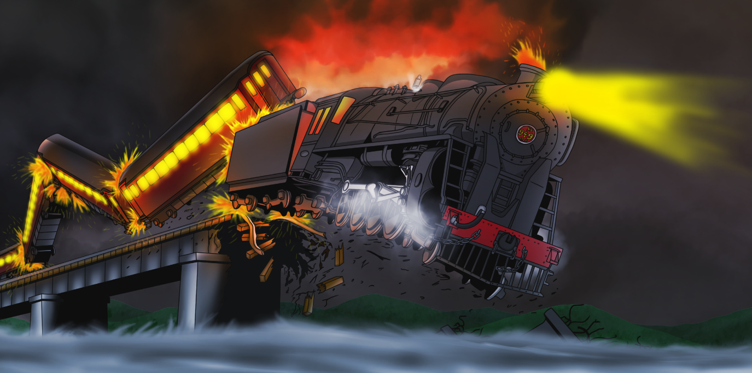
Success Criteria: Students will become familiar the Tangiwai Rail disaster and be about to recount what led to the event and how it could have been prevented.

Task 1: In your Red Books write today’s date and ‘Week 3 Lesson 1 – The Tangiwai Rail Disaster.

Brief Discussion: What do students know about this event?

Task 2: Watch the video clip: ‘The Tangiwai Train Disaster 66 Years Later’ at: https://www.youtube.com/watch?v=KJssGS9I4MM (12:48 sec.)

This gives an excellent overview of the event which is recreated with good actors.

1. How many passengers & crew were on the train? (1:50 sec. mark)

2. When Cyril Ellis sees the bridge is out – how does he try to stop the train?

3. Why didn’t the train stop for Ellis?

4. How many people died in the crash?
5. What is a lahar? (8:00 sec.)

6. What action did the government take after the accident to prevent another accident from happening? (9:00 sec.)

7. A similar event happened in 2007 at the same spot! What was the result? Did any trains crash? Why or why not? (10:00 sec.)

Task 3: Read the article below, ‘Death at Tangiwai: A Class Affair.’ Before you do, look up the following definitions:

1. First class travel.

2. Second class travel.

3. Carnage.

4. Derailment.

Task 4:

Read the article below and answer the following question in your Red Books: ‘Why did so many wealthier people survive the disaster, and so many poorer passengers die?’

Death at Tangiwai: a Class Affair
Almost everyone killed at Tangiwai was travelling in a second-class carriage – 148 out of 151. Traditionally located at the front of the train, these were more affected by the noise, smoke, coal dust and fumes of the locomotive, something those in first class paid to avoid. In a head-on collision or derailment, second-class passengers were at greater risk of death or injury. At Tangiwai, just 28 of the more than 170 second-class passengers survived. Only one first-class passenger was lost, along with the driver and fireman. Most of the passengers in the final three (first-class) carriages, which remained on the track, initially did not even know what had happened to their train.
The Tangiwai disaster was especially tragic for the Nicholls family from Palmerston North and the Benton family from Marton, which each lost five members, and the Fitzgerald family from Lower Hutt, which lost four. Amidst the death and carnage, though, there were some good-luck stories.
Seventeen-year-old Barbara Mahy and her younger brother John had first-class tickets but could only find seats in a second-class carriage. After leaving Waiōuru the guard moved them to the last first-class carriage, at the rear of the train. Almost all the occupants of their original carriage were killed. Christine Cole Catley and her three small children were booked to travel second-class that evening but due to a change of plans travelled a day earlier. For the rest of her life she wondered about ‘the people who considered themselves lucky’ to get those tickets at the last moment.
The Tangiwai tragedy killed more people than the combined total of all the other rail accidents in New Zealand history (the next-worst accidents, at Hyde in 1943 and Ōngarue in 1923, claimed 21 and 17 lives respectively). It is worth noting, too, that in 1953 road accidents in New Zealand claimed 279 lives.

Task 5: Go to: How did sand help to save the lives of many passengers on the train? The answer can be found on this page: https://tangiwai1953.weebly.com/causes-and-consequences.html

Write the question and answer into your Red Books.

Week 3 Lesson 2:
The Orpheus Shipwreck of 1863
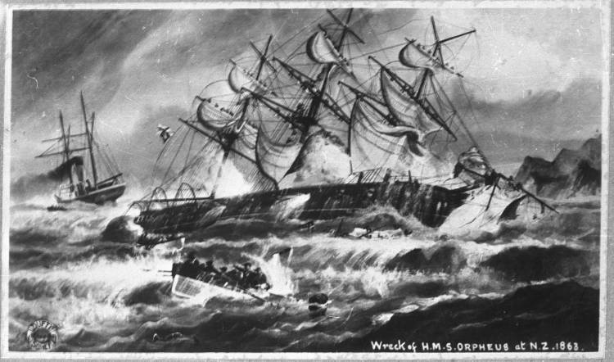

Read the following article:

The Orpheus Shipwreck
At approximately 1:30pm, on 7 February, 1863, the HMS Orpheus was only miles from her destination port of Auckland when it struck a sandbar at Manukau Heads. As the waves got heavier, the ship started breaking up. 189 people died, making this New Zealand’s worst maritime disaster.

What happened?
On 7 February, 1863, the HMS Orpheus was getting near to her destination port of Auckland. On board were 259 men, many of them British soldiers heading for the Waikato Land Wars.

The harbour bar at the head of the Manukau Harbour was a sandbank built up by the movement of the waves. Crossing it had to be done at the right time, when the tide was high enough and the water over the bar deep enough for ships to pass safely.
The signalman at the signal station on Paratutai Island signalled the Orpheus to “take the bar” (across the harbour mouth) at about 11am when the tide was right. Weather conditions were fine and sunny.

The signalman watched the Orpheus take a course too far to the south of the bar to cross it safely and tried to signal the ship to keep northward, but it did not change course. On board the ship, a seaman with experience of the harbour realised the ship was taking the wrong course. Alarmed, he went to the master of the ship and pointed out the correct course on the chart.

Before the turn could be made, the Orpheus struck the sandbar, burying the nose of the ship. The engines seized and gradually the Orpheus slipped further over on to her side. A south-westerly wind had sprung up and the waves were growing stronger.

A steamer had just been piloted out of the harbour when the skipper saw the Orpheus out by the bar. At first he did not realise that it was in difficulties, until he met two smaller boats from the Orpheus. Another boat from the Orpheus had been lost when it was lowered over the side. Most of the 40 men on board were drowned or crushed in the wreck.

Meanwhile the men remaining on the Orpheus had climbed the rigging in an attempt to stay clear of the waves which were breaking over the ship halfway up the mast. Some tried to climb forward to the bowsprit and jump into the water there, but many fell to the deck making the attempt.

Smaller boats from the steamer moved in around the Orpheus to rescue survivors from the sea. Between 8 and 8:30pm the masts fell into the sea, taking with them over 100 men who had climbed the rigging. Further attempts to save the drowning men were made at night by the light of the moon, but by dawn only the stumps of the masts and pieces of the deck remained visible. There were only 70 survivors.

How many died?
189 people died.

Other events and outcomes
Three major enquiries were held into the wreck of the Orpheus. There were differences between the powers of the New Zealand authorities and those of the Royal Navy, who refused to let any of its officers be blamed.
However, the navigation charts carried on the Orpheus were out of date. The sandbar had grown by some 800 metres and extended well out into the old channel and none of the officers on the Orpheus had had experience on the Manukau Harbour. They were sailing according to the directions on the out-of-date charts.
The Orpheus shipwreck is still New Zealand’s worst shipwreck, in which the greatest number of people died.

Assignment:

Disasters are often not an ‘act of god’ but human creations. That was true on the wreck of the Orpheus. This year marks the 160th anniversary of the Orpheus disaster. Based on the reading above – Imagine you are a newspaper reporter who has been asked to write a feature story remembering this famous event in New Zealand history. Your article will contain two paragraphs:

Paragraph #1: Write a big picture summary of the event in your own words – include who, what, where, when and why

Paragraph #2: Based on information contained in the article above, what lessons can be learned from this tragedy? That is, the even was the result of human error. What lessons can be learned from this event so it doesn’t happen again?

Week 3 Lesson 3

Current Event #1

The War on Rat

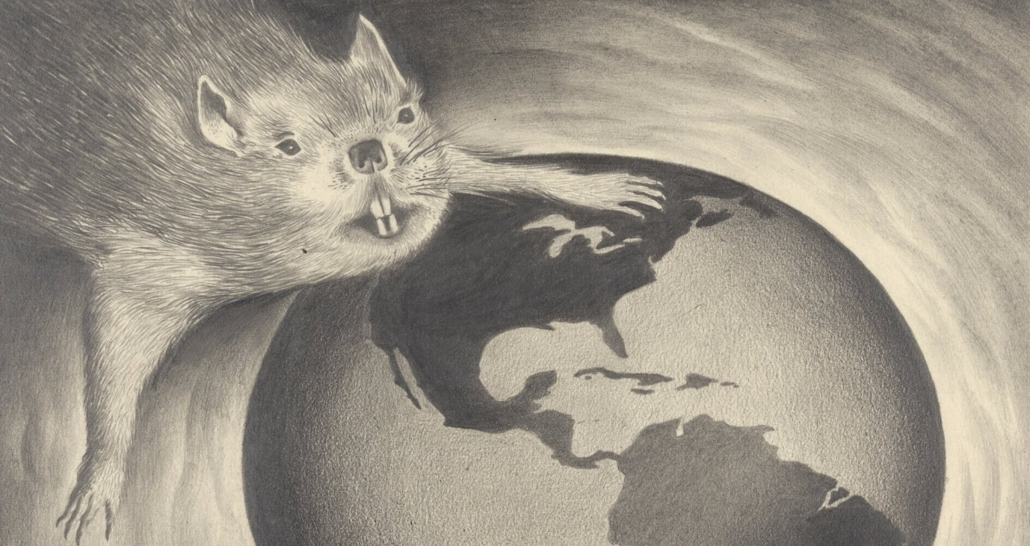

Recently New York City officials hired a person to tackle the city’s growing rat problem which made headlines recently with the viral posting of what became known as ‘pizza rat.’ Who or what was ‘pizza rat?’

Task 2: Watch the video:
https://www.youtube.com/watch?v=stzmvrn3jeU

However, recently the BBC reported that rats have gotten a bad rap and are not as dirty a most people thing.

Task 3: Read the following article: “Is it time to stop hating the rat?”

https://www.bbc.com/news/uk-42708127

By Kate Whannel
BBC News
You dirty rat; I smell a rat; like a rat deserting a sinking ship.
It's clear from the English language that rats don't have the best reputation in our culture.
Rats are seen as dirty, vicious and the spreaders of disease including the plague - which in the 14th century caused the deaths of more than a third of Europe's population.
However, a recent study has found that it was humans rather than rats that were responsible for the spread of the Black Death.

Life savers?
Today, in parts of Africa rats are helping to save lives and fight disease.
The charity Apopo, working with the Sokoine University of Agriculture in Tanzania, trains rats to react to the scent of explosives, enabling them to detect landmines in countries including Tanzania, Mozambique and Cambodia.

The detection of landmines is usually an expensive business, and countries often lack the resources to carry out the time-consuming and complicated work.
A human using a metal detector would take 25 hours to search a 200-sq-m area - a rat can do the same work in 20 minutes.

Apopo's James Pursey explains that not only are rats cheaper than dogs, they are also light enough that they don't set off the landmines.
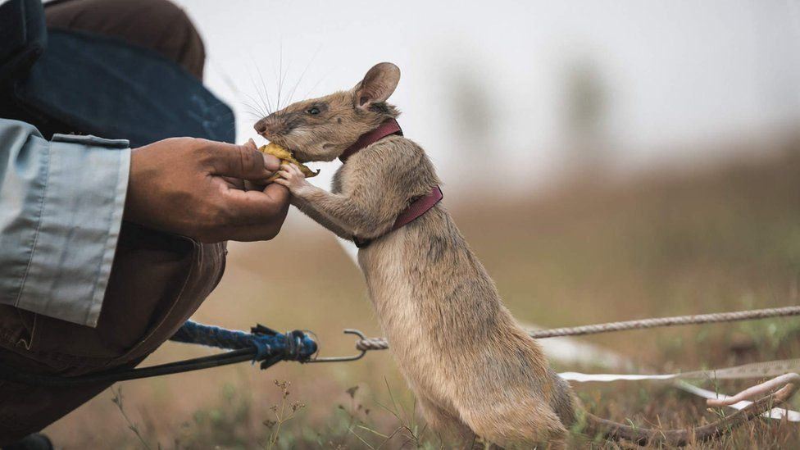
Apopo say their rats have helped clear over 100,000 landmines
And it's not just landmines.

Rats can also smell out the odour specific to tuberculosis.
Every year, three million people infected by TB go undiagnosed and therefore do not receive the care they need.

Apopo say that their trained rats can screen 100 samples in 20 minutes - a task that would take a lab technician four days.

The samples detected by rats are then rechecked using World Health Organisation (WHO) endorsed confirmation tests.
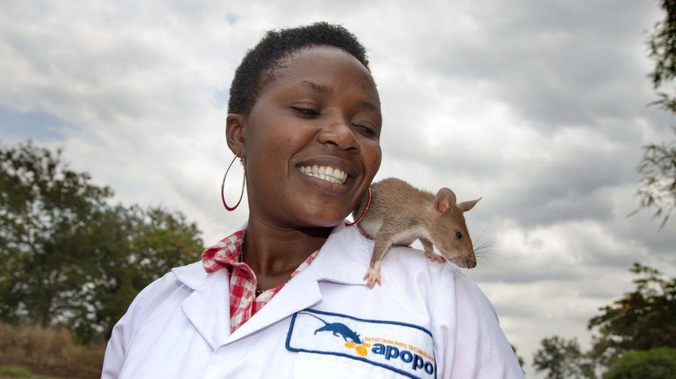
Rats can be trained to detect TB

Rats: Villains or Heroes?
In western culture the rat is frequently depicted as the villain:
- The scourge of the town in the Pied Piper of Hamelin
- The baby-eating intruders from Lady and the Tramp
- The rude and selfish Templeton from Charlotte's Web
- The ever-present threat in 1984
- The treacherous Peter Pettigrew in Harry Potter
The Pied Piper is hired by the people of Hamelin to lead the rats out of their town
Although, sometimes the rat has been given the chance to play the hero:
- The food-loving Remy from Ratatouille
- Nicodemus from the Rats of NIMH
- Roland Rat - saviour of TV-am

'So affectionate'
Not only can they help clear mines rats, their owners will tell you, also make good pets. Pets4Homes points out that contrary to their reputation rats are clean animals and spend more time grooming themselves than cats. Rachel Heaton is the publicity officer for Yorkshire Rats Club and an owner of 15 rats.

She told the BBC that: "Rats are so affectionate and so in tune with their owners' emotions."

"When I had my appendix out one of my rats could sense I was unwell and instead of trying to play as he usually does he sat quietly licking my hand."

"You can also teach them to do tricks - there is one woman who taught her rat to fetch her a tissue every time she sneezed."

Assignment: Write a letter to a friend describing common myths about rats and the many positive benefits that have brought to humanity. I have started the letterto get you going…

Dear Mary,

For the longest time I have hated rats and been afraid of them. That is why I was shocked today when I read that rats have gotten a bad reputation but much of it isn’t true. For instance, it has long been thought that rats were responsible for the Black Death during the Middle Ages…

