Week 3: Māori

This is a shortened week due to the public holiday – so before we begin the Assessment on Māori leaders in Week 4, it may be useful to have a better understanding of Māori culture by watching and reacting to the Aotearoa History Show.

= 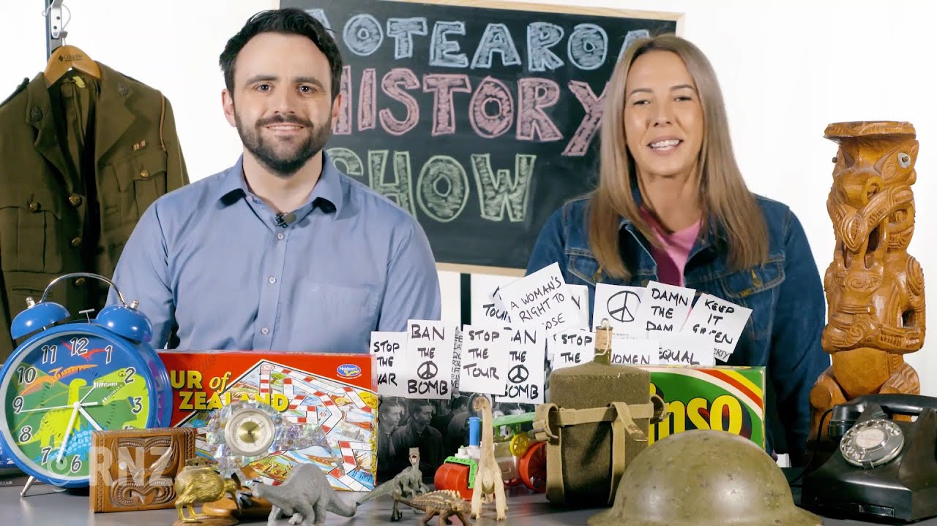

Success Criteria: To provide a historical context for New Zealand History today. By the end of the week students will be able to recount key events in the early history of what is now known as Aotearoa New Zealand including who were the first inhabitants, why did they light major fires, how do we know what we know about them, and concepts of mana, hapu, tapu and itu.

Lesson 1: The Prehistory of Aotearoa New Zealand – Zealandia
https://www.youtube.com/watch?v=WWuCxhapY88

As a class we will watch the History Show, occasionally stopping for discussions, while we answer the questions below:

1. The land mass known as Zealandia had dinosaurs that likely had feathers and large eyes. Why do scientists think this?

2. What killed the dinosaurs in Zealandia?

3. What happened to all the mammals that once lived in New Zealand

4. Why did birds love early New Zealand and why did they flock here?

5. Based on New Zealand’s history, why are scientists worried about global warming today?

6. What is New Zealand’s super volcano? Where is it located? Should we be worried that it may suddenly erupt?

7. In about 1290, something strange happened across New Zealand. What happened and how do we know it happened?

Class Discussion: What surprised you about the pre-history of New Zealand? List five things that are unique about New Zealand

Lesson 2: The Aotearoa History Show - Episode 2, Tangata Whenua

https://www.youtube.com/watch?v=AmGdmLW2HTo&t=415s

As a class we will watch the History Show, occasionally stopping for class discussions, while we answer the questions below:

1. Where did the Polynesians who would eventually discover and settle in New Zealand – originally come from? Why do scientists think this?

2. What is an ocean-going waka – and why were they so important in the eventual discovery of New Zealand?

3. When is it believed that the first Polynesians settled Aotearoa New Zealand?

4. Some historians think that the first people to settle what is now Aotearoa Zealand left because of crop failures and warfare caused by what?

5. Where do many historians believe that the first Māori settlers came from – that is – where is Hawaiki?

6. The Moriori are the indigenous Polynesian people of the Chatham Islands. How are they related to the Māori?

7. List a popular myth about the Moriori.

8. Why is it thought that this myth of the Moriori continues to endure today?

9. Define the Māori words ‘Hapu and ‘iwi.’

10. Define the concepts of mana, tapu, and itu.

11. Why did most early Māori live on the North Island?

12. Before Europeans arrived in Aotearoa New Zealand, what was the average lifespan for a Māori?

13. Why didn’t the early Māori refer to themselves as Māori? What does the word actually mean?

Class Discussion:

