Week 2: Lesson 1

Extreme Dictatorship: North Korea

Success Criteria: By the end of the week students will be able to recount the key differences between the dictatorship in North Korea and compare it with the workings of democratic countries such as New Zealand.

What are the key features of the North Korean Government? Reads the article below from the BBC. Answer the following questions:

https://www.bbc.com/news/world-asia-pacific-15256929

1. North Korea is a totalitarian state. What dies this mean?

2. What year was the country founded?

3. How many people live in North Korea and how long can they expect to live?

4. List 3 facts about the media in North Korea.

a.

b.

c.

5. What is the name of the current leader?

Because the leader of North Korea has total power, when the father of the current leader died several years ago – people were overcome by emotion because they had grown up with his images everywhere. He was considered almost super-human. Watch the reaction below to the death of Kin Jong-Un’s father. If a person didn’t cry, they faced possible arrest!

- Major problem – when the leader dies – there is a vacuum –
- https://www.youtube.com/watch?v=Ht6nWLEfdF8 (weeping)

- Absolute government control
https://www.youtube.com/watch?v=JTKopeQhiDo

Watch the clip on life in North Korea:
https://www.youtube.com/watch?v=-h_h0Tp6vZk (8:235 Seconds)

10-minute Write – Short paragraph

At the end of the clip the man said: ‘The next morning we flew out…leaving behind a country we weren’t sure we had actually ever been to.”
Explain what is meant by this.

Week 2: Lesson 2

What makes up a Democracy?

- Can you identify the characteristics of democracies and non-democracies by completing this checklist?

Task: Break up into small groups and write 1 to 14 on a sheet of paper. Answer the following 14 questions.

I will then call on different groups to answer the questions.

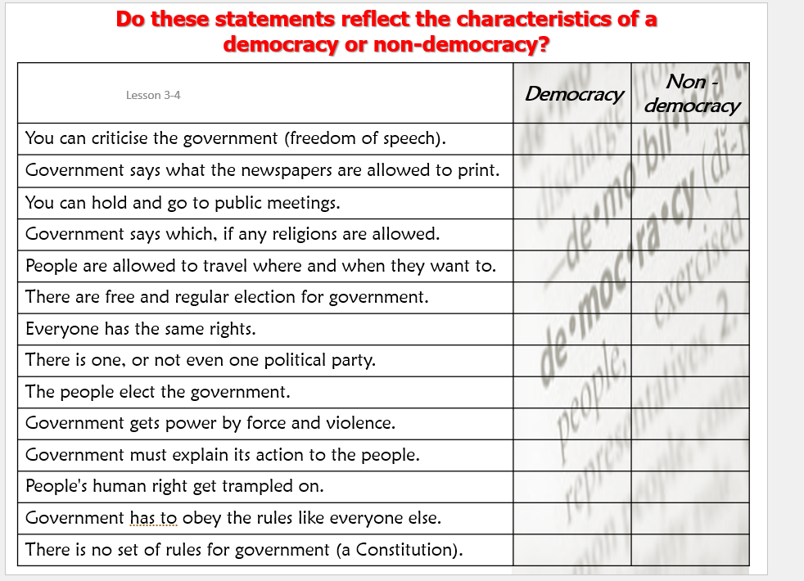

Task 2: Draw the following bubble map into your books, then fill it in based on the information in Task 3.

Task 3: Fill in the bubble map using the information below:

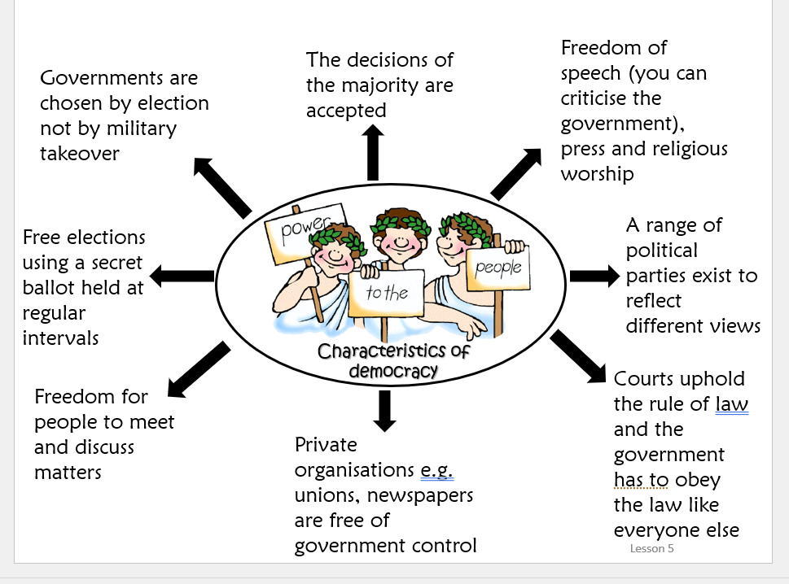

Week 2 Lesson 3:

Current Event Analysis

An Update on the ‘Global Warming Debate’

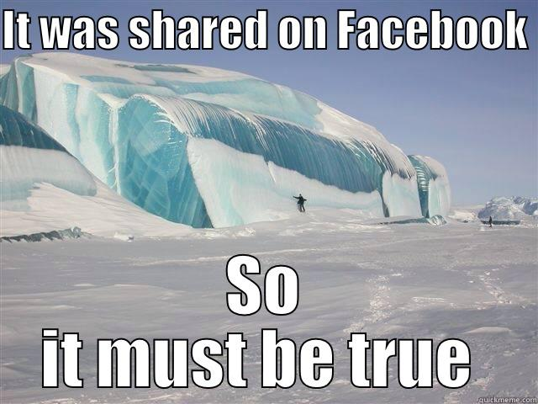

During Term 2 we looked at major weather events in New Zealand. We also looked at global warming and saw the documentary ‘An Inconvenient Truth’ narrated by Al Gore. At that time, I noted that the evidence for global warming was indisputable – the only question was – what was causing it and that most scientists believed it was humans pumping C0² into the atmosphere causing the Greenhouse Effect.

However, it should be made clear that there is now a consensus among the scientific community that global warming is real and is considered to be a fact. Because this is considered by many to be the greatest threat to have ever faced humanity – it is important that there is no misunderstanding on this issue. The evidence for global warming being caused by human beings is clear and overwhelming.

Go to the website from NOAA the National Oceanic and Atmospheric Administration. What NASA is to space, NOAA is to the Atmosphere. Read the article and create a series of key dot-points on climate change:

https://www.climate.gov/news-features/climate-qa/what-evidence-exists-earth-warming-and-humans-are-main-cause

