7 M1 & 7 M2
Assessment – Term 4

Aotearoa New Zealand Histories

Mana in Māori Society:

Influential Māori Leaders
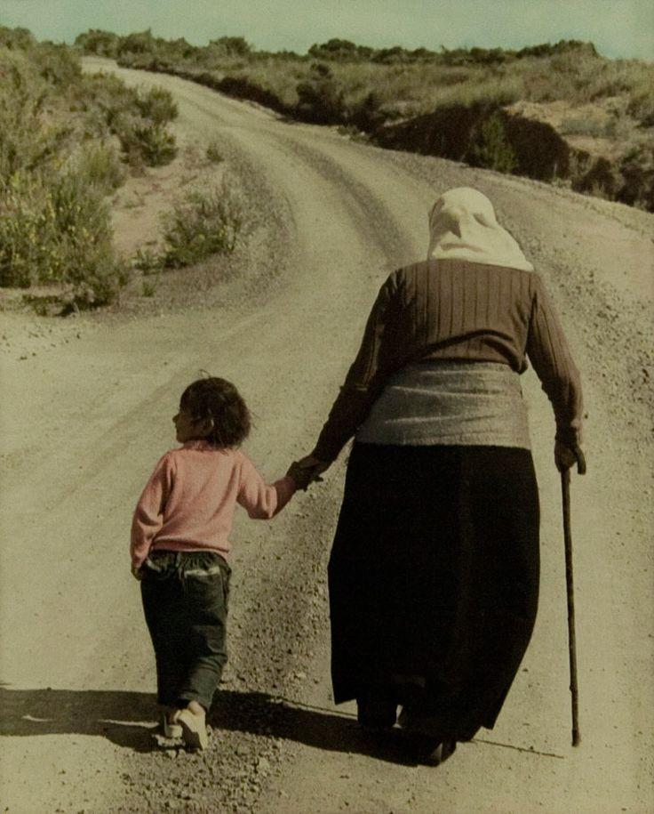
Above: Whina Cooper led 1000-kilometre march from
the Far North to Wellington in 1975, protesting more than
a century of colonial laws designed to alienate Māori from
their land. She is a famous Māori elder or kaumatua who
inspired people to follow her on the march. She is pictured
here starting the march with her granddaughter.

Date Handed out: Monday October 30, 2023 (Week 4)
Date Due: Friday November 17, 2023 (due Monday Week 6)

*Budget your time – Do not wait until the last minute to do the bulk of the work. As these assessments must be marked and online in Week 6, no extensions will be given. It is your responsibility to ask questions. I will happily meet with any student or group of students after class during interval, lunch, or Focus Friday for as long as is needed. If you are unsure of something – ask.

Assessment Summary:

Students will work individually on the following tasks:

Christopher Luxon

When referring to people, the word Mana refers to an extraordinary power, essence (a key quality) or presence that someone has. Throughout the history of Aotearoa New Zealand some Māori leaders have exhibited exceptional mana which they used to accomplish a goal for the betterment of their people. Imagine that New Zealand’s soon-to-be Prime Minister, Christopher Luxon, has heard that you are an expert on Māori history, and he has asked you to choose a famous Māori leader whose image will appear on the new $20 note. He wants you to create a Powerpoint presentation in which you will make the case to him why they should choose this person. Your job is to pick ONE famous Māori leader. Your presentation should include the following:

Section 1: Major influences on their life and beliefs (could include their childhood, values their
parents and different kaumatua (elders) impressed on them; it could include an
incident that happened to them or their family; you could include religious or
cultural beliefs [use bullet points & visuals with captions]
Section 2: What qualities did they have that attracted people to follow them.
Possible areas to elaborate on: were they inspiring; determined; committed; caring;
how were they as a speaker. You could include a story that someone told about them
that shows these qualities.) [should appear in paragraph form]

Section 3: What were their major accomplishments (you could include what a historian,
politician or others have said about them. Why are they remembered? What is their legacy (her contributions to future generations)? [should be in paragraph form]

*Please include: a catchy, relevant title for your presentation

Whina Cooper
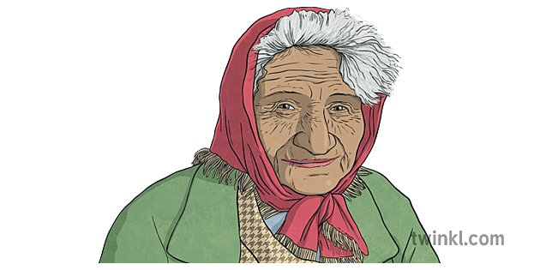
Readings and video clips:

1. https://teara.govt.nz/en/biographies/5c32/cooper-whina (Reading from Encyclopedia Te Arra)

2. https://nzhistory.govt.nz/whina-cooper-led-land-march-te-ropu-o-te-matakite-reaches-parliament
(Reading: story on Whina leading the land march to Parliament in 1975)

3. https://www.youtube.com/watch?v=yqeaDgs2T_g
(TV Show on Whina Cooper - This is Your Life (1987) when she was 94 years old! At 27 :17 sec. mark it describes her famous land march)

4. Another TV documentary on Whina’s life:
https://www.youtube.com/watch?v=wmK6vPypGUw (22:43 sec.)

5. https://kids.britannica.com/kids/article/Whina-Cooper/632973
(Reading on Whina Cooper from Encyclopedia Britannica)

6. https://natlib.govt.nz/schools/teaching-and-learning-resources/te-kupenga-stories-of-aotearoa-nz/not-one-more-acre
Advanced reading with a great photo!

7. https://nzhistory.govt.nz/people/dame-whina-cooper (Reading and overview of her life)

8. Check Papers Past; also check the MHJC Library for the EPIC database, specifically ‘The Australia and New Zealand Reference Centre’

Option #2

Basic Assessment

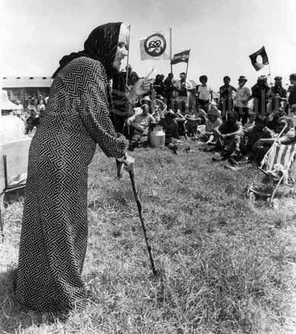

The Basic Assessment will involve less work, but it will be difficult to attain a mark higher than a ‘Working At.’ Students opting for the Basic Assessment must get permission from the teacher first.
You will write a paragraph on Dame Whina Cooper, summarizing her life and accomplishments. Include who, what, where, when, why, and how. You will then write a second paragraph where you reflect and offer your opinion of what she accomplished.

Paragraph #1 - Life of Dame Whine Cooper.
What qualities did she have that resulted in her becoming the leader of the land march? You can write about her early life and upbringing, her values and beliefs, determination, and the obstacles she had to overcome. Most Kiwis view her as a hero.

I have already provided you with a possible topic sentence below:

Dame Whina Cooper led a famous march for Māori land rights in the 1970s, and in doing so exhibited many qualities that can be viewed as heroic.

- Give an Explanation that expands, develop and clarifies your main idea – the first sentence (you could define the word ‘hero’ and mention some qualities that he exhibited and obstacles she overcame to succeed).

- Provide Examples that support your position that Whina Cooper was a hero. This could include facts about her accomplishments, quotations, proof, evidence, details that support your main idea

- Give your opinion - explain the significance of the idea – explain the example
- Paragraph #2: Give your opinion. Whina Cooper is a hero because…

- Possible ideas your could discuss - No matter how famous he became, Whina never changed. Explain. How did she inspire others? How did she help to create a better New Zealand society?

In Addition you must Include:

A. a catchy, relevant title
B. at least one image with a caption (a written description underneath the image that describes what is in it.

Suggested resources:

1. New Zealand Herald Trailblazers Series – Whina Cooper [great overview of her life, beliefs and leadership qualities]
https://www.youtube.com/watch?v=1jmbM5krIMg (3:20 sec)

2. TV 1 Story - Hundreds gather in Panguru, Northland as statue of Dame Whina Cooper is unveiled
https://www.youtube.com/watch?v=n10Dx_03hUU (2:03 sec.)

3. Whina Cooper – Kiwi Magic – New Zealand TV Show on her life from the 1980s – great overview of her accomplishments
https://www.youtube.com/watch?v=wmK6vPypGUw&t=1227s (22:43)

4. Kids Britannica (Reading)
https://kids.britannica.com/students/article/Whina-Cooper/633142

5. New Zealand Parliament overview story (Reading)
https://www.parliament.nz/en/get-involved/features/celebrating-dame-whina-cooper-and-the-fight-for-maori-land-rights/

Basic Assessment Checklist:

1) Catchy Title
2) At least 1 mage with a caption (where you explain in a few words what the image is about)
3) 1 paragraph on your chosen topic using the SEXY writing style
4) 1 paragraph Reflection

Key Points to remember:

a. Follow the instructions and use the S-E-X-Y writing style.

b. The greater the depth and relevance, the higher the mark.

c. Write in your own words. DO NOT cut and paste from the internet!

A Refresher on the S-E-X-Y Method

S – This is a Statement that establishes the main idea; also known as a topic sentence

E – Give an Explanation that expands, develop and clarifies your main idea.

X – Provide an Examples – facts, quotations, proof, evidence, details that support your main idea

Y – You Add - Give your opinion - explain the significance of the idea – explain the example

Rubric

Criteria | WORKING TOWARDS Curriculum expectation | Working AT curriculum expectation | Working ABOVE curriculum expectation | Working BEYOND curriculum expectation
Gathering of relevant information/evidence | You have attempted to gather some relevant information from a source provided to you | You have gathered some relevant information from a source provided to you | You have gathered relevant information from a source provided to you | You have gathered relevant information from a self identified source and use this to attempt to note take in your own words
The expression of mana in Maori society | You have yet to show an understanding of how mana was expressed by your chosen Maori leader | You have shown a limited understanding of how mana was expressed by your chosen Maori leader | You have shown some understanding of how mana was expressed by your chosen Maori leader | You have shown an understanding of how mana was expressed by your chosen Maori leader
Paragraph Structure (EX) | You have yet to use explanation and evidence (SEXY structure) to describe relevant ideas | You have attempted to use explanation and evidence (SEXY structure) to describe relevant ideas | You have used explanation and evidence (SEXY structure) to demonstrate some understanding | You have clearly used explanation and evidence (SEXY structure) to demonstrate your understanding
Accuracy in Writing | You have made errors in grammar, spelling and/or punctuation and these are intrusive at times, consequently the reader has to infer meaning | You have made some errors, but minimal reader inference is needed as meaning is mostly clear | You have carefully edited your writing to ensure you have few intrusive errors and meaning is consistently clear | You have carefully edited your writing to ensure you have no intrusive errors and meaning is consistently clear
Time management | You have yet to complete and submit your assessment | You have submitted your assessment late | You have submitted your assessment by the due date | You have submitted your assessment by the due date
Overall | WORKING TOWARDS Curriculum expectation | Working AT curriculum expectation | Working ABOVE curriculum expectation | Working BEYOND curriculum expectation

Other possible Maori leaders:

1. Princess Te Puea - A respected Maori Princess who dedicated her life to improving the well-being of Maori people and preserving their cultural traditions.

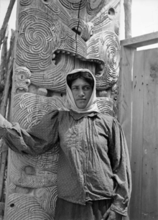

https://teara.govt.nz/en/biographies/3h17/herangi-te-kirihaehae-te-puea

https://nzhistory.govt.nz/keyword/tags-147

https://whatshernamepodcast.com/te-puea-herangi/

https://www.teaonews.co.nz/2018/09/19/the-continuing-legacy-of-princess-te-puea/

2. Valarie Adams: a prominent Olympic shot-putter who has overcome many obstacles in her life and who is has filled many leadership roles during her life.

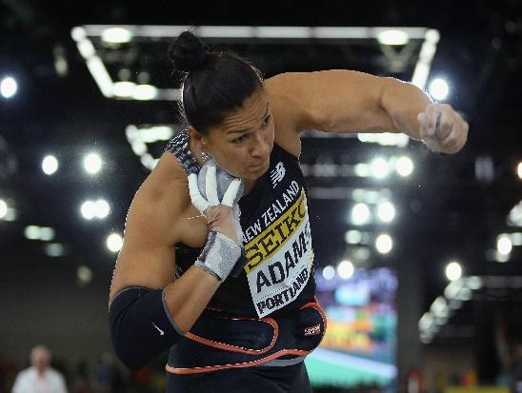
https://www.thefamouspeople.com/profiles/valerie-adams-5544.php

https://www.nzfilm.co.nz/films/dame-valerie-adams-more-gold

https://www.youtube.com/watch?v=SkJf1CtKlJM (summary of life story)

https://www.youtube.com/watch?v=p7WHvHVp4mA
(mini overview of her life)

https://www.youtube.com/watch?v=IP5jbWe2s30
(great look at her family and famous brother)

https://www.youtube.com/watch?v=K0iGgfdoY3w
(talks about her life story)

3. Lisa Carrington: is a Maori Kiwi and athlete who has been a leader for Maori people by helping her community and people beyond the sporting arena.
https://ipaddle.co.nz/pages/lisa-carrington
(bio of her life)

https://sportnz.org.nz/resources/balance-is-better-lisa-carrington-canoeist/

https://en.wikipedia.org/wiki/Lisa_Carrington

https://www.1news.co.nz/2021/08/05/carrington-connecting-to-my-maori-roots-has-helped-me/
(connecting to Māori roots)

https://olympics.com/en/news/lisa-carrington-exclusive-maori-heritage-future-history
(how her Māori roots have helped her)

https://www.youtube.com/watch?v=NqtpLoujeNE
(on inspiring others)

https://www.youtube.com/watch?v=HVdJZJiyn7A
(short clip on the recipe for success)

Apirana Ngata: Famous Maori statesman and leader of his people.
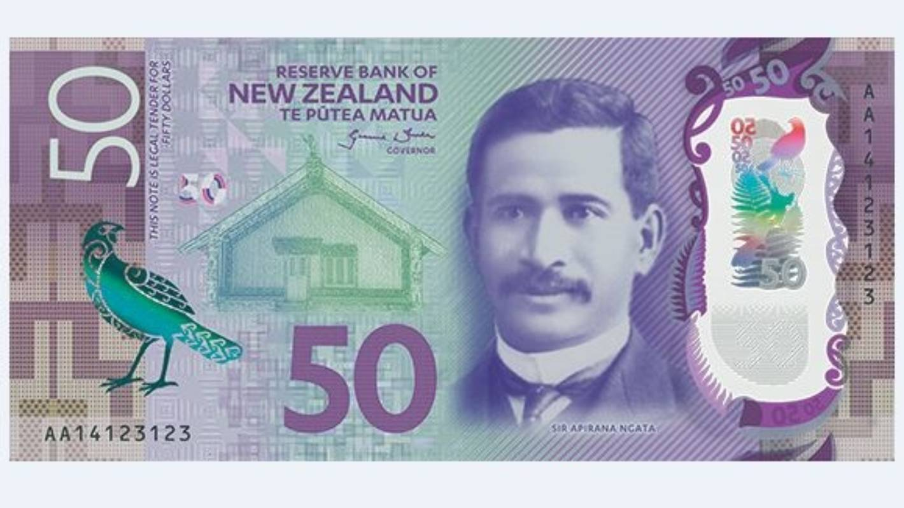
https://nzhistory.govt.nz/people/apirana-turupa-ngata

https://teara.govt.nz/en/biographies/3n5/ngata-apirana-turupa

https://www.youtube.com/watch?v=epFZkhUnKzo
(the man on the $50 note)

https://www.twinkl.co.nz/resource/nz2-t-163-apirana-ngata-fact-file (good overview of accomplishments)

https://www.youtube.com/watch?v=ai0u9sQCKDY

Apirana Ngata's advice for us| Janelle Riki-Waaka | uLearn20 keynote

For a list of other possible leaders, go to the New Zealand History site at: https://nzhistory.govt.nz/keyword/maori-leaders. This site has biographies of many historical figures and their accomplishments. Remember – write in your own words.

