Week 6
Digital Detox & Current Events

Success Criteria: By the end of the week students will be able to list several key features of a Digital Detox, how it can be achieved and several benefits. They will also become familiar with a relatively recent current event involving a conspiracy theory.

Week 6 Lesson 1: Digital Detox.
In this lesson we will look at the idea of ‘Digital Detox.’ Go online and look up the definition of this term and write it below:
Digital Detox:
The average American currently spends nearly 7 hours a day staring at screens.
Communication professor Josh Misner was one of those people until a shopping incident brought awareness about the harm screen addiction brings to relationships. In this talk, he shares the most important lessons learned from a decade of Screen Free Saturdays.

Watch the video clip about the story of Josh Misner.

“What I Learned from 10 Years of Digital Detox.” https://www.youtube.com/watch?v=o0xI45Vch0A&t=3s (15:52 sec.)

Answer the following questions:

1. What was ‘The Cosco Incident?’ (2:30 sec.)

2. How did Josh try to defend his answering of his phone at Cosco?

3. What was the request Josh’s wife made of him that he agreed to do once each week after ‘The Cosco Incident?’ (5:20 sec.)

4. When did he recognise he had a problem? (7:00 sec.)

5. List the different benefits that Josh experienced from his Digital Detox.

a.

b.

c.

d.

e.

6. Josh was worried that he would no longer have enough time to finish his work. What happened?

Week 6 Lesson 2:

Current Events
Conspiracy Theories
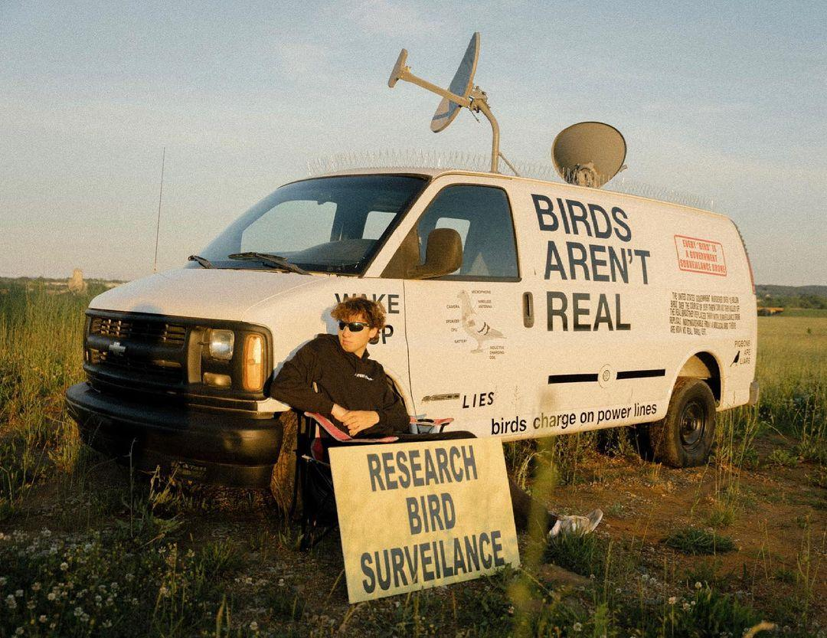
In Lesson 1 we are going to look at conspiracy theories.

Task 1: Write into your Red Books the following definition of a conspiracy theory:
A conspiracy theory is an attempt to explain harmful or tragic events as the result of the actions of a small powerful group. Such explanations reject the accepted story. Conspiracy theories are more common during times of stress like war or disease outbreaks like the recent spread of Covid-19.

Bird’s Aren’t Real!
Task 2: Watch the video on the ‘Birds Aren’t Real’ movement.
https://www.youtube.com/watch?v=3VEkzweBJPM&t=120s (13:50 sec.).

The man in the TedTalk video is Peter McIndoe. After watching the clip, imagine you are a reporter. Write an article summarizing Peter’s position about birds and whether or not they are real. Include –
1. a catchy title
2. at least 2 pictures with captions (writing under the image that explains what the image is about).
3. a two-paragraph summary of Peter’s story and the ‘Bird’s Aren’t Real’ story.
a. summarise his story – what did he do?
b. why did he do it?
c. Offer your opinion – do you agree with what he did? Justify your response – why or why not?

Week 6 Lesson 3

7 Daily Habits of High Performance Students

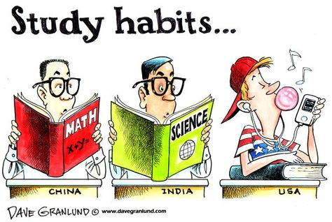

Task 1: Today students will break up into small groups after watching a video on 7 habits of effective learners. We will start by watching he clip at:

https://www.youtube.com/watch?v=vO1bpod0vKM

After viewing the video, in your group you will write down each of the seven habits.

Task 2: In your group read and discuss the article from the link below on “What Makes A Good Student? 10 Characteristics of Successful Learners” at:
https://stemeducationguide.com/make-good-students/

List each characteristic and write a one-sentence summary for each one. Do so as a group.

