RULES FOR SCIENTIFIC DRAWINGS and

DIAGRAMS:

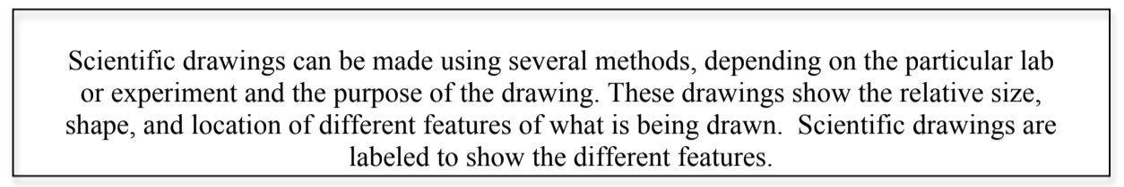

Use the following guidelines to help make your scientific drawing as clear as possible:

• Use pencil
• Use color
• Pay attention to detail
• Title your drawing at the top center of the page with a
descriptive title.
• If you want to do multiple views you may do so on another
page or neatly on the same page.
• Put your name, class, and date in the top RIGHT hand
corner
• Use a ruler to draw label lines
• Do not use arrows for label lines
• Label lines do not cross each other
• Label lines should point to the center of the structure being
labeled
• Print all labels horizontally
• Print, do not write in cursive
• Label around the drawing

Descriptions of What You Included in Your Design and WHY:

For our air flow drawings you will also have to provide a description of how the respiratory system is using the principles of gas exchange.

Either under the label or on a separate piece of paper you will write in complete sentences how the respiratory system assists the flow of air and gas exchange. If there isn’t room on your scientific drawing you may neatly create this information on a separate piece of paper.

