Year 7 - Week 1:
The Week of July 25 to July 31, 2022

An Introduction to Consumer Education

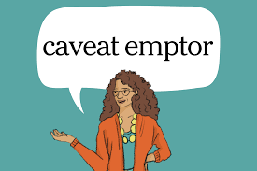

Success Criteria: Students will be able to recite basic definitions that surround the term ‘Consumerism’ and be aware of the many products and services that they consume on a daily basis. They will also have a greater awareness of the way certain companies target children to consume unhealthy products and whether it is morally appropriate.

Task A:

1. Write the following definition of ‘consumer’ into your Red Books:

Consumer: Someone who buys goods or services.

2. Look up the definition of ‘goods.’

3. Look up the definition of ‘services.’

4. What does ‘caveat emptor’ mean?

5. Write down the following definition of Consumerism:’

the idea that acquiring goods, and especially the buying of goods, as a way to achieve personal satisfaction while helping the economy.

Task B: Write in Your Red Books, ’What have I consumed today?’

Now answer the question – make a list of all the things have you either ate or used today from the moment you woke up to right now?

Technology- for example, woke up to an alarm clock, listened to the radio/television during breakfast, used the toaster, etc.

Clothing- pyjamas, footwear…. _________________________________________________________________________

At School- pens, pencils…. ________________________________________________

Transport- car… ___________________________________________________________

Task C: Go to the bottom of page 2 in the booklet ‘Consumer Stuff for Kids.’ Create a Venn Diagram and list Goods, Services and Both in the two overlapping circles.

Class Discussion:

- Do you think many of us take for granted many of the things that we buy?

- Discuss the difference between ‘need’ and ‘want.’

- Do you think that some advertisers are to blame for trying to get us to buy things we don’t really need?

Week 1 Lesson 2

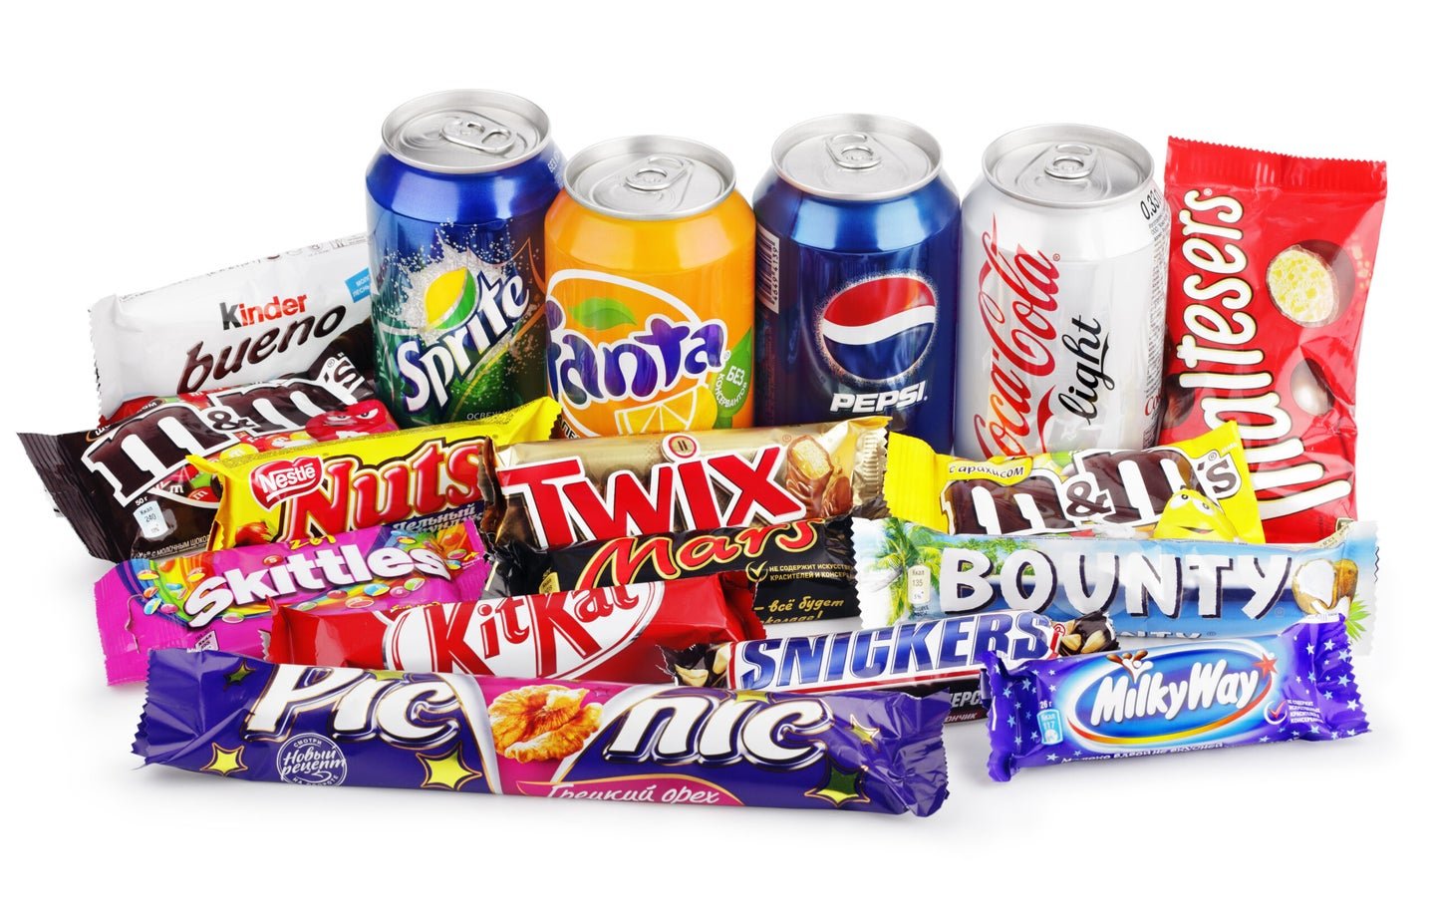Class Discussion:

Do you think that companies often target young adults your age and young children with unhealthy products that taste good, in order to make money without regard to the health consequences?

Do companies and big corporations have a moral obligation to not target children and young adults with certain products when they know it is promoting unhealthy food habits?

Should there be laws that ban certain products being sold or eaten in schools?

Some schools in other parts of the world do not allow soda to be consumed in school along with other junk foods.

Should we do this in New Zealand?

Task 1: Watch the clip, ‘Compilation of Junk Food Commercials aimed at children and teens’ at: https://www.youtube.com/watch?v=xk_hkdGf1tc (4:18 sec.)

Watch clip #2: https://www.youtube.com/watch?v=ab9zbqHJ_p4 (2:22 sec.)

Task 2: Break up into groups of 3-5. Come up with a list of the different ways that these commercials try to get kids to eat their products. Each group member should write the full list that your group came up with, into their Red Books.

1.

2.

3.

4.

5.

Task 3: Each group will share their lists with the class on the board.

Lesson 3: Read the article below.

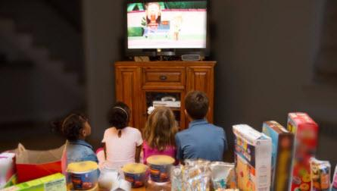

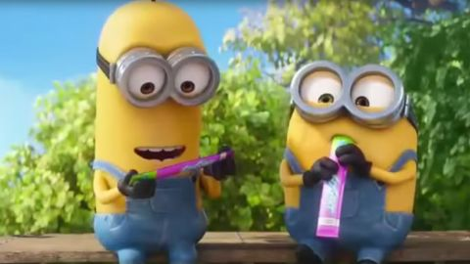Task 1: Read the article, ‘Unhealthy food marketed to Kiwi kids by Belinda Castles at: https://www.consumer.org.nz/articles/marketing-food-to-children

Answer the following questions based on the article:

1. What ways do companies get kids your age to buy/eat unhealthy foods – how are they advertised? (see paragraphs 1 and 2).

2. Go down to the bottom of the article under the section – ’10 Lunchbox Snacks to Avoid.’

Pick 3 of these snacks. Show:

1) Why they are not healthy, and

2) How the packaging of the item is designed to be attractive to children

Refer to the example below:

Example: Nice & Natural Fruit Watches Strawberry
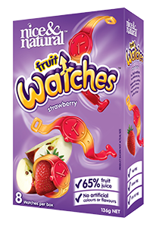

Health
1. They may be low in fat and salt, but they are very high in sugar
2. Each ‘watch’ contains 2 tablespoons of sugar
3. They use words like ‘glucose syrup’ which is another form of sugar
4. Just because it says ‘natural’ does not mean it is good for your health
Packaging
5. It has bright colors and looks exciting & has swish marks to make it seem like there is action going on

