Mini Murder Mystery Straight line graphs
One of the following 6 people has murdered one of the others.
Each has made 4 statements about these 2 graphs.
The murderer has made 3 errors, the victim made 0 errors.
The other suspects made 1 or 2 errors
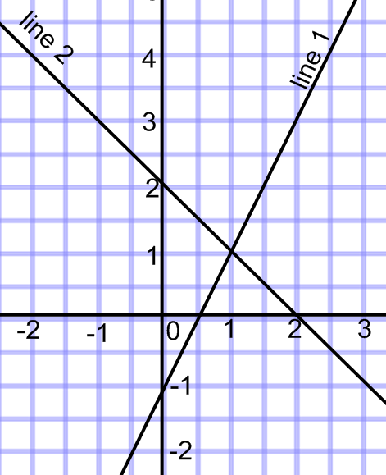
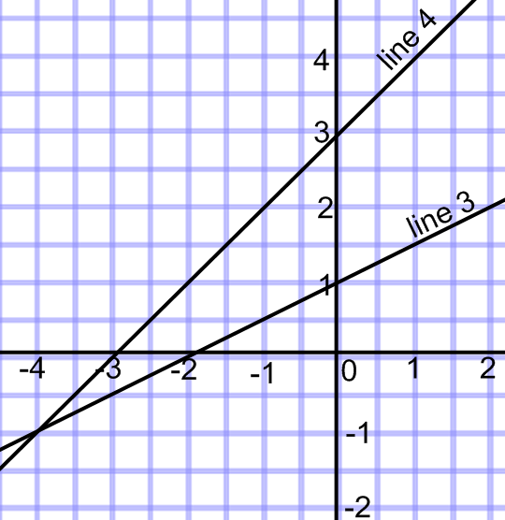
Claire says  - Line 1 is steeper than line 3  - Gradient of line 3 is 0.5  - (1,0) is on line 3  - (2,3) is on line 1 |  |  |  |  |  |  |  | 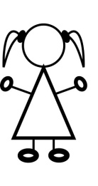  Lucy says  - The gradient of line 4 is 1  - The gradient of line 2 is -1  - The y intercept of Line 3 is 1  - (4,3) would be on line 3
Duncan says  - Lines 1 & 2 are perpendicular  - The gradient of line 4 is 3  - (0, -1) is on line 1  - Line 3 is steeper than line 4 |  |  |  |  |  |  |  | Jack says  - The gradient of line 2 is -1  - (0,2) and (2,0) are both on line 2  - (2,5) is on line 4  - The gradient of line 3 is 2
Josh says  - Gradient of line 1 is 2  - (-2,1) is on line 4  - (0,-3) is on line 4  - (-1,-4) is on lines 3 & 4 |  |  |  |  |  |  |  | Ashley says  - Line 4 would be parallel to y = x  - (0.5,0) is on line 1  - (4,-2) is on line 2  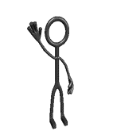  - Gradient of line 3 is 2
Accusation,,________________________ murdered ______________________
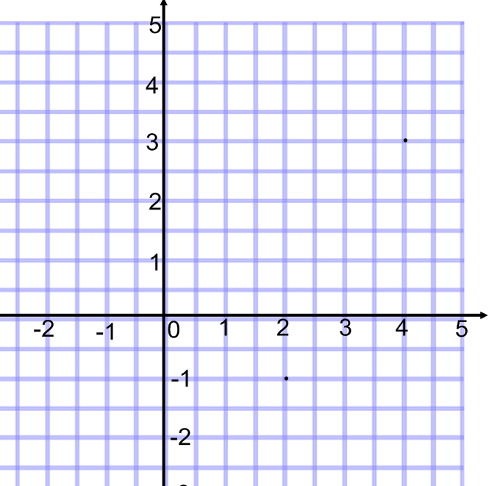
Where
The murder took place at the coordinates described by the following.
Draw the line and think about coordinates on the line.

Mark your answer with a large “x”

- It is on the line y = 2x - 5
- The x coordinate is less than the y coordinate
- The sum of the coordinates is 8.5
Why
a |  | b |  |  | c |  |  |  |  | d |  |  | e
Grad of y = 2x-1 |  | Grad of y = -4x-9 |  |  | Grad of y = 5x+6 |  |  |  |  | Grad of y = 3x+1 |  |  | Grad of y = ¼x+5
f |  | g |  |  | h |  |  |  |  | i |  |  | j
Grad of y = 0.6x |  | Grad of y = x-1 |  |  | Grad of y = -3x+2 |  |  |  |  | Grad of y = 6x-7 |  |  | Grad of y = 20x-10
k |  | l |  |  | m |  |  |  |  | n |  |  | o
Grad of y = -1.2x-1 |  | Grad of y = -2½x+5 |  |  | Grad of y = -2x+3 |  |  |  |  | Grad of y = 0.5x+6 |  |  | Grad of y =-12x+3
p |  | q |  |  | r |  |  |  |  | s |  |  | t
Grad of y = -x+8 |  | Grad of y = 8x-6 |  |  | Grad of y = 1.5x-1 |  |  |  |  | Grad of y = 10x |  |  | Grad of y = 2.5x+3
u |  | v |  |  | w |  |  |  |  | x |  |  | y or z
Grad of y = 3 |  | Grad of y = -0.5x+1 |  |  | Grad of y = -7x |  |  |  |  | Grad of y = 9x+10 |  |  | Grad of y = 4x+5
-4 | ¼ |  | 5 | 2 |  | 0 | 10 |  | ¼ |  | 10 | -3 |  | ¼
6 | 10 |  | 10 | 4 |  | -2 | -2 |  | ¼ |  | 2.5 | 1½ |  | 6
5 | 2 |  | -2.5

