Mini murder mystery
Multiples, factors, primes, powers, roots
One of these 6 people has murdered one of the others. Each has made 4 statements about the following list of numbers.
The murderer has made 3 errors. The victim has made 0 errors.
The other suspects have made 1 or 2 errors.

5, 8, 13, 16, 21, 38, 49,
52, 61, 64, 72
Chloe says  - There are 5 odd numbers  - There are 2 square numbers  - There are 2 multiples of 7  - The lowest prime number in the list is 13 | Phil said  - There are 3 primes  - The difference between the 1st 2 odd numbers in the list is 8  - There are 6 even numbers  - There are 3 factors of 64 in the list
Pauline says  - There are 2 cubes in the list  - There are 2 multiples of 9 in the list  - The largest gap between numbers is 9.  - The answer to 2⁵ is in the list | Carl says  - The answer to √121 is in the list  - There are 2 multiples of 13 in the list  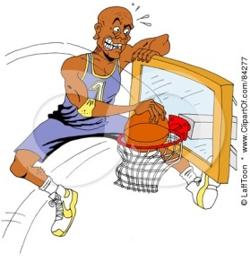  - There are 4 square numbers  - There are 4 multiples of 8
Miss Lune says  - 2⁴ is in the list  - √169 is in the list  - There are no factors of 18 in the list  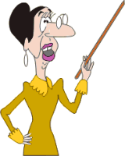  - The product of the 2 lowest odd numbers is 63 | Geoff says  - There are 2 cubes in the list  - 2⁶ is in the list  - √81 is in the list  - There are no multiples of 12
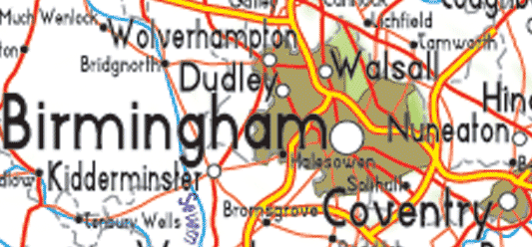
Where
The murder was committed in a Midlands town near to Birmingham.
It was Wolverhampton if there are 3 prime numbers in the 20’s
It was Kidderminster if there are 4 multiples of 30 between 100 and 200
It was Nuneaton if there are 9 factors of 36
It was Walsall if there are 5 perfect square numbers between 50 and 150
When.
Calculate the time and date from these
(eg hours answer =17 minutes part =28 gives a time of 17:28
The hour part of the time is the answer to | √16 x ( 4²- √121)
The minute part of the time is the answer to | 3³
The day part of the date is | The factors of 8 added together
The month part of the date is | The 3rd multiple of 4
The year part of the date is | (10³x √4) + √100
Why
a |  | b |  |  | c |  |  |  | d |  | e
4² |  | √100 |  |  | 1² + 1³ |  |  |  | 10² ÷ 4 |  | 3² - √4
f |  | g |  |  | h |  |  |  | i |  | j
Next prime after 13 |  | 1st prime no in the 20’s |  |  | 3 + 3² |  |  |  | 5th prime number |  | 2nd prime x 4th prime
k |  | l |  |  | m |  |  |  | n |  | o
LCM of 2 & 7 |  | 2² |  |  | √169 |  |  |  | 1¹⁰ |  | 2³
p |  | q |  |  | r |  |  |  | s |  | t
HCF of 30 & 45 |  | 5² - 1² |  |  | Cube root of 125 |  |  |  | √400 |  | √9
u |  | v |  |  | w |  |  |  | x |  | y or z
√36 |  | √81 |  |  | 4²+1²+1²+1² |  |  |  | 9th multiple of 2 |  | 5² - √9
12 | 7 |  | 25 | 8 |  | 7 | 20 | 1 |  | 3 | 14 | 1
8 | 19 |  | 12 | 8 |  | 19 | 3 | 8 |  | 20 | 24 | 6
16 | 5 |  | 7 | 16 |  | 1 | 6 | 13 |  | 10 | 7 | 5

