Landmark Task:
Surprise Game Activity!
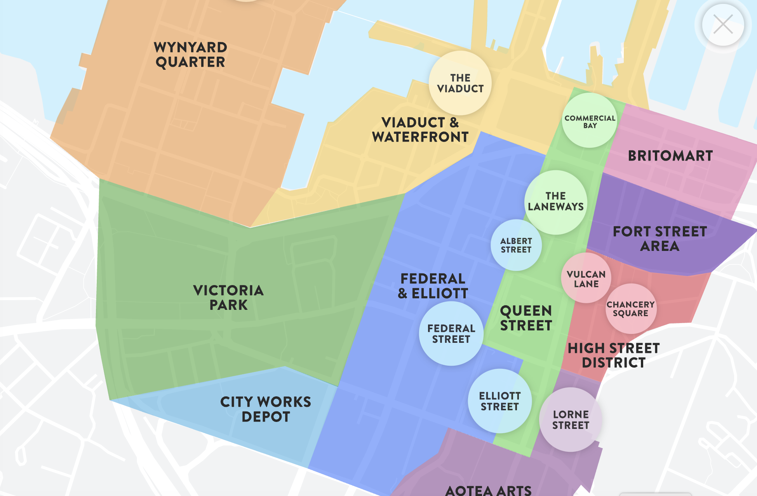
You have been sorted into small groups to complete a speed challenge. This is a race - with prizes! The first team to finish will win a small prize, and that’s it! No second place, no nothing. However, your work must be of high quality, and if you show me work that I consider low quality, you’ll have to try again and maybe lose your place!

Byshop  Chloe  Rocco  Saaniya  Azaan  Annie | Yuvi  Eden  Mason  Gowtham  Tanveer | Natasha  Alex  Paakiza  Ruben  Hayley
Vaisioa  Faith  Lina  Azheen  Tabarak | Chhavi  Danny  Lawrence  Raees  Jasneh | Marius  Caren  Selina  Gurveer  Azhar
Using the Heart of the City landmark map, as pictured above, as groups you must locate various landmarks within the city, all colour-coded for your convenience. Below you will find a list of various landmarks that you must locate on the map, and then write about.

PART 1
YOU MUST
a) Locate the address of the landmark. It will be on the site. However, if you cannot locate the address, you will have to go to Google and find it through searching.
b) Using words from the list below, describe the purpose or function (need) of the landmark. Example: food for a well-known cafe, entertainment for a theatre, so on. Use two if you are unsure.
c) You must then find out the time it takes to walk from the landmark to the SkyTower, the ‘central hub’ of Auckland’s CBD.
List of Purpose/Function words:
Food, Transport, Business, Entertainment, History, Community, Nature.
Recommendation:
- Have a person on Google Maps doing the calculations on Google Maps once you have found the address of a location.
- Have one person editing the document and the rest researching.

Landmark Location | Address | Purpose/Function | Time to SkyTower via walking
Victoria Park:  a) Perfume Playground  b) Allpress Studio  c) Sweat Shop Brew Kitchen  d) 45 Nelson Street Carpark | a)  b)  c)  d)
Britomart:
a) Jo Malone London
b) Tiffany & Co
c) Mövenpick Hotel Auckland
d) Britomart Train Station
Viaduct & Waterfront:
a) The Container Library
b) Shed 10
c) New Zealand Maritime Museum
d) Thrillzone
Aotea Arts Quarter:
a) Q Theatre
b) Auckland Central City Library
c) Academy Cinemas
d) Biang Biang
High Street:
a) Krispy Kreme
b) Jason Books
c) Coin Singing Booth
d) Cassette Nine

PART 2 - Reflection
Once you have finished the task above, you must answer these questions as a team.
1. Who had what role when carrying out the activity?
https://heartofthecity.co.nz/about-heart-of-the-city
2. Read the link above and think about the landmarks you saw on the map. The website describes itself as promoting businesses in the city - landmarks/businesses that make a profit. What landmarks is Heart of the City not promoting?
Overall, do you think the site does a good job at showcasing what real ‘landmarks’ are?

3. How do you think the map could be improved? Either in style, readability or the types of landmarks it shows, or something else? (Your opinion)

Answer 1:
Answer 2:

Answer 3:

