Week 6
Current Events Week

Lesson 1: Conspiracy Theories
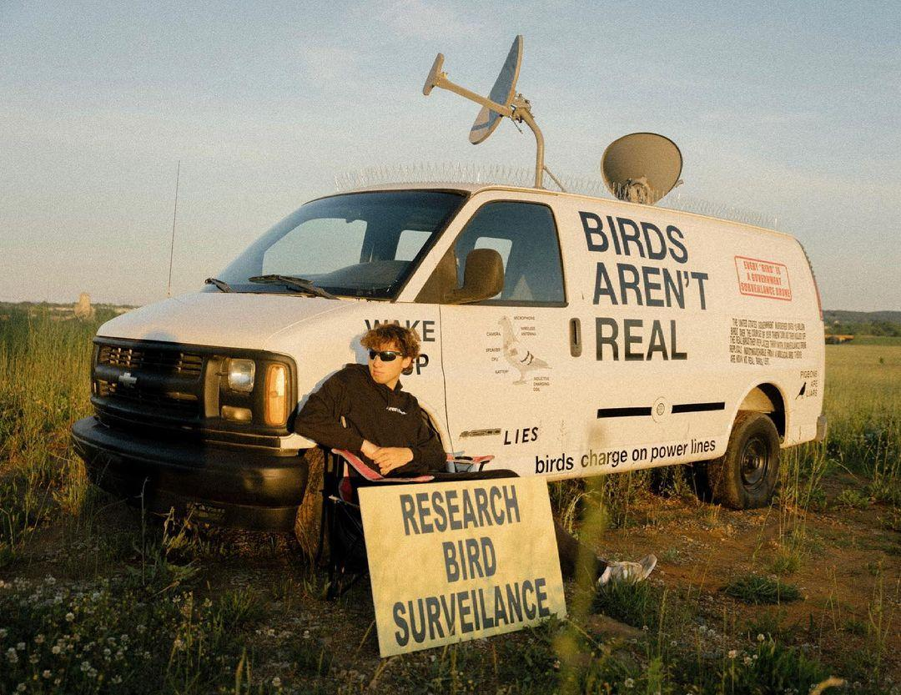

Success Criteria: By the end of the week students will be able to define what constitutes a conspiracy theory and be able to describe the ‘Birds Aren’t Real’ movement. In addition, they will be able to describe several key study habits.

In Lesson 1 – Task 1:
Write into your Red Books the following definition of a conspiracy theory:
A conspiracy theory is an attempt to explain harmful or tragic events as the result of the actions of a small powerful group. Such explanations reject the accepted story. Conspiracy theories are more common during times of stress like war or disease outbreaks like the recent spread of Covid-19.

Bird’s Aren’t Real!
Task 2: Watch the video on the ‘Birds Aren’t Real’ movement.
https://www.youtube.com/watch?v=3VEkzweBJPM&t=120s (13:50 sec.).

The man in the TedTalk video is Peter McIndoe. After watching the clip, imagine you are a reporter. Write an article summarizing Peter’s position about birds and whether or not they are real. Include –

1. A catchy title
2. At least 2 pictures with captions (writing under the image that explains what the picture is about).
3. A two-paragraph summary of Peter’s story and the ‘Bird’s Aren’t Real’ story.
a. Summarise his story – what did he do?
b. Why did he do it?
c. Offer your opinion – do you agree with what he did? Justify your response – why or why not?

Week 6 Lesson 2

7 Daily Habits of High Performance Students

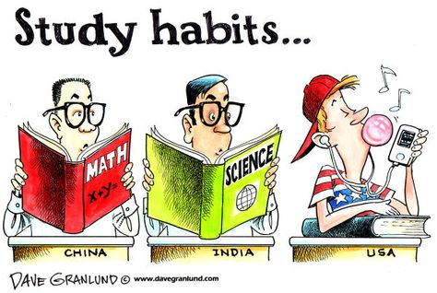

Task 1: Today students will break up into small groups after watching a video on 7 habits of effective learners. We will start by watching he clip at:

https://www.youtube.com/watch?v=vO1bpod0vKM

After viewing the video, in your group you will write down each of the seven habits.

Task 2: In your group read and discuss the article from the link below on “What Makes A Good Student? 10 Characteristics of Successful Learners” at:
https://stemeducationguide.com/make-good-students/

List each characteristic and write a one-sentence summary for each one. DO so as a group.

Week 6 Lesson 3

Working in pairs or group of 3 maximum, based on the video and reading from Lesson 2, create a poster over 2 pages in your Red Books that highlight the different habits and characteristics of High Performance Students.

Include at least 2 images with caption

A catchy, relevant title

