RULES FOR SCIENTIFIC DRAWINGS and

DIAGRAMS:

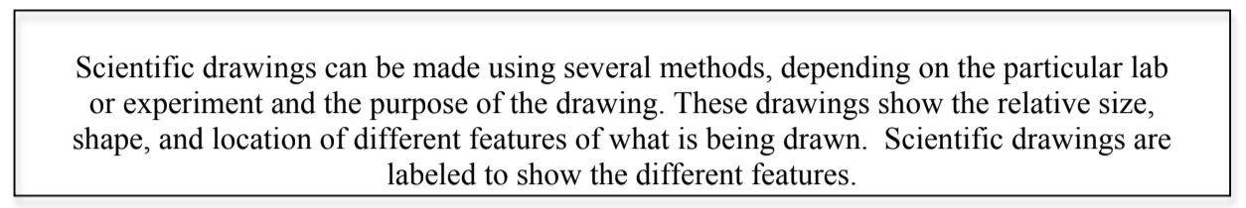

Use the following guidelines to help make your scientific drawing as clear as possible:

• Use pencil
• Use color
• Pay attention to detail
• Title your drawing at the top center of the page with a
descriptive title.
• If you want to do multiple views you may do so on another
page or neatly on the same page.
• Put your name, class, and date in the top RIGHT hand
corner
• Use a ruler to draw label lines
• Do not use arrows for label lines
• Label lines do not cross each other
• Label lines should point to the center of the structure being
labeled
• Print all labels horizontally
• Print, do not write in cursive
• Label around the drawing

Descriptions of What You Included in Your Design and WHY:

You will need to draw the digestive system in detail and to scale. You need to label each organ and give a brief description of the function. You can use an A4 paper to draw your diagram. Color in your organs.

