Names:
Camera Shots to Apply to my Film
Framing and Composition
Learning Objective: We are learning to understand the effects framing and composition have on the viewer.
Camera Shot | Description: What does it look like? | Effect: Why is this shot used? | Visual Example:
Rule of Thirds | An image should be ‘imagined’ as being divided into nine equal parts by two equally spaced horizontal lines and two equally spaced vertical lines.  Important compositional elements should be placed along these lines or their intersections | The main reason for observing the rule of thirds is to discourage placement of the subject at the center, or prevent a horizon from appearing to divide the picture in half.  Using the rule of thirds draws the viewer’s eye into the composition, instead of just glancing at the center.  By placing the subject off center, you also embrace more blank space. The rule of thirds is also helpful for highlighting an interesting background.  Off-centered subjects tend to convey more of a feeling of motion than centered ones. | 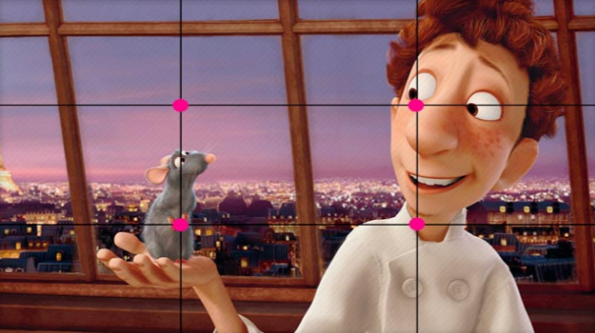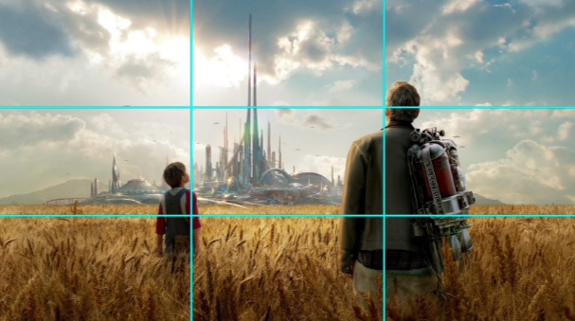
Extreme long shot (ELS)  or establishing shot | There is usually an extreme long or long shot offered at the beginning of a film, or scene. This is a panoramic view of an exterior location, photographed from a great distance. | The extreme long shot or establishing shot provides the viewer with the ‘where’ (and sometimes the ‘when’) the remainder of the scene will take place. | 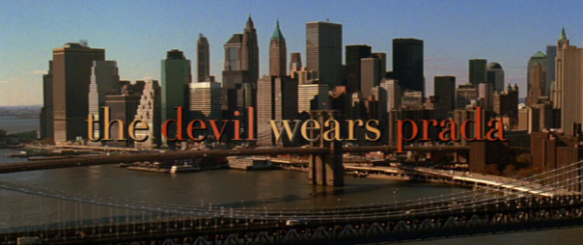
Long shot (LS) | A long shot shows the whole subject: a car on the road
Medium shot (MS) | A medium shot shows the human body from mid-shin or mid-thigh up and is often used to show interaction between two or more characters.
Medium close-up | A medium close-up shot (or MCU) is a shot that frames the subject from just above their head down to about midway on their tors
Close-up | A close-up shot is a type of camera shot size in film and television that adds emotion to a scene. It tightly frames an actor's face, making their reaction the main focus in the frame. The director of photography films a close-up with a long lens at a close range
Extreme close-up | An extreme close-up includes shots of a person’s face,
Two shot | A two shot is a type of shot in which the frame encompasses two people.
Over-the-shoulder shot | A camera angle that offers a medium close-up on one actor while showing part of another actor's shoulder.
Panning | A pan shot or panning shot is when you turn the camera on a fixed head.
Tracking | In cinematography, a tracking shot is any shot in which the camera physically moves sideways, forward, or backward through the scene.
Bird’s Eye View Shot | In filmmaking and video production, a bird's-eye shot refers to a shot looking directly down on the subject. The perspective is very foreshortened, making the subject appear short and squat.
Point of View Shot | A point of view shot is a short film scene that shows what a character is looking at.
Dolly shot | A dolly shot refers to the camera movement when a camera is mounted on a dolly. In a dolly shot, the camera moves towards, away from, or alongside your subject, which can be an actor, location setting, product, etc.

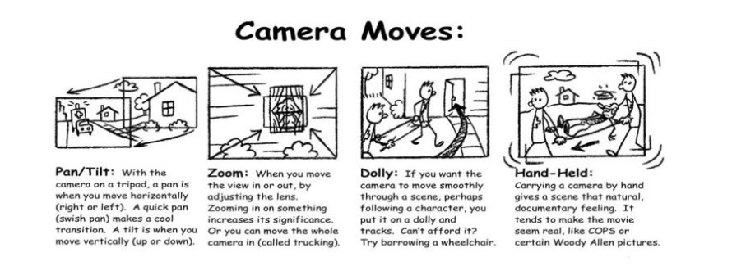
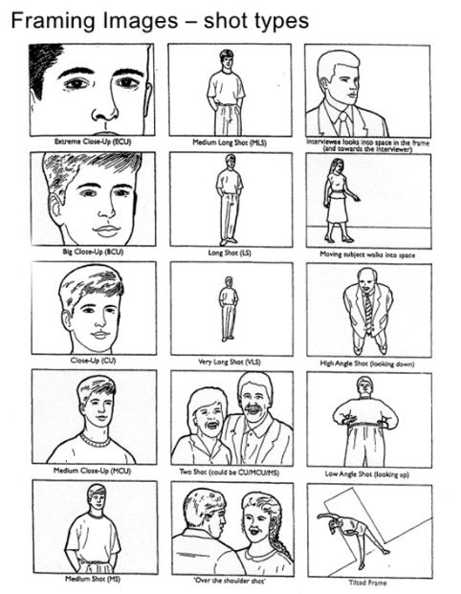

Verbal Techniques
 | Description: What does it look like? | Effect: Why is this shot used? | Visual Example:
Dialogue
Voice Over Narration
On screen text
Diegetic Sound
Non-diegetic sound
Music Score

Other Techniques (including editing)
 | Description: What does it look like? | Effect: Why is this shot used? | Visual Example:
Costume
Focus | Sharp Focus
 | Shallow Focus
Props
Mise-en-scene
Lighting | Natural lighting
 | Soft lighting
 | Blue light
 | Chiaroscuro lighting
 | Use of shadows
 | Warm yellow lighting
Cross Cutting
Symbolism

