Current Event Analysis #2
Are People being attacked by a Mysterious new Weapon?
Is ‘Havana Syndrome’ Real or in the Mind?
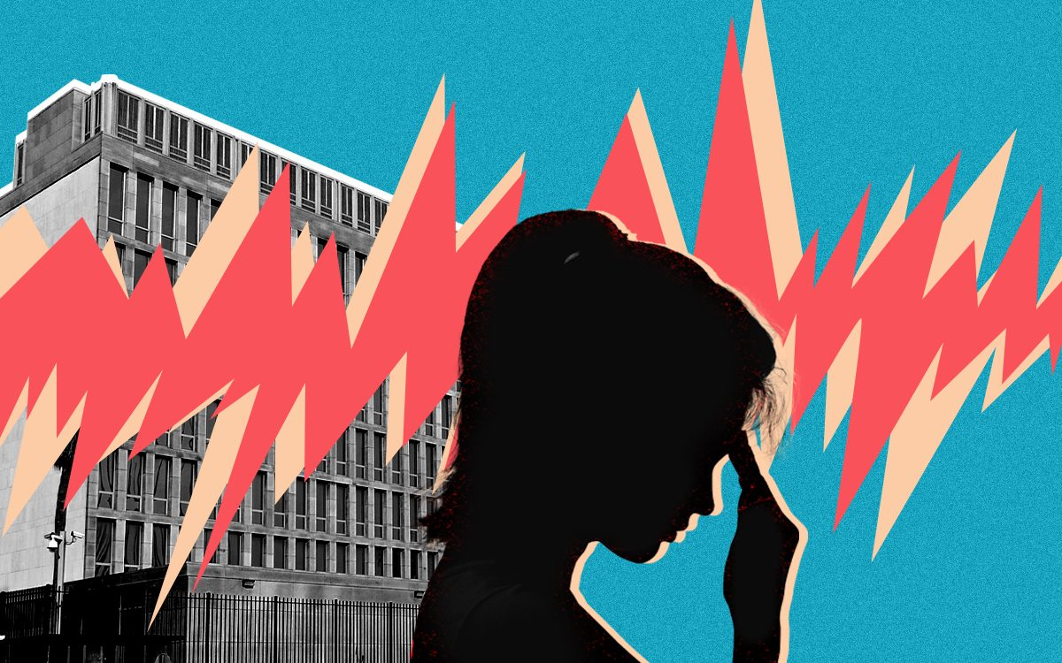
Over the past several years, dozens of American and Canadian officials have reported hearing strange sounds and feeling unwell. Some scientists believe that they are the victims of a secret weapon that causes brain damage. Because it was first reported in Havana, Cuba in 2016, it was given the name ‘Havana Syndrome.’
Task 1: Listen to the news report summarising the story:
https://www.youtube.com/watch?v=TbFRomflb2M&t=7s

Task 2: Read the article: ‘CIA Skeptical of ‘Havana Syndrome’ in Psychology Today Magazine, January 20, 2022’ at: https://www.psychologytoday.com/nz/blog/its-catching/202201/cia-skeptical-havana-syndrome

Create a series of key dot-points that make the case that ‘Havana Syndrome’ is an imaginary illness. We will work on this assignment on class together.

