Class Treaty
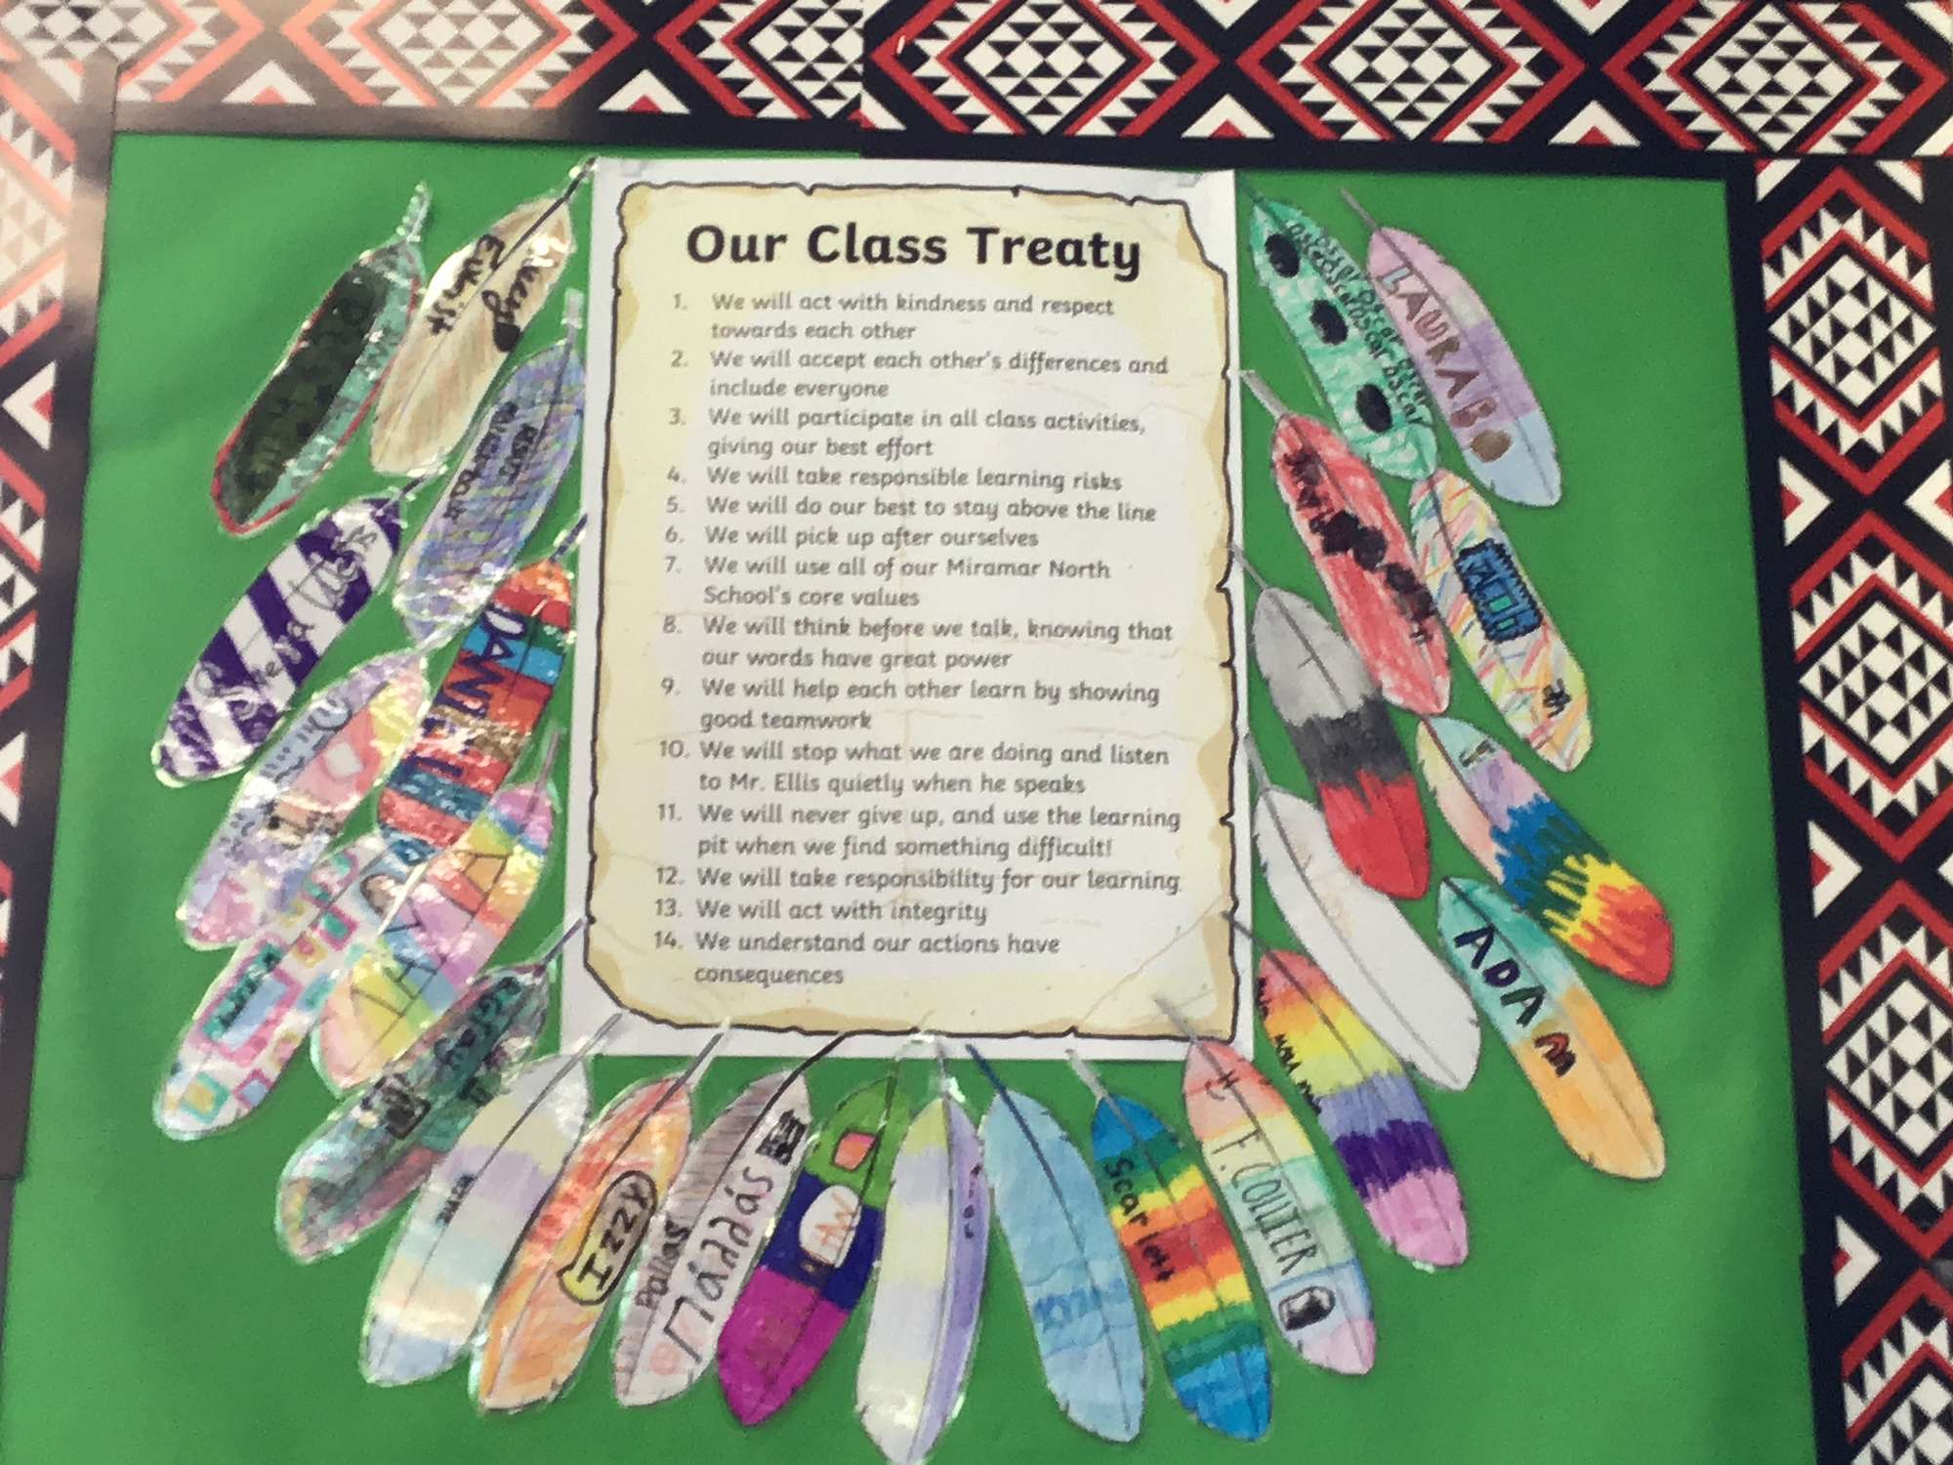
What are five values that you want the class to live by? By values, we mean words, ideas and beliefs that are important to you and guide the way you think and act. An example of a value would be respect, the golden rule of treating others how you want to be treated.

These values will be binding: meaning that we all agree to them and they are fixed, solid and unbreakable. The most popular/common ones will be placed together on a treaty for us to sign.
List Your Values
In the tables below, you will list out five values that you most agree with. The value itself is only 1 to 3 words, you will answer this in the pink box. You then need to explain in the box below with one sentence about why that value is important to you.
For example: Respect (pink box). I believe the class needs to be guided by respecting and working with our differences (white box).

You do not need to submit it when done, I will see what you have put down. I will do my best to translate the names of the values into their Māori wording, as we are also honouring Te Tiriti in our lives & our classroom by carrying out this activity. But if you know the name of the Māori value you want to write, please use it! We will be looking at some of these concepts later on.

