Democracy & Leadership in
New Zealand &
Around the World

Week 1: Lessons 1 to 3

Task 1: Open your Red Books to 2 blank pages. One the first page draw a line across the page about a third of the way down. Above the line write the Unit Title. Below the line write down the lesson heading (An introduction to Democracy) and today’s date.

Task 2: Why We Need Rules

We have many sets of rules:
  - School rules
  - Road rules
  - Sports rules

Rules are made for a reason.

As New Zealanders our Parliament makes rules that make it easier for us all to live together. We call these rules laws.

Task: Rules Exercise – Create the following grid in your books and list the different rules you have to follow in any given week:

Why we need Rules?

Watch the video clips –

India – importance of rules (crazy driving)
https://www.youtube.com/watch?v=pLUm3Q-7iZA

Ukraine Parliament (importance of rules)
https://www.youtube.com/watch?v=emKIIv2_cNI

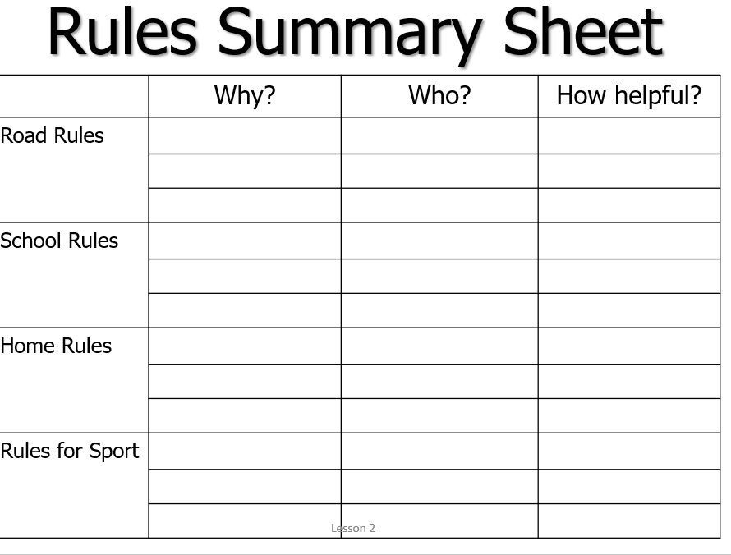
Week 1 Lesson 2:

Task 1: Write the following into your books:

What is a Government?

Government involves a group of people who are in charge, who have the authority to sets the rules for a society.

Governments –
- Make laws
- Keep order
- Protect people and property
- Make rules
- Enforce laws

Class Discussion: Did you know that your parents pay money to the government – it’s called taxes. So, what do our tax dollars pay for?

Task: Write down key dot-points about Democracy:

Different Types of Governments

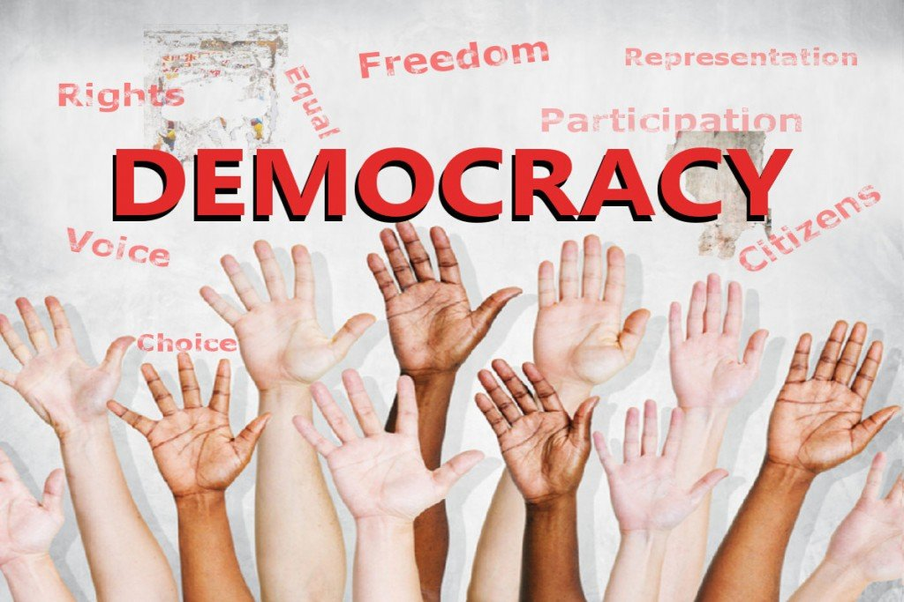

1. What is a Democracy?

- The government is elected by the people.
- Everyone who is eligible to vote has a chance to have their say over who runs the country.
- A democracy is determined either directly or through elected representatives.

Examples:
- New Zealand
- Australia
- United States
Capitalism

- Most democracies practice capitalism where people can own their own businesses and property. People can also buy services for private use, such as healthcare.

- But most capitalist governments also provide their own education, health and welfare services.

Watch the clip:

The Profit Motive: Going Places | Pro-Capitalism Propaganda Cartoon | 1948
https://www.youtube.com/watch?v=eFvOPpBVff0

Class Discussion: The pros and cons of capitalism

Students break up into small groups and discuss the benefits and drawbacks of Communism for 10-minutes.

Teacher to call on each group and write their key points on the board

Week 1 Lesson 2:

Write the following key information into your books in the form of dot-poinrs

Communism

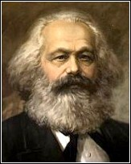
Karl Mark founder of Communism

- Communism - a government where people share work fairly and are paid equally (on paper)
- The word “Communism” comes from the Latin word “Communis” which means common or belonging to all.

- In a communist country, the government owns property such as businesses and farms.
- It provides its people's healthcare, education and welfare.
- Problems with Communism

- Lack of individuality
- Lack of choice
- Equal treatment for all, even if you work harder than all the rest (a doctor could make the same money as a farmer or janitor) – so where is the incentive to work hard and get ahead?

During the 1940s and 1950s, many people living in New Zealand and other Western countries like the United States, had a fear of Communists. The fear was that Communists were going to try and take over the world. Watch the short clip as an example. This was once showen on American TV:
https://www.youtube.com/watch?v=SkYl_AH-qyk

Now watch the short clip on an overview of Communist beliefs:
Video clip: What is Communism
https://www.youtube.com/watch?v=qElx_EyTTKA

Class Discussion: The pros and cons of Communism

Students break up into small groups and discuss the benefits and drawbacks of Communism for 10-minutes.

Teacher to call on each group and write their key points on the board.

Week 1 Lesson 3:

Write the following key information into your books in the form of dot-points:

Dictatorship

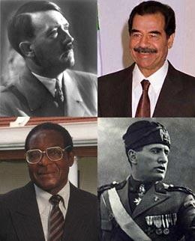

- A country ruled by a single leader – a dictator who tells everyone what to do and takes orders from no one.
- The leader has not been elected and may use force to keep control.
- In a military dictatorship, the army is in control.

Examples:
- Iraq under Saddam Hussein
- Germany under Adolf Hitler and Italy under Benito Mussolini.

Task: Watch the short clip on Saddam Hussein –
- https://www.youtube.com/watch?v=bm64E5R12s8

1. What qualities of a dictator did he have? List them in your books.

Task: Watch the clip on the rise of Hitler. What qualities of a dictator did he have? Again - list his qualities that made him effective – in your books.

- https://www.youtube.com/watch?v=opchjf3vzQk (from 21:12 sec to 32:14 sec.)
Monarchy

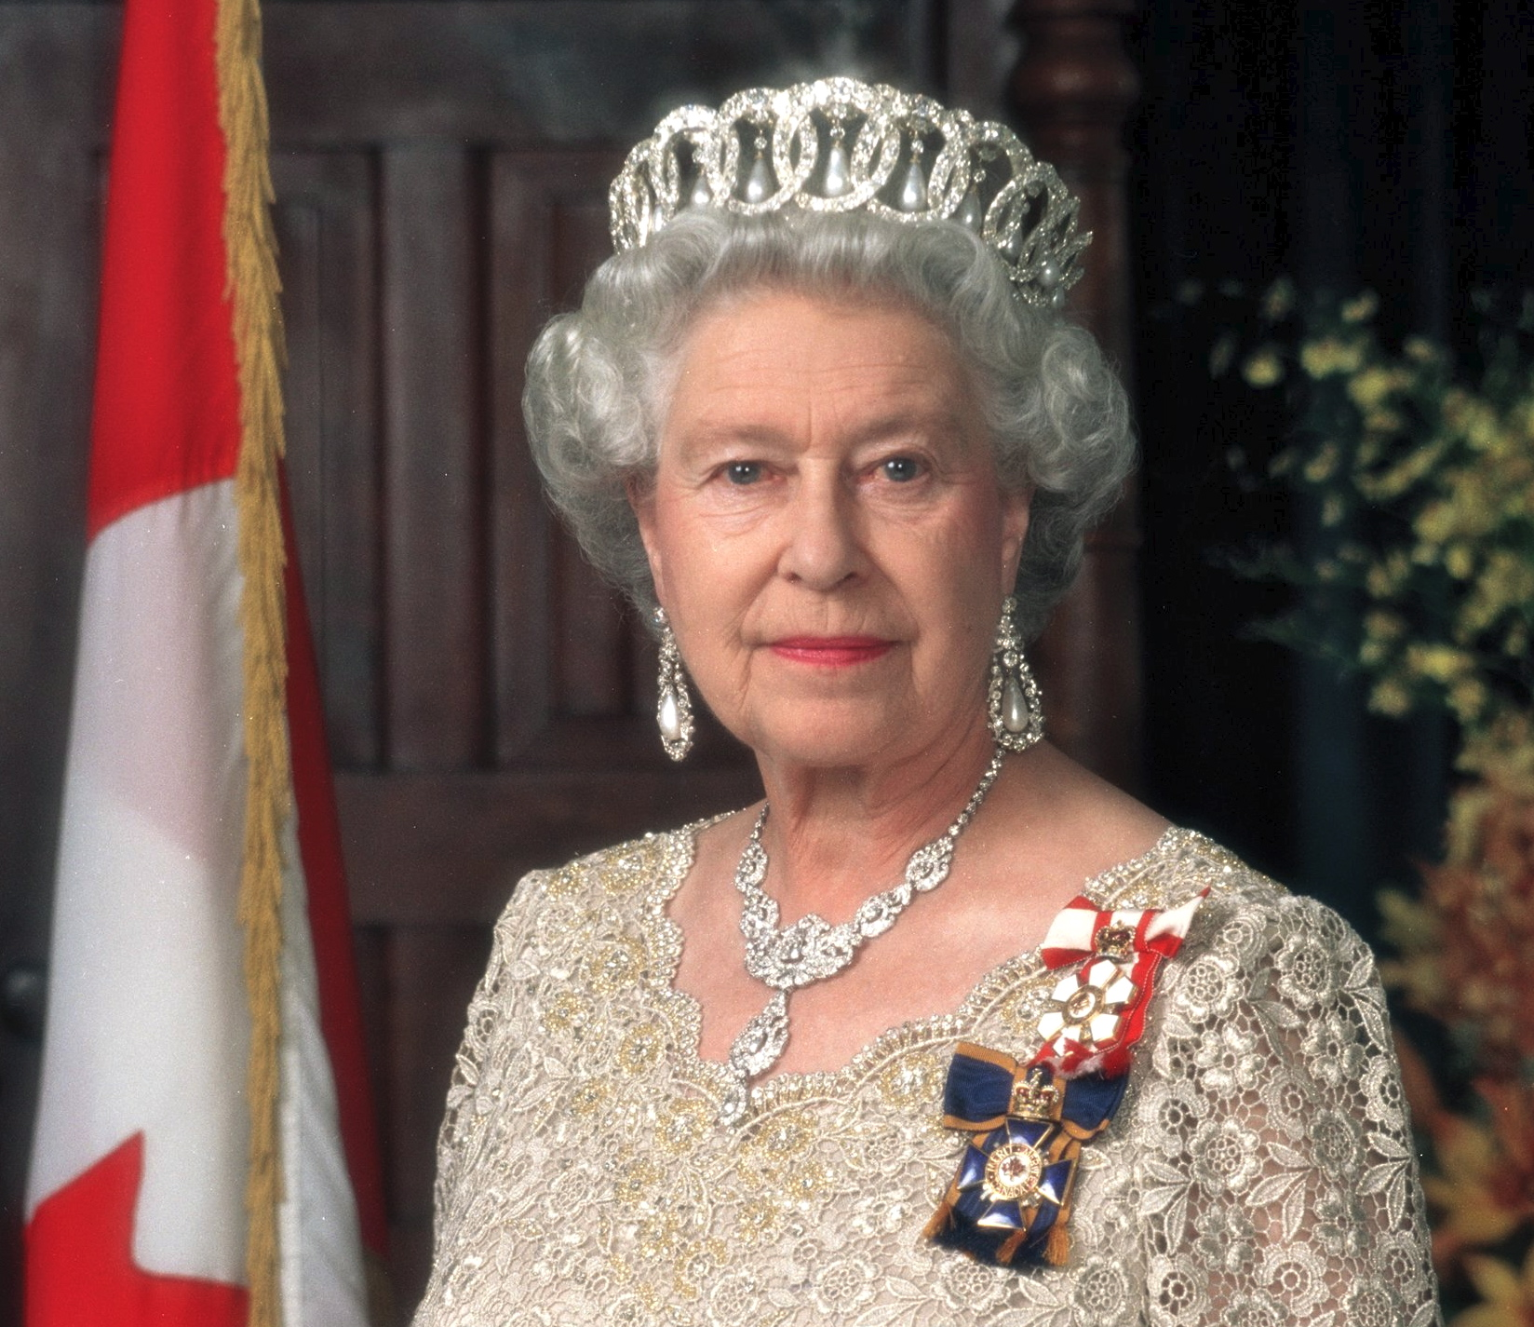
- A monarchy has a king, queen, emperor or empress.
- The ruling position can be passed on to the ruler’s heirs.
- In some traditional monarchies, the monarch has absolute power.
- But a constitutional monarchy, like the UK, also has a democratic government that limits the monarch's control.

Examples:

- United Kingdom (Constitutional Monarchy)
- Saudia Arabia (Absolute Monarchy)

Watch what life is like in Saudi Arabia:
https://www.youtube.com/watch?v=tg7lRBjuECw

Make a list of the restrictions in Saudia Arabia for women that would be allowed in New Zealand. List at least 5 examples:

1.

2.

3.

4.

5.

Week 2: Lesson 1

Extreme Dictatorship: North Korea

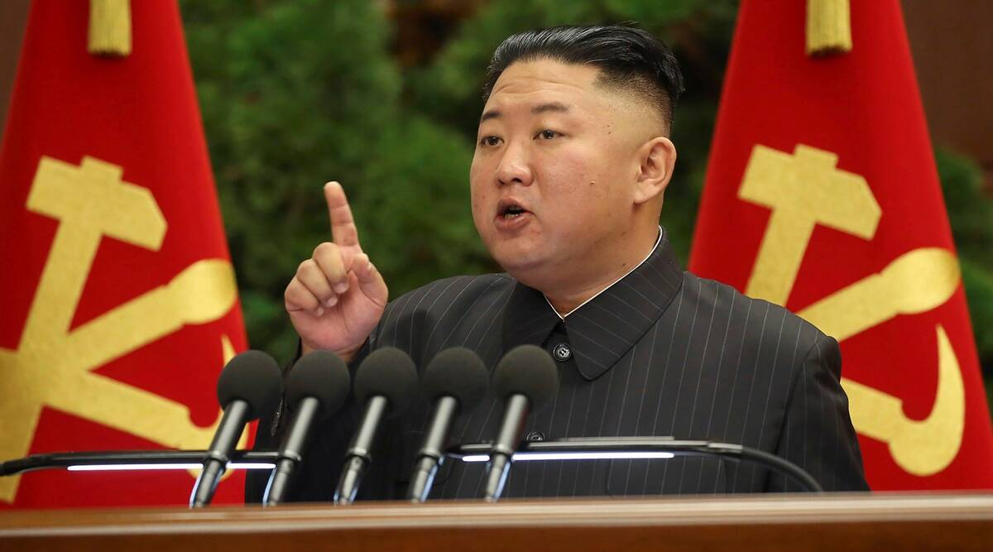

What are the key features of the North Korean Government? Reads the article below from the BBC. Answer the following questions:

https://www.bbc.com/news/world-asia-pacific-15256929

1. North Korea is a totalitarian state. What dies this mean?

2. What year was the country founded?

3. How many people live in North Korea and how long can they expect to live?

4. List 3 facts about the media in North Korea.

a.

b.

c.

5. What is the name of the current leader?

Because the leader of North Korea has total power, when the father of the current leader died several years ago – people were overcome by emotion because they had grown up with his images everywhere. He was considered almost super-human. Watch the reaction below to the death of Kin Jong-Un’s father. If a person didn’t cry, they faced possible arrest!

- Major problem – when the leader dies – there is a vacuum –
- https://www.youtube.com/watch?v=Ht6nWLEfdF8 (weeping)

- Absolute government control
https://www.youtube.com/watch?v=JTKopeQhiDo

Watch the clip on life in North Korea:
https://www.youtube.com/watch?v=-h_h0Tp6vZk (8:235 Seconds)

10-minute Write – Short paragraph

At the end of the clip the man said: ‘The next morning we flew out…leaving behind a country we weren’t sure we had actually ever been to.”
Explain what is meant by this.

Week 2: Lesson 2

What makes up a Democracy?

- Can you identify the characteristics of democracies and non-democracies by completing this checklist?

Task: Break up into small groups and write 1 to 14 on a sheet of paper. Answer the following 14 questions.

I will then call on different groups to answer the questions.

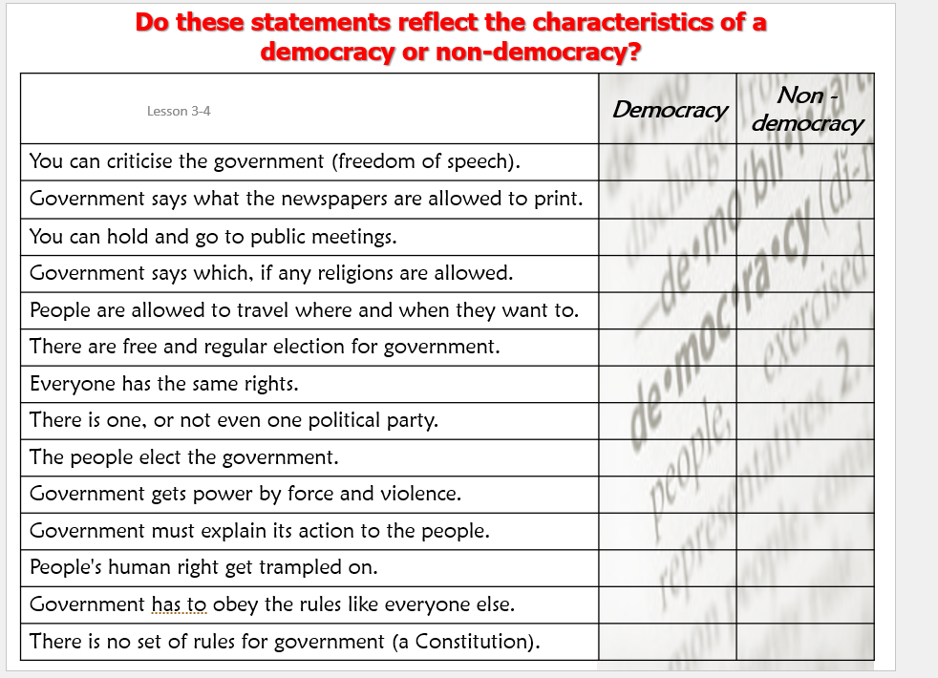

Task 2: Draw the following bubble map into your books, then fill it in based on the information in Task 3.

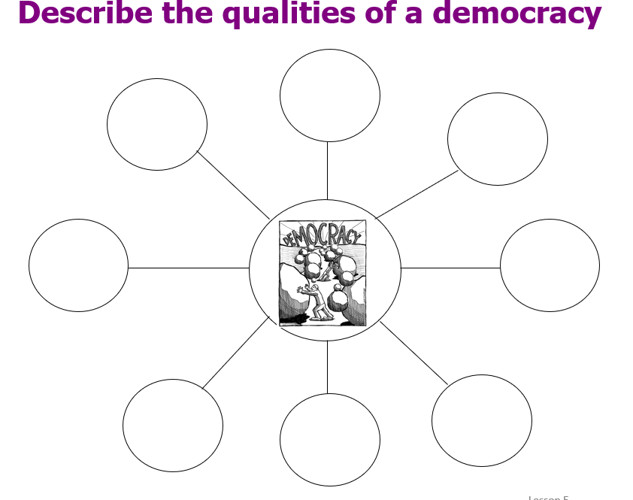

Task 3: Fill in the bubble map using the information below:

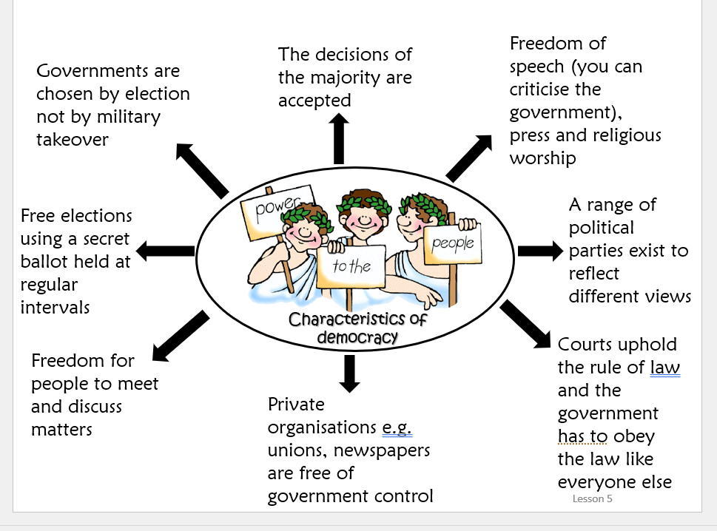

Week 2 Lesson 3:

Current Event Analysis

An Update on the ‘Global Warming Debate’

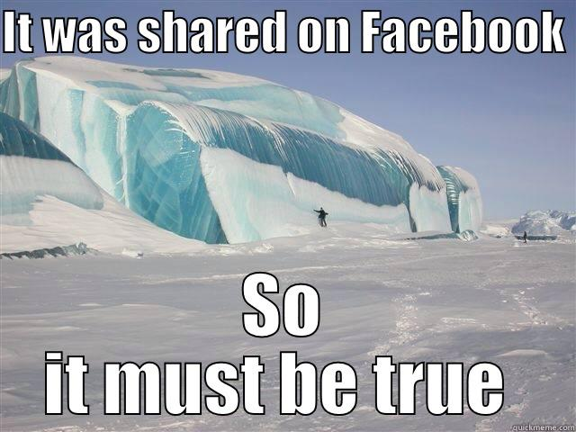

During Term 2 we looked at major weather events in New Zealand. We also looked at global warming and saw the documentary ‘An Inconvenient Truth’ narrated by Al Gore. At that time, I noted that the evidence for global warming was indisputable – the only question was – what was causing it and that most scientists believed it was humans pumping C0² into the atmosphere causing the Greenhouse Effect.

However, it should be made clear that there is now a consensus among the scientific community that global warming is real and is considered to be a fact. Because this is considered by many to be the greatest threat to have ever faced humanity – it is important that there is no misunderstanding on this issue. The evidence for global warming being caused by human beings is clear and overwhelming.

Go to the website from NOAA the National Oceanic and Atmospheric Administration. What NASA is to space, NOAA is to the Atmosphere. Read the article and create a series of key dot-points on climate change:

https://www.climate.gov/news-features/climate-qa/what-evidence-exists-earth-warming-and-humans-are-main-cause

Democracy & the Freedom of Speech
Debate in New Zealand

Week 3: Lessons 1 to 3

Why We Do Not Have Freedom of Speech in New Zealand
(& that’s a good thing!)

“Injustice anywhere is a threat to justice everywhere. We are caught in an inescapable network of mutuality, tied to a single garment of destiny.”
–Martin Luther King, Jr.

Task 1: Write down the lesson heading and today’s date.

Class Discussion: Do we have freedom of speech in New Zealand? America?

Hint: Can you walk into a theater and yell ‘Fire!’ Can you threaten to kill someone or use ethnic slurs or use words like the ‘N’ word to refer to people?

In 2018, the former leader of the Opposition in New Zealand, Don Brash, who some Kiwis feel is anti-Maori, was invited to a debate at Auckland University. Watch what happened:

https://www.youtube.com/watch?v=WdsstP-xSyc (1:20 sec.)

Reading: We will read the following statement as a class:

New Zealand, like other Western countries, has some freedom of speech – but only to a certain point. There are certain limits to speech. You just cannot go around saying whatever you think. If you don’t believe me – walk up to the principal or a police officer and start shouting obscenities or threatening to harm them and you would find yourself arrested – and in the case of the principal – suspended and possibly expelled. The reality is – we cannot just go around saying anything we like. It would be chaos if we could. Society must have rules and order.

You cannot yell ‘Fire!’ in a crowded theatre or target people because of their ‘race,’ sexual preference, weight, ethnic group or other features. Such actions would qualify as harassment and some cases, a hate crime. For instance, it is inappropriate to single people out because of where they were born, ethnic background, skin color, religious beliefs, sexual orientation, to name a few examples. To physically or verbally attack someone solely because they identified as Jewish or Pacifika or European, would be considered harassment and a crime.

It is important to remember that race is a myth. It is an imaginary concept. There is no such thing as a race. All human beings belong to a single species called Homo Sapiens. In this sense, there is but one race, the human race. The DNA (our genetic code) of every human being on the planet is over 99% identical. Unfortunately, while race may be a myth, it is a social reality. That is to say, if people believe that something is real, it is real to them, even though there is no scientific evidence to support it. Instead of the term ‘race,’ we should use ‘ethnic group’ – people who share a common heritage or cultural background.

Class Discussion: Should people have the right to express their views publicly without being shouted down so they are unable to speak?

This issue was recently in the news in New Zealand when a person labeled as an anti-trans activist tried to speak but was shouted down and stuck by objects, forcing her speeches to be canceled.

The issue of freedom of speech – even in a democratic country, is a tricky one. For instance, during the 1950s in the United States, some libraries banned the book ‘Rabbit’s Wedding.’ They saw it as encouraging black and white people having relationships and getting married.

Task 2: We will watch the video as a class:

https://www.youtube.com/watch?v=LkIADVhvnoM (6:01 sec.)

Answer the following question in your Red Book:

What do you think would happen if someone tried to ban this same book today in America or New Zealand? Explain your answer.

Lessons 2 and 3:

The Great Freedom of Speech Debate at Auckland University

In April 2017, a History professor at Auckland University (Paul Moon) expressed his concerns about freedom of speech in New Zealand. He said that many people and groups with unpopular views are not being allowed to speak on University campuses. He was specifically referring to the forced closure, by Auckland University, of a European student club (celebrating European heritage) and threats made to its members. Many students felt that having such a group on campus, appeared to promote white supremacy, and said they felt nervous and intimidated about it.

Task:

Read the two articles:
Reading A: Maude, Simon (2017). “’We're not Racist’ claims new European Student Association.” March 6, accessed at:
http://www.stuff.co.nz/national/education/90073114/were-not-racist-claims-new-european-student-association

Reading B: Loren, Anna (2017). “Controversial European students group folds after ‘constant threats to safety.’”
https://www.stuff.co.nz/national/90007049/controversial-european-students-group-folds-after-constant-threats-to-safety

Write two paragraphs.
Paragraph #1: Explain why the European student club was not welcome on the campus of Auckland University. For instance, what actions had they taken that made people worried that they might be promoting white supremacy? How did this make some students feel?

Possible starter topic sentence:
In 2017, the formation of a European student club to celebrate European heritage resulted in much concern over fears that it was supporting racism. …..

Paragraph #2: A nearly identical group (with the same name) applied to become a club at AUT (Auckland University of Technology) and were allowed to exist – and seem to have been more accepted. What actions did the AUT club take to make students feel more at ease with them, and to allay fears that they are racist.

Possible starter topic sentence:
When a separate group was formed at Auckland University of Technology and also claimed to be supporting European heritage, the University allowed them to do so based on actions taken by the group.
…..

Paragraph #3: Where do you stand on this issue? Write a forceful summary of your opinion on this debate.

Possible starter topic sentence:

The issue of being able to exercise freedom of speech at New Zealand universities is important and I side with the actions taken by (AUT or Auckland University – pick one)/

References:

Anonymous (2017). “High-profile Kiwis: Free speech under threat in NZ Universities.” New Zealand Herald, April 4.

Loren, Anna (2017). “Controversial European students group folds after ‘constant threats to safety.’” March 3, accessed at: http://www.stuff.co.nz/national/90007049/controversial -european-students-group-folds-after-constant-threats-to-safety.

Maude, Simon (2017). ‘We’re not Racist’ claims new European Student Association.” March 6, accessed at: http://www.stuff.co.nz/national/education/90073114/were-not-racist-claims-new-european-student-association.

The Attributes of Effective Leaders

Week 4: Lessons 1 to 3

Why We Do Not Have Freedom of Speech in New Zealand
(& that’s a good thing!)

Success Criteria: To be able to identify and recount the attributes of an effective leader with a specific emphasis on their speaking style. They will also be able to recount key steps in how a bill becomes a law and how governments are formed (either with an outright majority or a collation of smaller parties).

Task 1: Write down the lesson heading and today’s date.

Class Discussion: List attributes of an effective leader

Task 2:
Today we are going to look at 3 different types of speakers:

Motivational – Spiritual – Inspirational

1. Leo Buscaglia (Spiritual)
https://www.youtube.com/watch?v=ALPEQAP7c8o

2. Martin Luther King, Jr. (Inspirational)
https://www.youtube.com/watch?v=Oehry1JC9Rk

3. Les Brown (Motivational)
https://www.youtube.com/watch?v=g-jwWYX7Jlo

4. Charlie Chaplin (The Great Dictator)
https://www.youtube.com/watch?v=J7GY1Xg6X20

5. Inky Johnson
https://www.youtube.com/watch?v=NyY9D4nflSw

In your Red Books write the 5 headings below followed by 5 spaces underneath each section. In those spaces you will write down the attributes of each speaker – what makes their speeches so powerful?

1. Leo Buscaglia (Spiritual)
2. Martin Luther King, Jr. (Inspirational)
3. Les Brown (Motivational)
4. Charlie Chaplin (The Great Dictator)
5. Inky Johnson

Week 4: Lesson 2:

How a Government Forms in New Zealand

Task: Today we will learn about how governments form.

Majority Government
After the election, the party with the most seats in parliament forms the government which will run and control the country.

Coalition
Because there are 121 seats in parliament and many parties, often a single political party will not get an outright majority (61+ seats). When this happens, two or more parties must team up, or form a coalition to win the majority.
When this happens, the bigger party in the coalition is the main party which runs the government, but they have to listen to, and give responsibilities to their partner political party.
When the winner is decided (either a single party or group of parties) because they have over half the seats in parliament (61+), they are then called the government. The smaller side, or the losers, then form the opposition.

How an idea becomes an Act of Parliament

You will be given a paper copy of the following handout to fill in and glue into your books:

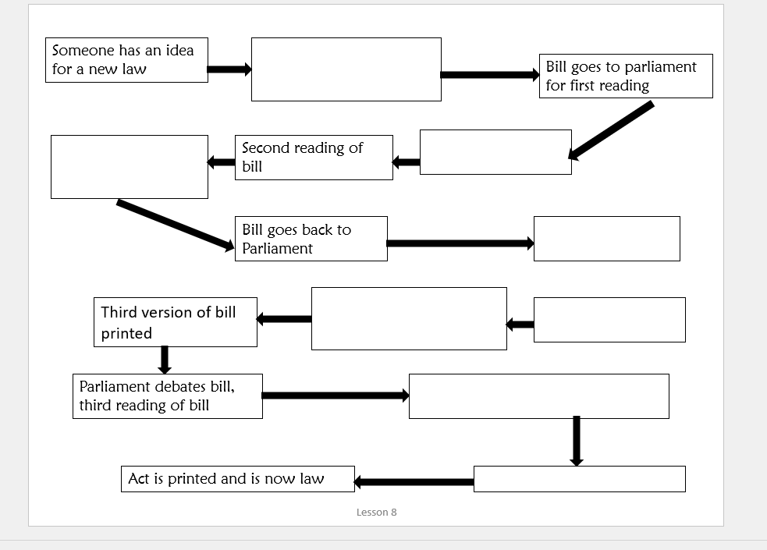

Answers:

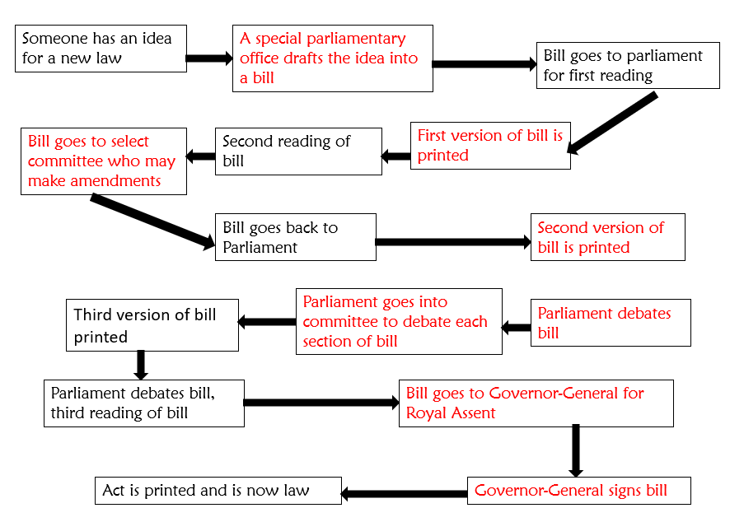

Handout #2: Fill in using the answers below. Students will break up into small groups and I will call on them for the answers. Possible answers appear below:
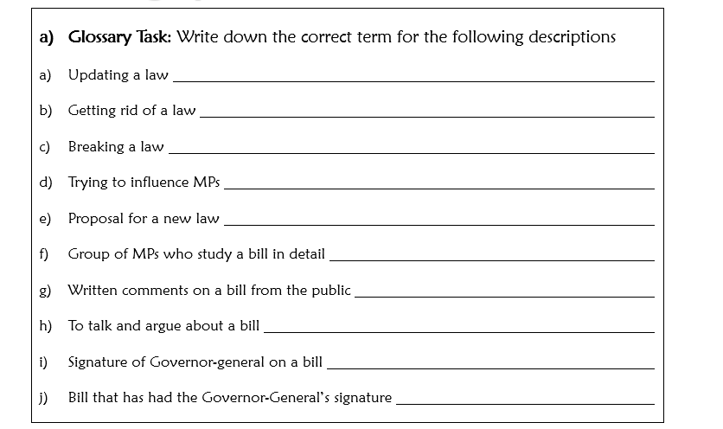

Possible Answers:

To talk and argue about a bill debate
Getting rid of a law Repeal
Signature of Governor-general on a bill Royal Assent
Written comments on a bill from the public submissions
Breaking a law criminal offence
Trying to influence MPs lobby
Proposal for a new law Bill
Group of MPs who study a bill in detail select committee
Bill that has had the Governor-General’s signature Act or Statute

Week 4: Lesson 3
The Upcoming Election in New Zealand
Later this year there will be an election in New Zealand. These are the top six political parties who want to run the government and decide where our tax dollars should be spent:
- New Zealand Labour Party (Labour): The Labour Party has historically been one of the major parties in New Zealand and is currently in power.
- New Zealand National Party (National): The National Party is the main opposition party in New Zealand and has also held the government in the past.
- Green Party of Aotearoa New Zealand (Greens): The Green Party is known for its focus on environmental and social justice issues.
- ACT New Zealand (ACT): ACT is a right-leaning political party that advocates for free-market policies and individual freedoms.
- Māori Party: The Māori Party represents the interests of the indigenous Māori population in New Zealand and focuses on Māori rights, culture, and issues.
- New Zealand First Party (NZ First): NZ First is a party that was founded by Winston Peters and has held a significant number of seats in Parliament in the past.

Each of their platforms (their plans for the country) have been paid out on their websites below. The class will be split up into groups of 5. In each group, one member will research one issue that you will become an expert on. You will prepare a summary of the issue using the following format:

Name of Problem:
Party Plan to address it
How much will it cost:
How is it an improvement of the status quo (the way it is at present)

Create a poster using this information to convince people that your idea is the best for the country and will solve the problem

1. The Labour Party Platform
https://www.labour.org.nz/our-plan

2. The National Party Platform
https://www.national.org.nz/plan

3. The ACT Party Platform
https://www.act.org.nz/

4. The Green Party Platform
https://www.act.org.nz/

5. The Maori Party
https://www.maoriparty.org.nz/

6. The New Zealand First Party
https://www.nzfirst.nz/

Week 5 Lessons 1-3
Students will research their issues

