Week 9:
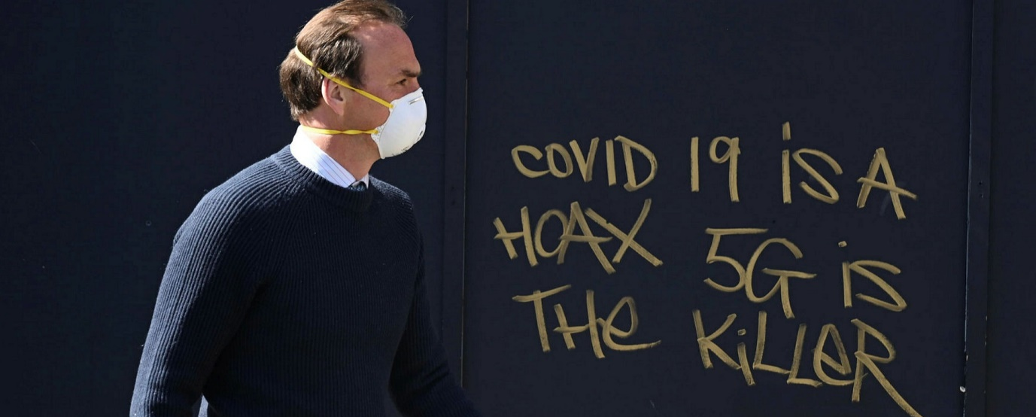
Success Criteria: We only meet twice due to the Holistic Report Day on Tuesday. This week students will be become familiar with conspiracy theories and by the end of the week will be able to recount the definition of what constitutes a conspiracy theory and historical examples within a New Zealand context.
Lesson 2: Current Event Analysis
Why Conspiracy Theories Thrive
during times of Crises

Class Discussion: Some people believe that 5G Towers cause cancer and help spread Covid. There is no evidence to support these claim – so why do some people believe them?

Task 1: Watch the video clip on the fear of 5G towers that has recently swept across New Zealand.
Listen to the Radio New Zealand interview on Conspiracy Theories at:
https://www.rnz.co.nz/programmes/the-detail/story/2018747089/why-conspiracy-theories-thrive-in-times-of-crisis
Next, write out and answer the questions below:
Questions
Task 2: Read the article in the Otago Daily Times, ‘Why Conspiracy Theories Thrive in times of Crisis?’ Answer the following questions:
1. How many attacks have there been on New Zealand 5G cell towers?
2. How does damaging 5G towers put peoples’ lives in danger?
3. When the article was written, how many Covid0related conspiracy theories were there in New Zealand?
4. How far back can conspiracy theories be traced?
5. Name a conspiracy theory from the 1920s.
6. What was the conspiracy theory about ice cubes and talking on the telephone?
7. What does Robert Bartholomew think are key factors that generate conspiracy theories?
8. Look up the word ‘vetted.’ What does he mean about ‘unvetted news?’
9. How does he think that Donal Trump has influenced what some people believe?
10. What does he say is the problem with getting our news from places like Facbook and Twitter.
11. Go online and look up the definition of a ‘Deep Fake.’ Write it down.

2. Read the article, Why conspiracy theories thrive in times of crisis

Lesson 3: Red Book Check for Term 3
Students will spend Lesson 3 ensuring that their books are up-to-date as they will be assessed class 1 of Week 10.

