Week 2 Lesson 1: Gender Inequality & Current Events

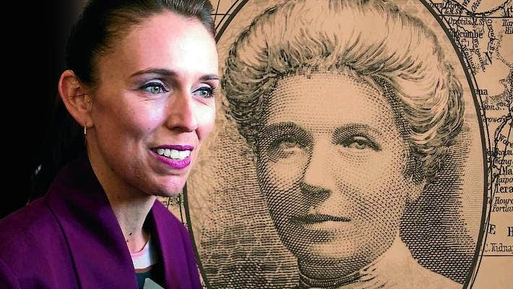

Success Criteria:

Students will be able to recount by the end of the week, the definitions of key types of gender inequality in addition to key events in the history of gender inequality in New Zealand.

Task: Write down the definition of gender and age inequality below into your books.

Types of Inequality

1. Gender Inequality
The unequal treatment of someone based on their gender.

2. Age Inequality (known as ‘Agism)
The unequal treatment of someone based on their age. It could be because they are considered too young or too old.

3. Ethnic and Cultural Inequality:
Describes discrimination based on ethnic or cultural background, including unequal treatment, limited opportunities, and social exclusion.

Examples: Māori in New Zealand, Aborigines in Australia, and Africa-Americans in the United States have faced widespread discrimination, and while it has improved, it still occurs.

Task:
The Case of the Māori Newsreader

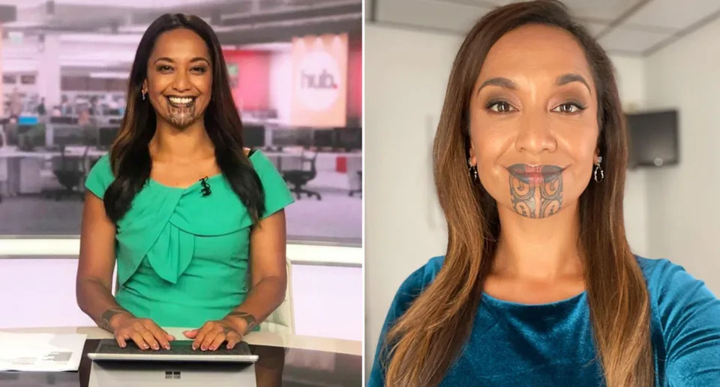
Look at the Reading below and complete the following exercise:
Bass, Carly (2022). “NZ newsreader hits back at viewer who called her Māori tattoo 'offensive.’” Yahoo News Australia, August 26, 2022.

Task: Letter Exercise
Write a letter to a friend who lives in Europe. Imagine that she heard that New Zealand TV stations were now letting people with facial tattoos read the news. She thinks it’s a bad idea because she says it promotes gangs and isn’t a good look. Write back to her explaining the significance of the moko to Māori and why it should be accepted. What key points would you make?

Reading:
NZ newsreader hits back at viewer who called her Māori tattoo 'offensive
A news reader from New Zealand has defended her traditional face tattoo after a disgruntled viewer called the Māori marking "offensive" and "aggressive," she revealed.
Oriini Kaipara, a journalist and presenter for Newshub, became the first woman to anchor on primetime TV with the traditional marking, called a moko kauae, but one viewer doesn't approve.
As a proud and passionate advocate for her Māori culture and language, Kaipara took to Instagram to hit out at the man who continued to complain about her chin tattoo to the Newshub news team.
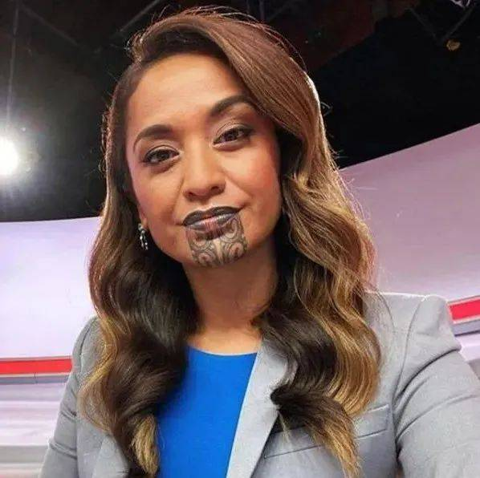
Journalist Oriini Kaipara was the first woman on prime time TV in New Zealand to wear the traditional Māori chin tattoo. Source: Instagram/Oriini Kaipara

"We continue to object strongly to you using a Māori newsreader with a moku (sic) which is offensive and aggressive looking. A bad look," he wrote in an email which Kaipara shared on Instagram this week.
"She also bursts into the Māori language which we do not understand," he continued, before requesting that she "stop it now".
The man addressed the email to the entire newsroom and not her directly, Kaipara revealed in a series of Instagram stories which have now expired. He also spelled moko wrong which she rightly pointed out.
The journalist described the viewer, known only as David, as the "gift that keeps giving" in screenshots shared by media on Friday.
She said she'd normally ignore such comments but "today I had enough."
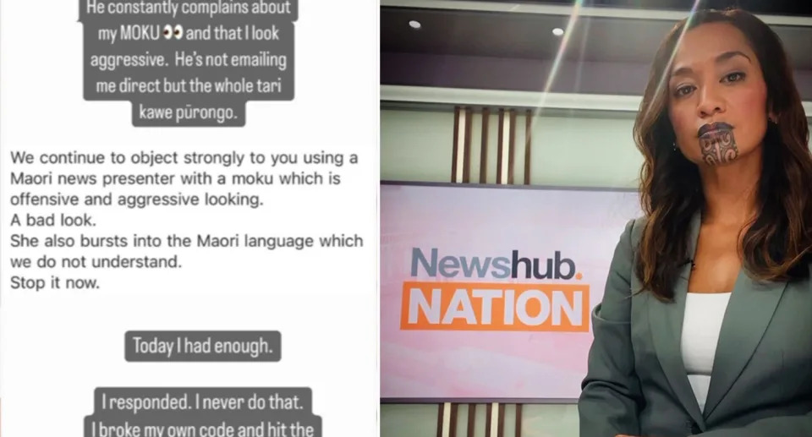
The journalist shared the man's complaint on her Instagram.

Journalist defends indigenous markings in scathing email
"He constantly complains about my MOKU and that I look aggressive," she wrote, emphasising the incorrect spelling of her cultural tattoo.
Kaipara shared her email response to David where she said she found his complaints "difficult" to take seriously "given there is no breach of broadcast standards".
"If I may, I’d like to correct you on one thing — it is moko not moku," she hit out.
"A simple, helpful pronunciation guide of ‘Maw-Caw’ will help you articulate the word correctly."
Week 2 - Current Event Analysis Week
Lesson #2 - Advanced

Food & Culture

Meet the Island Where People
Live the Longest in the World

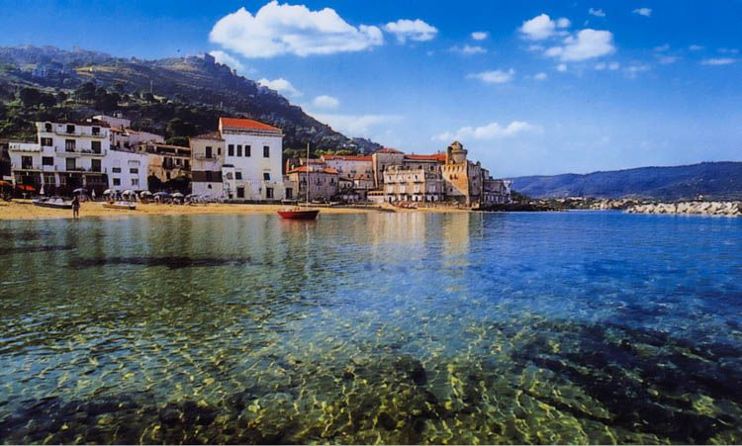

Success Criteria
Students will learn about the village in the world with the longest life expectancy and will be able to recount at the end of the lesson what factors contribute to their long lives.

Why are the people in the village of Acciaroli living well above Italy's national average? And why does it have one of the world's highest concentrations of people over 100 years old? Seth Doane reports on what scientists discovered.

Task 1: Watch the video clip, “Does an Italian village hold secrets to a long life?” at: https://www.youtube.com/watch?v=mlnpk5zNH9E (3:04 sec.)

Task 2: Watch the clip, “Life in the Blue Zone Diet” at: https://www.youtube.com/watch?v=_pg5IV5ehX8&t=11s (5:13 sec.)

Task 3: Create a poster that highlights key factors in parts of the world where people live the longest. Do it under the following headings:

Foods to Eat

Foods to Avoid

Lifestyle Factors (for example, getting enough sleep, exercise, etc.)

Current Event Lesson #2

Food & Culture - Basic

Meet the Island Where People
Live the Longest in the World

Success Criteria
Students will learn about the village in the world with the longest life expectancy and will be able to recount at the end of the lesson what factors contribute to their long lives.

Why are the people in the village of Acciaroli living well above Italy's national average? And why does it have one of the world's highest concentrations of people over 100 years old? Seth Doane reports on what scientists discovered.

Task 1: Watch the video clip, “Does an Italian village hold secrets to a long life?” at: https://www.youtube.com/watch?v=mlnpk5zNH9E (3:04 sec.)

Task: Watch the video, then go back and watch it again, but this time stopping and starting it while you write down key points about what factors have been linked to people in the village living such long lives.

