Mr Bartholomew Week of May 15 to 21, 2023
Global Studies Year 9

Kiwi Inventions & Innovators
Week 4 Lesson 1

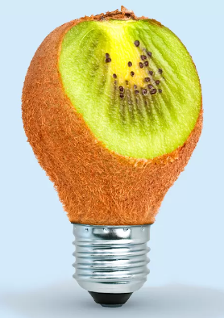

Success Criteria: Students will become familiar basic terms on the topic of innovation and invention as it relates to New Zealand and will be able to recount key definitions and people who were considered exceptional Kiwi innovators.

Week 4 Lesson 1:

Task 1: Open your Red Books to two blank pages and at the top of the 1st page write in large letters the Unit Title – “Kiwi Inventions & Innovators.”

Then draw a line underneath and write the following definition and examples into your book:

Innovation: The process of creating something new – it could be an idea, a device, or a product.

Examples:
Product = a new type of cheese
Device = a machine that helps cool the planet by reducing greenhouse gasses
Idea = coming up with a new dessert such as pavlova
Class Discussion: How many ideas or inventions can people name that came from Kiwis?

Watch the video clip:

“New Zealand Inventions that Changed the World” at:

https://www.youtube.com/watch?v=891gpAqf6Dg

Now read the short article on famous Kiwi inventions at –
https://zorb.com/2018/05/29/ten-quirky-kiwi-inventions-like-our-ogo-ball/

Task: Based on the inventions listed in the video, create a poster using one or two pages in your Red Books. It is designed to show how Kiwis are creative people who are famous for their innovations.

Week 4 Lesson 2:

Meet Sean Simpson:

The Kiwi with a Revolutionary Idea to Save the Planet

Watch the video clip: https://www.youtube.com/watch?v=hgw7zdIUvHM

and answer the questions below. STOP the clip at the 10-minute mark.

1. What is the idea Sean Simpson has come up with to help save the planet? (2:30 sec.)

2. Sean’s new technology has 3 big wins for the planet which are listed below. For each one, write a sentence or two describing how it helps the earth? The first answer has already been completed as an example (4:00 sec.).

a. Natural Resources: One win for the planet is that it avoids the need to make ethanol from plants like corn so the corn can be used for eating by people and animals.

b. Factory Pollution

c. Ethanol

3. While ethanol is already being blended with petrol, this is the first time it has been created from pollution and rubbish. Name 3 countries where this technology is being used.

a. b. c.

4. While Sean’s company is valued at over a billion dollars, how does he travel to work in the morning? (8:20 sec.)

5. Sean talks about New Zealand being a great place to start a new business because of “the number 8 wire mentality.”* Read the article on No. 8 wire below and write a summary of that mentality in your own words:

*Number 8 Wire: https://www.helen.co.nz/digital-prints/kiwi-slang-number-8-wire/

New Zealand is famous for bungy jumping, which is a good example of how one person can build on the idea of others. Read the article on New Zealand’s first bungy jumping business. While bungy did not start in New Zealand – when some Kiwis saw it – they decided to tun it into a business.

“A.J. Hackett and the history of bungee jumping.”
https://www.talk-business.co.uk/2016/09/22/aj-hackett-history-bungee-jumping/

1. On what small Pacific island did bungy jumping originate from? Hint – it wasn’t New Zealand.

2. The bungy jumpers on this island referred to it by the name of _____-_____ing.

Week 4 Lesson 3

Current Event:

How Bungy Jumping Impacts on the Kiwi Economy

*domestic refers to activities that are done by Kiwi citizens within the country (as opposed to foreigners coming here to visit). Write this definition into your Red Books

Task: Read the article below: “The fall and rise of New Zealand bungy as AJ Hackett pivots to domestic tourists” by Thomas Bywater, New Zealand Herald, June 26, 2020.
1) Create a series of key dot-points in your own words.
2) This article was written during the Covid lockdowns. How did this event affect the bungy jumping business in New Zealand?
3) In what ways can bungy companies be creative and attract more domestic customers?
4) How could the Government help Kiwi companies to get more customers?
*Use the Number 8 mentality to try to come up with interesting ideas.
Bungy is an activity that has been exported as a great Kiwi pastime. Up there with Rugby Union and dagging sheep, jumping is a ritual that has helped New Zealand find a niche in international tourism.
However, like the oval ball and manhandling livestock, it's something that fewer Kiwis can relate to than overseas guests might assume. Very few New Zealanders have done a jump.
AJ Hackett - the pioneers of bungy as both a sport and a commercial tourism attraction - recently revealed that just two out of 10 jumpers across their business are from New Zealand. At the Kawarau Gorge, AJ Hackett's premiere attraction, 83 per cent of paying visitors are from overseas. At least they were until this year, when the Covid-19 pandemic abruptly stopped the movement of international tourists.
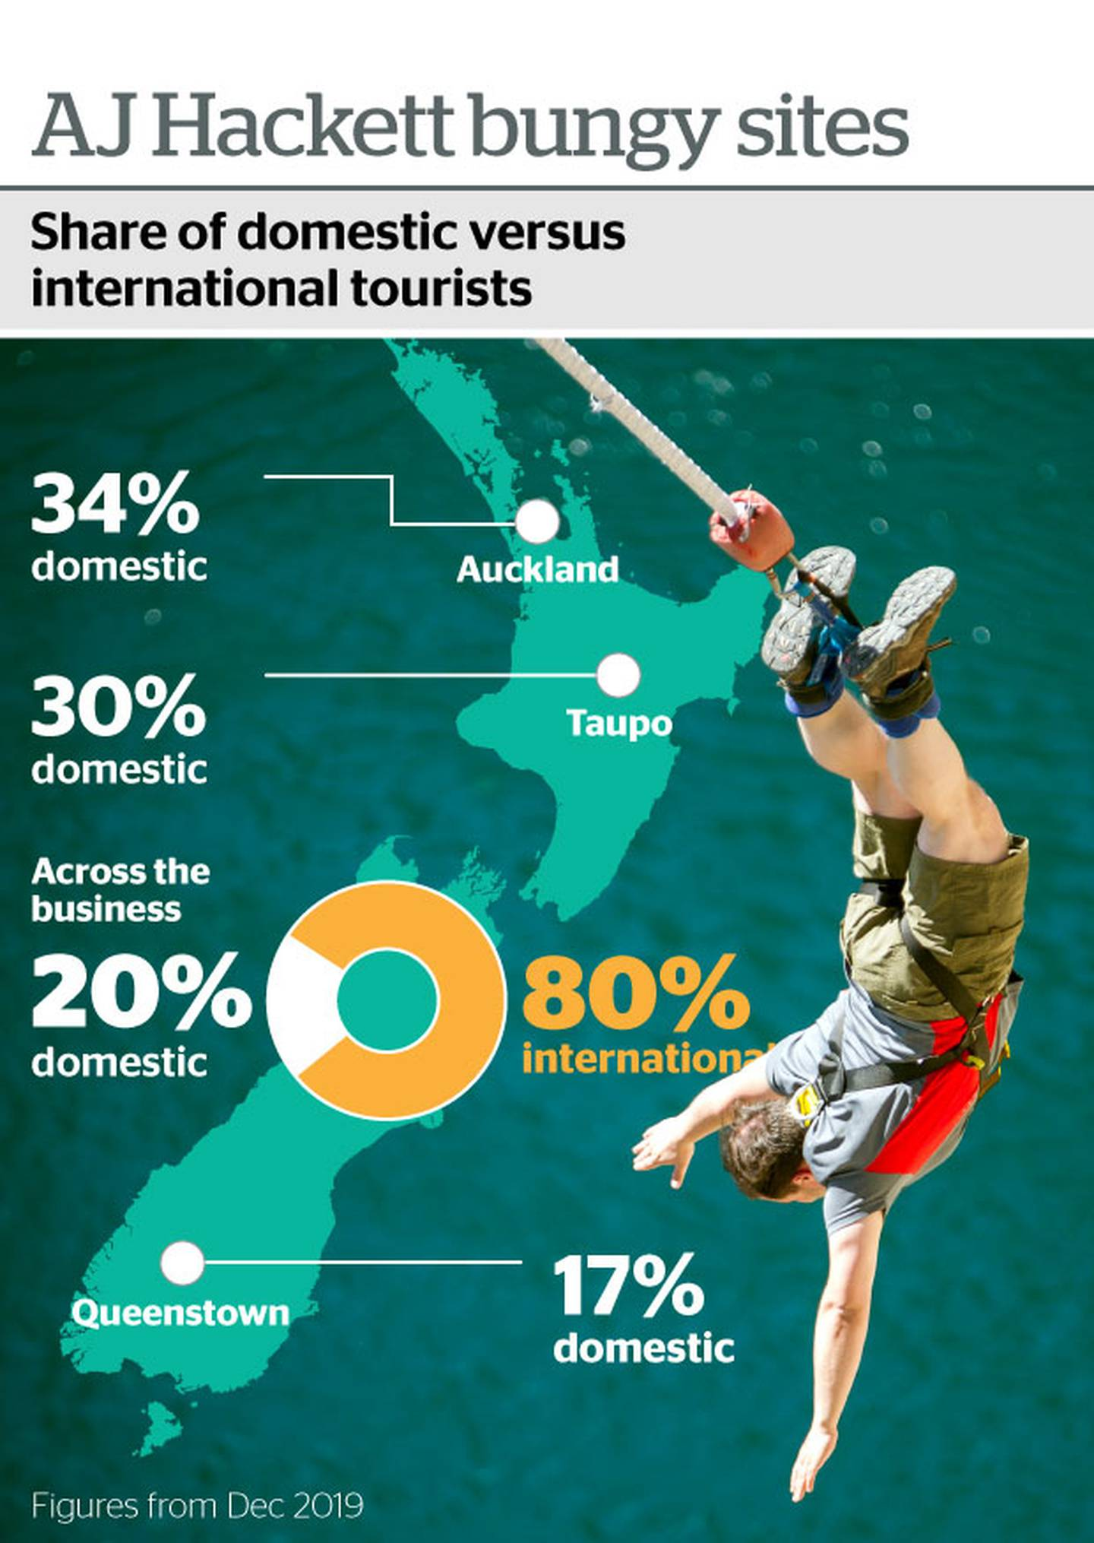
The national lockdown has been hugely disruptive for business, says MD and co-founder Henry van Asch, especially for one as relentless as bungy jumping.
"We've been operating Bungy for more than 30 years – some 11,520 days onsite – and the 50 days in lockdown has been the only time, apart from Christmas, that we've closed since we began," he said.
The company recently received a $10.2 million government bailout which has allowed AJ Hackett staff to retain 20 jobs. The Otago Daily Times reported that the money would allow the company to reopen across all 13 sites.
However, van Asch acknowledges this $10 million lifeline is a temporary fix. Without international tourism or a huge shakeup of the business, they could soon be back over the precipice.
"With the marked absence of international tourists, we're operating on a fraction of the number of customers we usually accommodate and with no clear idea of when the international market might return," he said.
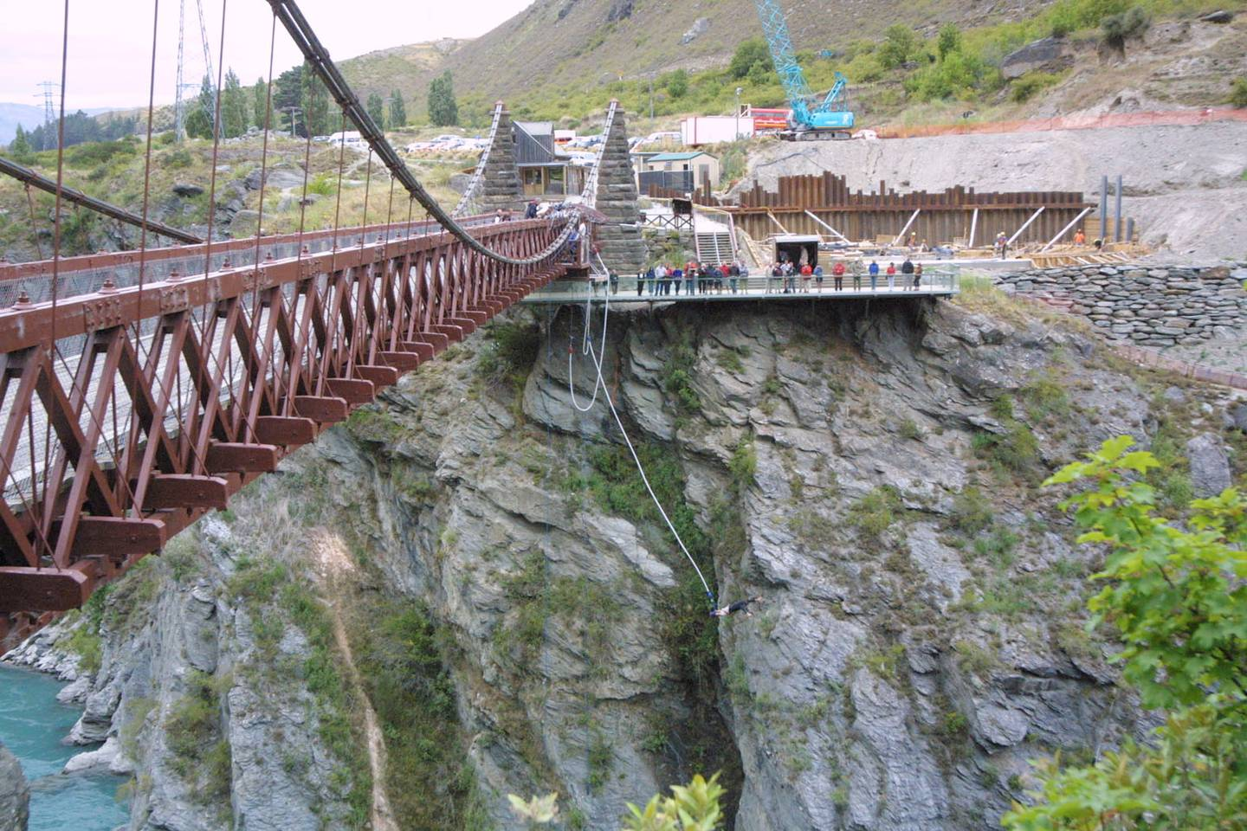Just 17 per cent of tourists at AJ Hackett's Kawarau Bridge jump are from New Zealand.

Clearly the business needs to start wooing more domestic tourists, but this will be no easy task. Part of this will be answering the question: why is it that so few New Zealanders have taken part in the extreme sport?
As with any high adrenaline, adventure activity – bungy is not for everyone. The sport has been used to study the addictive qualities of high-risk behaviour – something from which Hackett has benefitted, in growing their business internationally, among repeat jumpers – however, talking people up to taking a death-defying leap is no easy task.
So is it that Kiwi tourists are too chicken, or too cheap?
Bungy operators have conceded that price point might be a part of it. Years of international jumpers have pushed up prices.
AJ Hackett reopened with specials and is still offering a third off jumps until July 19. The Nevis Bungy – the company's most expensive attraction – is now under $200 a jump, (down from $275). Still, it's a price some New Zealanders might consider steep. In Ngongotaha, Velocity Valley operates Rotorua's only bungy. Dangling 43m, suspended from a crane arm it's the tallest and most expensive of the six adventure attractions on offer. A jump normally costs just under $150, but it's still New Zealand's most affordable bungy.
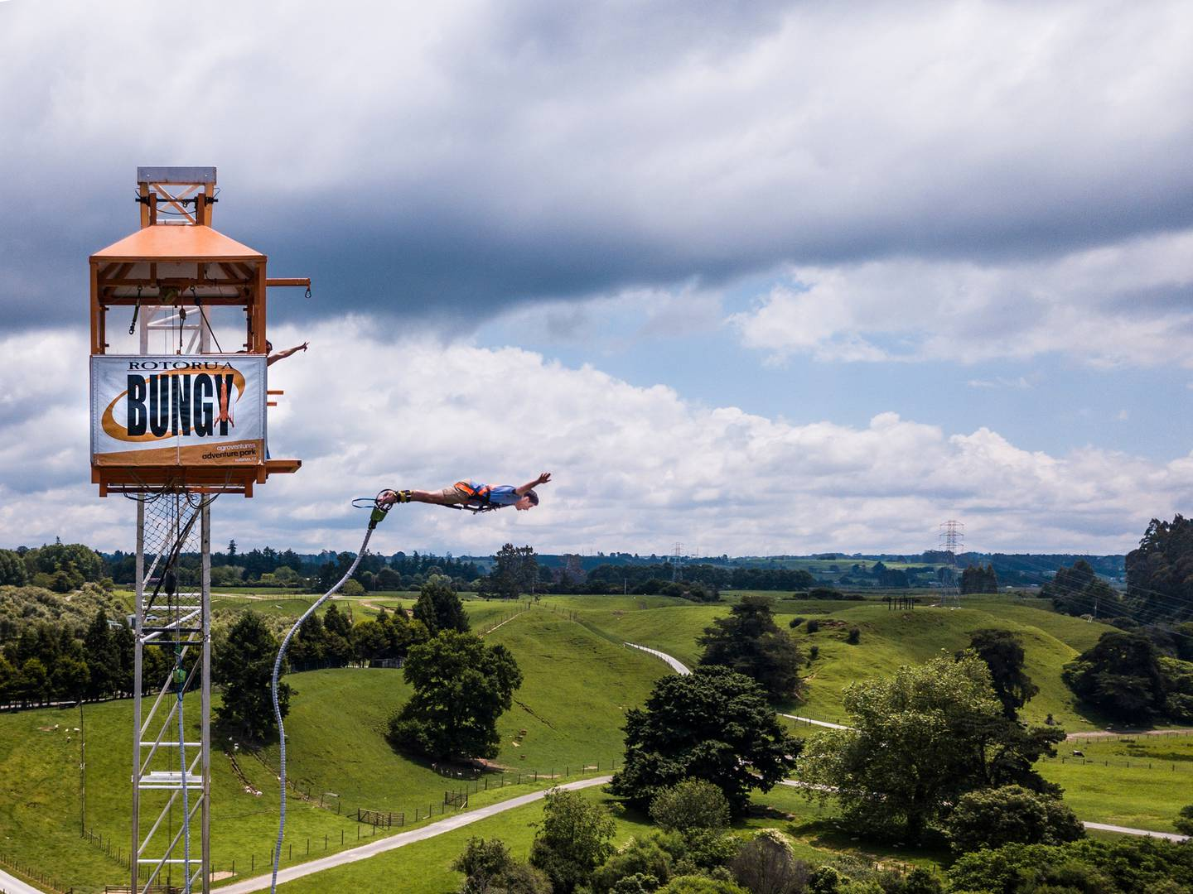The Rotorua Bungy at Velocity Valley is New Zealand's most affordable jump.

It's also one of the rare jumps where domestic riders are in the majority.
Sixty-five per cent of its riders are from New Zealand says Debbie Guptill, sales manager for the park.
"Yes our numbers have dropped but we are well known locally," says Guptill. "We're still in a pretty good place."
Although international tourists were an important part of the business "unlike some other operators we haven't allowed our prices to be inflated".
Kiwis are very price driven on deciding holiday activities, however, offering jumps too cheaply risks undercutting the whole sport.
"Running a bungy isn't cheap" Guptill says. As a New Zealand sport, the national code of practice for bungy has helped form industry standards around the world. Auditing, insurance, design, testing and approval or equipment and staff operating procedures all add up.
"We make our own bungy cords on site," she explains. There are many costs not obvious to jumpers, who only see a bungy and 43m of thin air.
"New Zealander's have the expectation that just because it's at home you should be able to do it more cheaply."
Dropping prices too low would lead to a false economy. Instead, those trusting their life to the elastic strips and expertise of Kiwi operators should find the price tag reassuringly expensive.
Still, as New Zealand remains closed to international tourists, we may have to wait some time to see the sport bounce back.

