Global Studies
Week 4 Current Events & Cultural Traditions

Success Criteria
This week we will focus on current events, and continue with our theme of Halloween traditions in different cultural settings. By the end of the week students will be able to identify key symptoms of the current outbreak of tic disorders and be able to explain what is driving it.

Lesson 1: The Strange Case of the TikTok Tics
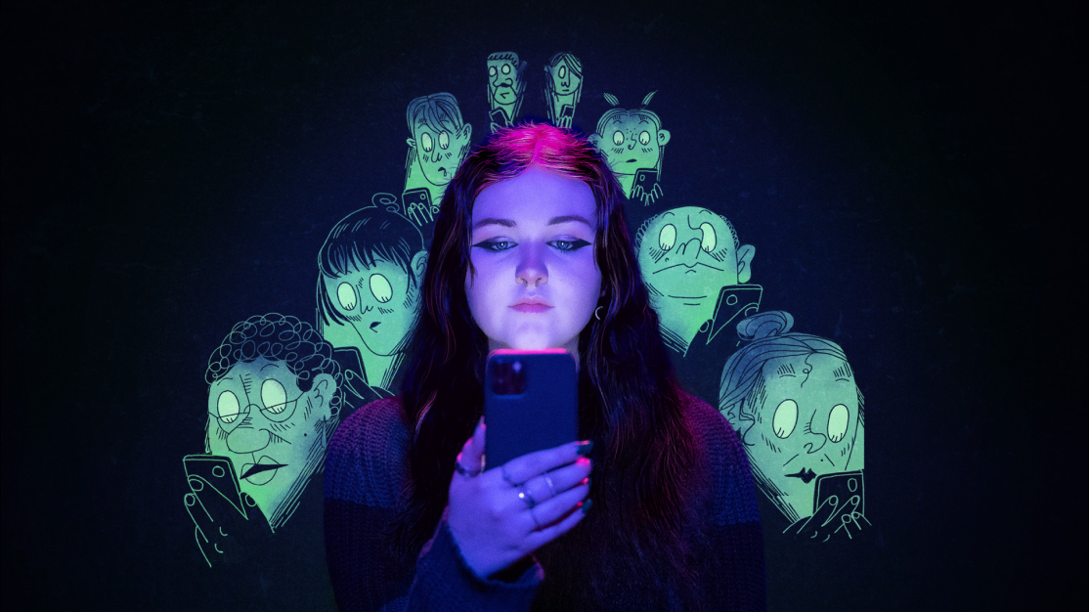
A mysterious outbreak of tic disorders among young people the question:
Is social media making us sick?
Doctors in New Zealand and around the world have recently identified a worrying trend among young people – tic disorders that are apparently spread on social media platforms like TikTok and Facebook.
Task A: Watch the video ‘Believing in Seeing’ in full without stopping at: https://loadingdocs.net/believing-is-seeing/
Class discussion: Do you think it’s possible that social media can make kids sick?
Task B: Read the article: https://www.wired.com/story/they-watched-youtuber-with-tourettes-then-adopted-his-tics/ (the Reading appears below).
It should take you 10 minutes to watch the video; 2-5 minutes for the discussion, and 20 minutes to complete the reading. You will spend the rest of the period on writing your answers.
After completing the reading, answer the following questions in your Red Books (The questions are based both on the video and the reading).
1. The main investigator in the short documentary was once a believer in a variety of strange things. Why did he change his mind? (video)
2. What is the definition of ‘mass psychogenic illness.’ (video at the 1:45 sec. mark)
3. How is mass psychogenic illness comparable to the Placebo Effect? (2:00 mark)
4. Some people say that mass psychogenic illness is ‘all in your head.’ Why is this not true. (2:28 sec.)
5. Why were cats feared in parts of Europe during the Middle Ages? (3:50 sec.)
6. What does the author believe is responsible for the recent upsurge in cases of tics? (general information found in the reading and video)
7. The girl in the documentary (Bella) is from Auckland and began to catch her tics from watching videos of people with Tourettes and Tourettes-like disorders online. When do scientists think Bella’s tics are related to stress? (hint: what was going on when the started) (video)
9. According to Auckland Neurologist Dr Rekesh Patel, over the past 3 years, by how much have the number of people with tic disorders in New Zealand increased? (video)
10. What are the symptoms of Tourettes, and how are the TikTok tics different? (Reading)
11. Dr Patel says that these new tic disorders are not a psychological disease but
__________________________________________.
12. What is Bella’s biggest fear?
13. What did Dr. Müller-Vahl do that resulte din a number of girls with tics disorders, to get better? (Reading)

Lesson 1 Reading:

They Watched a YouTuber With Tourette’s—Then Caught His Tics
Wired UK, September 2, 2022.
Dr Kirsten Muller-Vahl has a major mystery on her hands. It was June 2019 and Müller-Vahl, a psychiatrist in Germany and head of its Tourette’s outpatient department, was seeing a surge in the number of patients with tics unlike anything she had seen before.
Not only were the tics complex, even more bizarrely the symptoms of the patients were remarkably similar. “The symptoms were identical. Not only similar, but identical,” she says. Although all had been formally diagnosed with Tourette’s by other physicians, Müller-Vahl, who has been working with patients with Tourette’s syndrome for 25 years, was certain it was something else entirely. Then a student came forward who knew where she had seen those tics before.
All the patients were displaying the same tic-like behaviors as the star of a popular YouTube channel. The young man’s was Jan Zimmermann, a 23-year-old from Germany with Tourette’s.
Some of Zimmerman’s tics are specific. He can often be seen saying the phrases “Fliegende Haie” (flying sharks), “Heil Hitler,” “Du bist häßlich” (you are ugly), and “pommes” (chips). Other tics include smashing eggs and throwing pens at school.
The patients that visited Müller-Vahl’s clinic were pretty much mimicking Zimmerman’s tics. In total, about 50 patients at her clinic presented symptoms similar to those of Zimmerman. Many patients readily admitted to having watched his videos.
Tics are usually simple, short, and abrupt. They are mainly located in the eyes, the face, or the head, such as blinking, jerking, and shrugging. The syndrome typically manifests at around 6 years old, and much more often in boys—an average of three to four boys to one girl. What springs to mind when you picture Tourette’s—an uncontrollable urge to utter obscenities in public—is actually rare, she says.
But if it wasn’t Tourette’s, what was it? According to Müller-Vahl, these patients were actually suffering from mass psychogenic illness – a condition triggered by stress.
For some patients, all their symptoms disappeared when Müller-Vahl explained that what they had wasn’t Tourette’s. For others, a course of psychotherapy improved their symptoms significantly. Still, the sheer number of patients with the exact same symptoms puzzled Müller-Vahl and her colleagues.

Mass sociogenic illness—also known as mass psychogenic illness or historically called mass hysteria—spreads like a social virus. Symptoms spread by unconscious social mimicry to vulnerable people, thought to be triggered by emotional distress. Historically, the condition affects women more than men. The reason why is unknown, but one hypothesis is that females generally tend to have higher levels of anxiety and depression, which could make them more susceptible to the illness.
Outbreaks of mass sociogenic illness are dotted throughout history. Perhaps the most famous began in October 2011, in Le Roy, a tiny town in Western New York, when a group of schoolgirls inexplicably developed Tourette’s-like tics, including sudden verbal outbursts and dramatic jerking movements. The outbreak was eventually determined to be psychoilogical. The story became the subject of a media frenzy at the time and was shared widely online, resulting in people who never met the girls coming down with the same symptoms. It was the first case of mass psychogenic illness to be shown to have spread through social media.
Today, the reach of social media means that these outbreaks won’t be confined to a single school or community—they can reach far and wide to every corner of the world easily through a screen.
Robert Bartholomew, a sociologist in New Zealand who has been studying mass sociogenic illness for decades, was the irst person to speculate that it could spread through social media, as in the case of the Le Roy girls. He thinks this outbreak is no different, and not the last. “I believe we are seeing a major shift in the presentation of mass psychogenic illness—where the internet and the mass media are the primary vectors,” he says. The phenomenon, he says, has morphed over the centuries to reflect the fear of the times. In the 17th century that was witches. Today, it’s technology
Social media, particularly platforms such as TikTok, has become a place of refuge for people with Tourette’s. They can share their symptoms with their audience, feel part of a community, and receive support from peers and fellow sufferers. And the videos are popular; the hashtag currently has 4.6 billion views. At the same time, the uptick in these communities has had a peculiar effect. Recently, there have been a flurry of reports of people “catching” these behaviors through consuming them online. The past 2 years has seen an increase in teenage girls who developed tic-like behaviors through watching TikTok—so much so that the behaviors have nicknamed the ‘TicTok tics.’

The girls presenting with this their tics “had a lot of clinical differences from what we typically observe in the onset of tics,” says Martino. The patients were young, almost exclusively female. The speed of onset was also shockingly rapid; Tourette’s tends to develop slowly, with symptoms creeping in over months or a year. In these patients, their symptoms were appearing over a period of hours or overnight. “I have never seen this level of distress in young people in my career,” Pringsheim says. “It’s alarming.”
The pandemic has exacerbated mental illness amongst teenagers. In the UK, rates of mental health problems in children and young people rose by almost 5 percent between 2017 and July 2020. Widespread anxiety and fear combined with prolonged isolation plausibly creates the perfect breeding ground for an illness just like this one. And the world locking down has forced people to stay in their homes, and on their phones.
Pringsheim and Martino reckon the pandemic has played a big role; the patients they saw were highly distressed and scored high for anxiety and depression. “I don’t know that this would have happened if there wasn’t a pandemic going on,” Pringsheim says.
Both Bartholomew and Müller-Vahl point fingers at social media. “Similar outbreaks like this have been going on for at least a decade—and we didn’t have a pandemic,” Bartholomew says. “I think that being in a cloistered lockdown environment, and spending more time on sites such as YouTube and TikTok, have likely intensified the effects of these sites on young people.” Müller-Vahl agrees: She had been seeing these patients for over two years, before the world had ever heard of Covid-19. But she concedes that the pandemic may have accelerated the outbreak.
The pandemic will, eventually, fade. But social media isn’t going away anytime soon, which means there are more outbreaks to come. “It looks like this new trend is here to stay,” Bartholomew says, “so we need to study these cases.”

Lesson 2 and 3:
Halloween still has not quite caught on in New Zealand.
Imagine that the Prime Minister is not happy with Kiwis celebrating Halloween. She has asked you to create a new public holiday in New Zealand that is going to replace Halloween because some people think it can be too scary. The new holiday must keep some components of Halloween but at least half of the holiday should be different.
Your mission is to improve on Halloween by creating a new super holiday.
Students will work in pairs:
1. What is the name of your new holiday
2. What are the key components of the new holiday?
3. What day will it be celebrated on?
4. What foods will be eaten? What activities will people engage in? What age groups will participate?
You can create you new holiday on a Powerpoint or in the form of a poster that will be presented to the class during Week 5.

