Week 7 Global Year 8
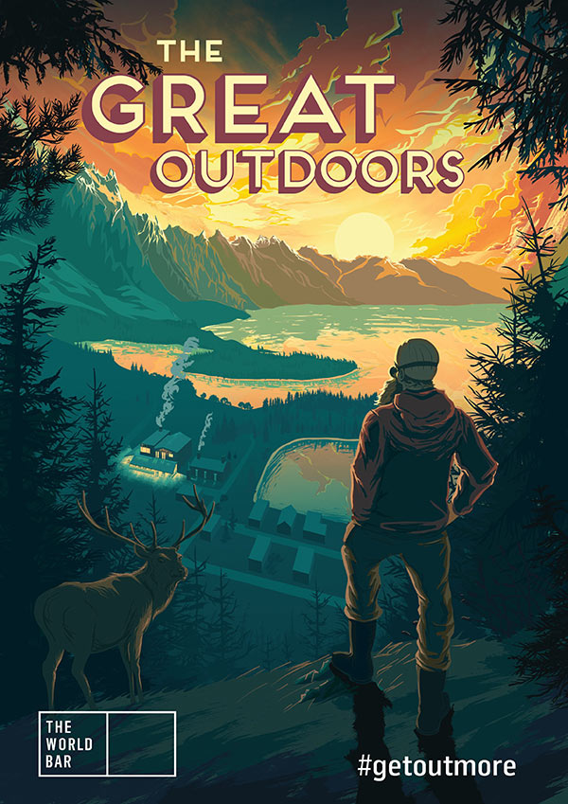

Success Criteria – students will be up-to-date in all of their assignments for the term and ready for the assessment over weeks 8 and 9. By the end of the week students will be familiar with both the dangers and benefits to sun exposure in New Zealand.

Lesson 1:
Students are to complete their Sunsmart posters by the end of the lesson (this is a continuation from last week).

Week 7: Lesson 2
Current Event Analysis
Why Conspiracy Theories Thrive
during times of Crises
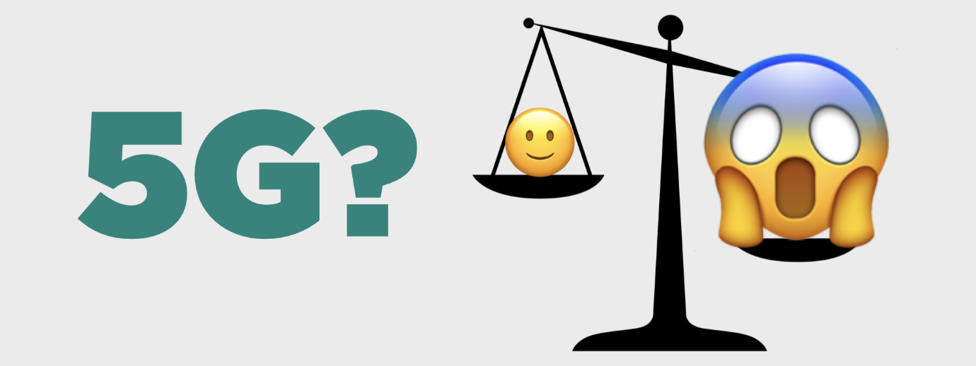
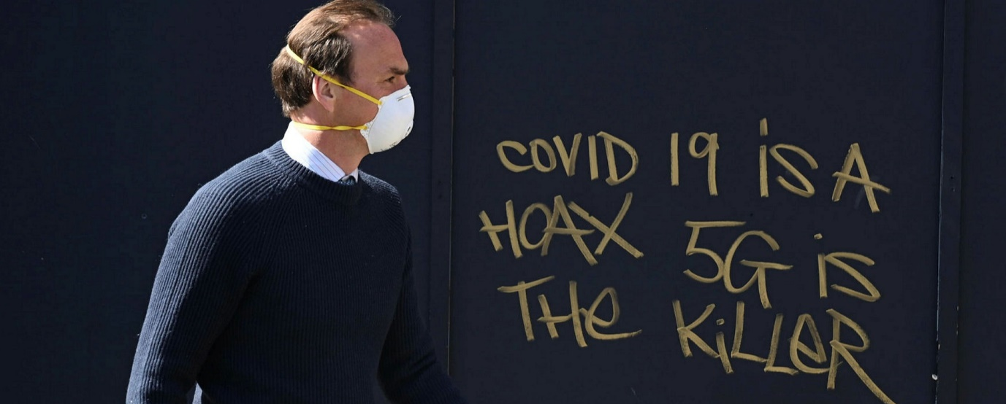
Some people believe that 5G Towers cause cancer and help spread Covid. There is no evidence to support these claim – so why do some people believe them?
Task 1: Watch the video clip on the fear of 5G towers that has recently swept across New Zealand and write a 1-sentence summary of David Farrier’s views on 5G and health.
https://www.newshub.co.nz/home/entertainment/2020/05/david-farrier-s-surprise-at-5g-conspiracy-theories-taking-hold-in-new-zealand.html

Task 2: Read the article in the Otago Daily Times, ‘Why Conspiracy Theories Thrive in times of Crisis?’ May 21, 2020. Answer the following questions in your Red Books:
1. How many attacks have there been on New Zealand 5G cell towers?
2. How does damaging 5G towers put peoples’ lives in danger?
3. When the article was written, how many Covid-related conspiracy theories were there in New Zealand?
4. How far back can conspiracy theories be traced?
5. Name a conspiracy theory from the 1920s.
6. What was the conspiracy theory about ice cubes and talking on the telephone?
7. What does Robert Bartholomew think are key factors that generate conspiracy theories?
8. Look up the word ‘vetted.’ What does he mean about ‘unvetted news?’
9. How does he think that Donald Trump has influenced what some people believe?
10. What does he say is the problem with getting our news from places like Facbook and Twitter.
11. Go online and look up the definition of a ‘Deep Fake.’ Write it down.

Week 7: Lesson 3
Trip to Tane!
Students will need to wear their hats.

