Week 4: Effective Leaders &
How Governments are Formed

Week 4 Lesson 1: Current Event Analysis

As I will be away periods 3 & 4, we will begin the week with Current Events All students are expected to do the Advanced unless otherwise agreed to by me before hand.

Meet the Town that Drinks the
Most Coca-Cola in the World –Are they Healthy?

Success Criteria:
Students will gain a thorough understanding of the health consequences of consuming fizzy drinks, and specifically Coca-Cola. While eating or drinking most foods/drinks in small quantities is usually not harmful, overdoing it can cause major health problems – even in young people. By the end of the lesson students will be able to list the major health consequences of drinking too sugar-based many fizzy drinks.

KEY POINTS

- Nobody in the world drinks more Coca-Cola and other fizzy drinks than the residents of Chiapas.

- But this obsession with the fizzy drink is having dire health consequences.

Coca-Cola is Killing Thousands in This Mexican Town?

2-Minute Write:
How much Coke do you drink? What about soda in general? What impact do you think it can have on your health?

Task 1: Watch the video clip:

“Coca-Cola is Killing Thousands in This Mexican Town.”
https://www.youtube.com/watch?v=OuF19EAP9E0

1. Chiapas is Mexico _____________ most state and one of the p - - - - - -.

2. How much Coca-Cola does the average person in Chiapas drink per day? How does this compare to people in America?

3. For the Tzotzil people of Southern Mexico, how have they brought Coca-Cola into their religious practices?

4. As a result of drinking so much Coke, diabetes has become a major health problem.

Next research the link between drinking sugary soda drinks and diabetes by reading the article below from Medical News Today, :

How to prevent Type 2 Diabetes in Children & Teens

While Type 1 Diabetes not preventable, an individual can take steps to reduce the more common type 2 diabetes.
Factors that can raise the prevalence for type 2 diabetes include:¹
- Above weight or obesity
- Sedentary lifestyle (not having much physical activity)
- Hormonal changes in puberty
- Family history of type 2 diabetes
- Your birth parent having gestational diabetes (diabetes during pregnancy)

Foods to Eat and Avoid
To help prevent type 2 diabetes, incorporate the following foods into your child's diet:
- Fruits
- Non-starchy vegetables like peppers, broccoli, asparagus, and spinach
- Whole grains like brown rice, steel-cut oatmeal, and quinoa
- Lean cuts of meat
- Low-fat or fat-free dairy products
- Low-salt foods

What to Avoid
Foods that create sudden changes to blood sugar levels should be avoided or limited. These food items include:
- Highly processed foods, including baked goods, fried foods, and processed snack bars
- Sugary foods and beverages, including fruit juice
- High-fat foods such as full-fat dairy (milk products) and fatty meats
- Simple carbohydrates like white bread or flour
- Takeout or convenience meal items
Get Active
The Centers for Disease Control and Prevention recommended that every child participate in at least 60 minutes of physical activity a day.¹ This can be accomplished in several smaller sessions or all at once by participating in activities.
Task: Create a poster in a single page of your Red Books on what Children & Teens can do to prevent getting Diabetes.
Current Event Analysis #2
Basic

The New Study that Shows Napping
can be Good for You!

Success Criteria
Students will gain a basic understanding of the health benefits from taking a nap and by the end of the lesson will be able to recall the positive impact it has on the human brain.

Read the Article below and answer the questions.

Reading: Banbury, Shem (2023). Kiwi Kids News, June 27.

New STudy:
NAPS CAN BE GOOD FOR YOU
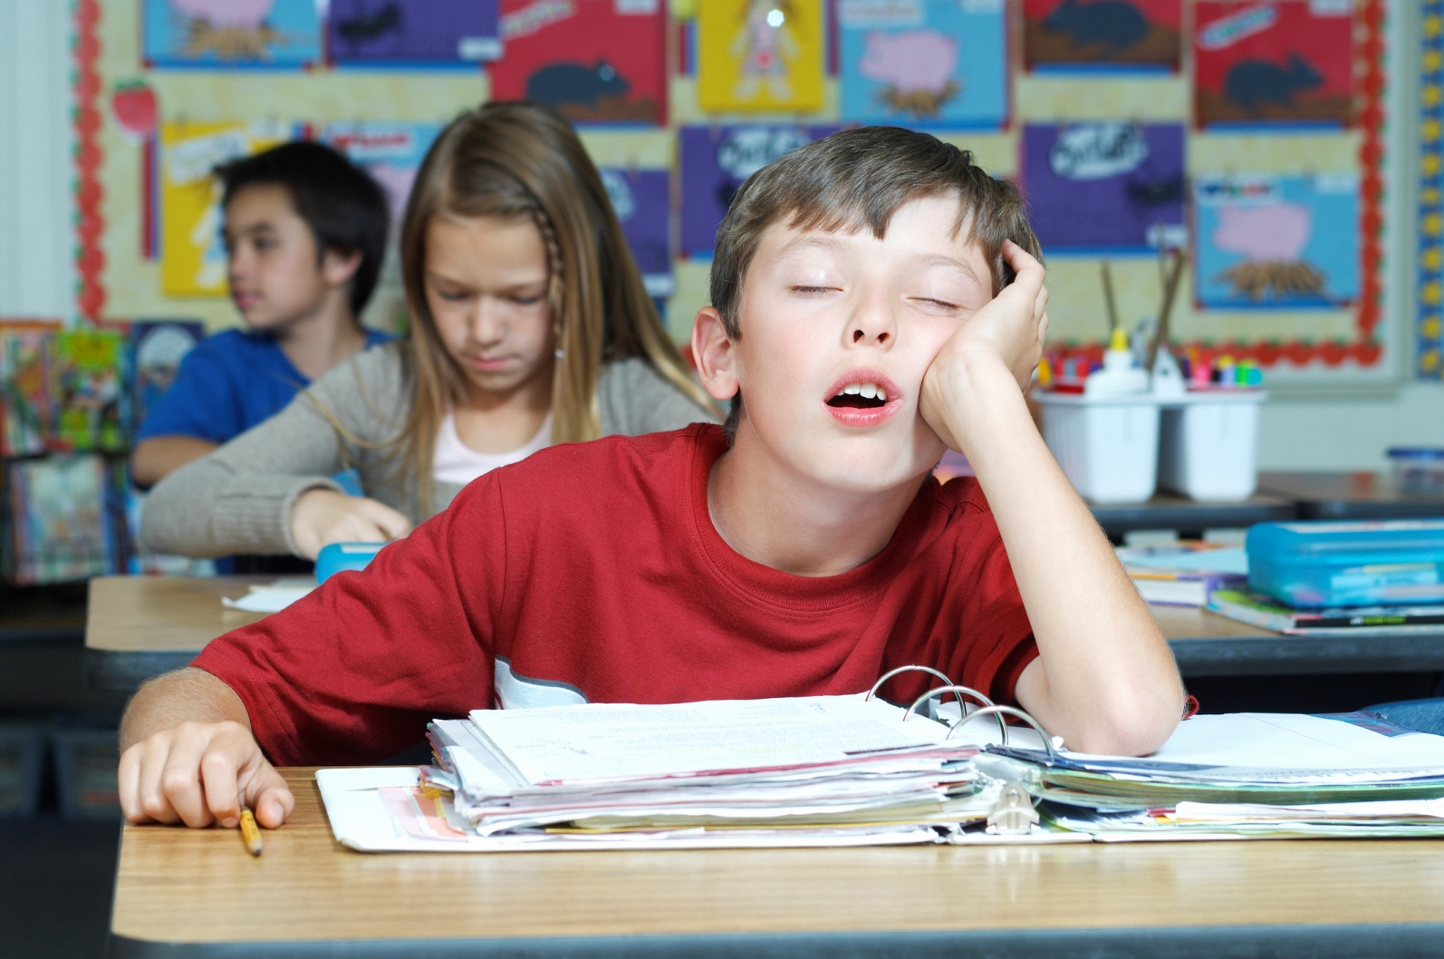

Taking regular naps has been found to be beneficial for our brains and can help keep them healthy for longer, according to researchers from University College London. The study revealed that people who took naps had brains that were 15 cubic centimeters larger than those who didn’t nap, which is equivalent to delaying the aging process by three to six years.
However, the scientists recommend keeping naps to less than half an hour. Unfortunately, daytime sleep can be challenging for many people due to work culture and the disapproval of napping in many careers.
Dr. Victoria Garfield, one of the researchers, emphasized that everyone could potentially benefit from napping and described the findings as exciting and novel. She also highlighted that napping was a simple activity compared to weight loss or exercise, which can be difficult for many individuals.
Napping is more common in babies for their development, becomes less frequent as we grow older, and regains popularity after retirement, with around 27 percent of people over 65 reporting daytime naps.
While napping has shown positive effects on brain health, further research is needed to determine if it can help prevent diseases like Alzheimer’s. Maintaining overall brain health is crucial for protecting against dementia, and there is a link between disturbed sleep and the condition.
The researchers suggest that poor sleep damages the brain over time by causing inflammation and affecting the connections between brain cells. They propose that regular napping could compensate for deficient sleep and potentially protect against neurodegeneration.
However, Dr. Garfield mentioned that she prefers other methods of brain care, such as exercising for 30 minutes, rather than napping. Each individual can find what works best for them.

Questions:
1. What effect do short daytime naps have on our brains?
2. If you are planning to take a nap, how long is recommended?
3. What percentage of people over the age of 65 take a daytime nap?
4. What is a health problem associated with poor sleep?
5. What is another way of helping your brain besides taking a nap?

Week 4 Lesson 2:

Success Criteria: To be able to identify and recount the attributes of an effective leader with a specific emphasis on their speaking style. They will also be able to recount key steps in how a bill becomes a law and how governments are formed (either with an outright majority or a collation of smaller parties).

Task 1: Write down the lesson heading and today’s date.

Class Discussion: List attributes of an effective leader

Task 2:
Today we are going to look at 3 different types of speakers:

Motivational – Spiritual – Inspirational

1. Leo Buscaglia (Spiritual)
https://www.youtube.com/watch?v=ALPEQAP7c8o

2. Martin Luther King, Jr. (Inspirational)
https://www.youtube.com/watch?v=Oehry1JC9Rk

3. Les Brown (Motivational)
https://www.youtube.com/watch?v=g-jwWYX7Jlo

4. Charlie Chaplin (The Great Dictator)
https://www.youtube.com/watch?v=J7GY1Xg6X20

5. Inky Johnson
https://www.youtube.com/watch?v=NyY9D4nflSw
In your Red Books write the 5 headings below followed by 5 spaces underneath each section. In those spaces you will write down the attributes of each speaker – what makes their speeches so powerful?

1. Leo Buscaglia (Spiritual)
2. Martin Luther King, Jr. (Inspirational)
3. Les Brown (Motivational)
4. Charlie Chaplin (The Great Dictator)
5. Inky Johnson

Week 4: Lesson 3:

How a Government Forms in New Zealand

Task: Today we will learn about how governments form.

Majority Government
After the election, the party with the most seats in parliament forms the government which will run and control the country.

Coalition
Because there are 121 seats in parliament and many parties, often a single political party will not get an outright majority (61+ seats). When this happens, two or more parties must team up, or form a coalition to win the majority.
When this happens, the bigger party in the coalition is the main party which runs the government, but they have to listen to, and give responsibilities to their partner political party.
When the winner is decided (either a single party or group of parties) because they have over half the seats in parliament (61+), they are then called the government. The smaller side, or the losers, then form the opposition.

How an idea becomes an Act of Parliament

You will be given a paper copy of the following handout to fill in and glue into your books:

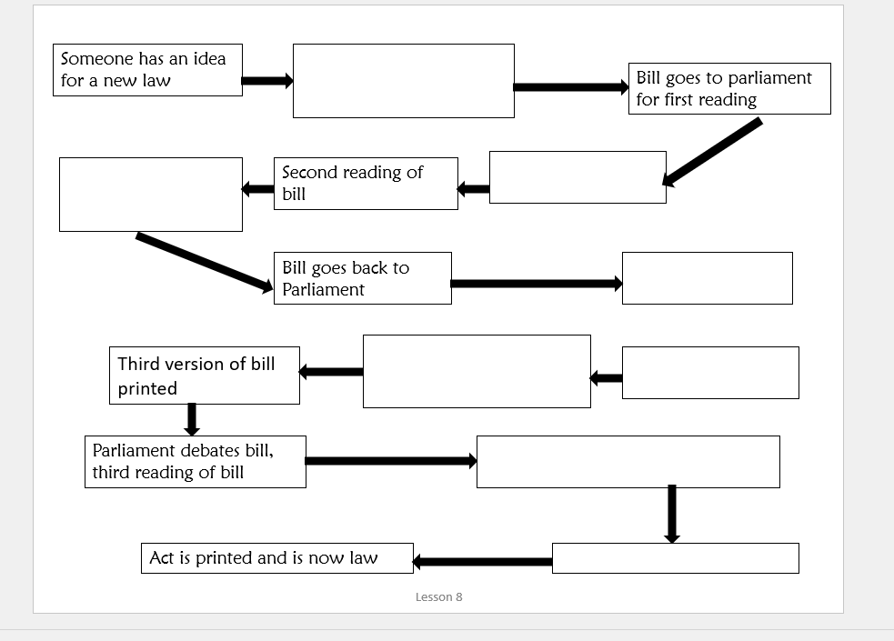

Answers:

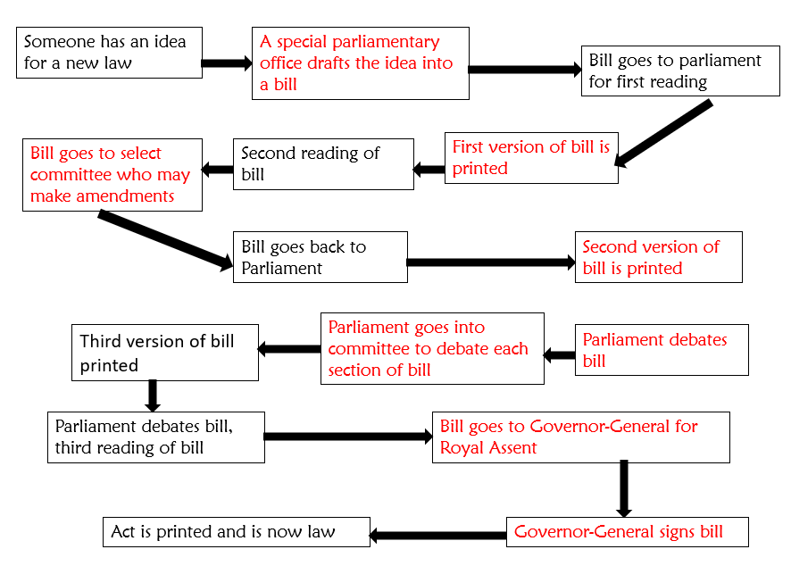

Handout #2: Fill in using the answers below. Students will break up into small groups and I will call on them for the answers. Possible answers appear below:
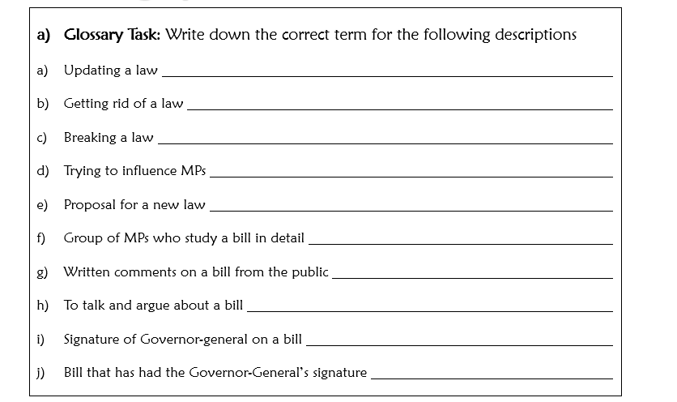

Possible Answers:

To talk and argue about a bill debate
Getting rid of a law Repeal
Signature of Governor-general on a bill Royal Assent
Written comments on a bill from the public submissions
Breaking a law criminal offence
Trying to influence MPs lobby
Proposal for a new law Bill
Group of MPs who study a bill in detail select committee
Bill that has had the Governor-General’s signature Act or Statute

