Yenka Installation Guide
To install yenka using the Mission Heights Junior College licence, follow these steps (the licence is only available to current MHJC students)

- Goto the url
:https://www.yenka.com/en/Downloads/;jsessionid=513863D1C7D1B56EDBBA25CABA5A30F8
- Follow the installation instructions relevant to your device

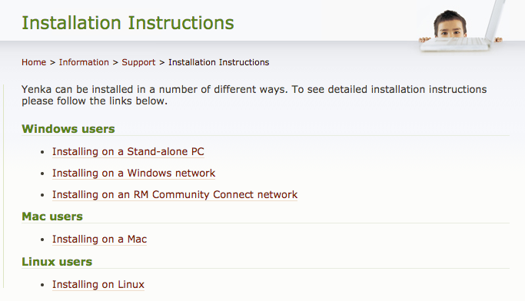
- Drag the yenka icon to the applications or desktop
- Activate Yenka by entering the 12 digit activation code :” 5164-3433-4385”
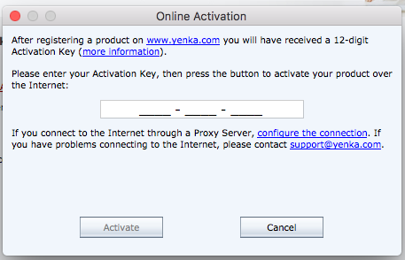

- Click on ‘activate’ to start using yenka
- When you open Yenka, use the “PCB with electronics” version (the other versions do not contain all of the microcontroller components)

