Pepeha Activity
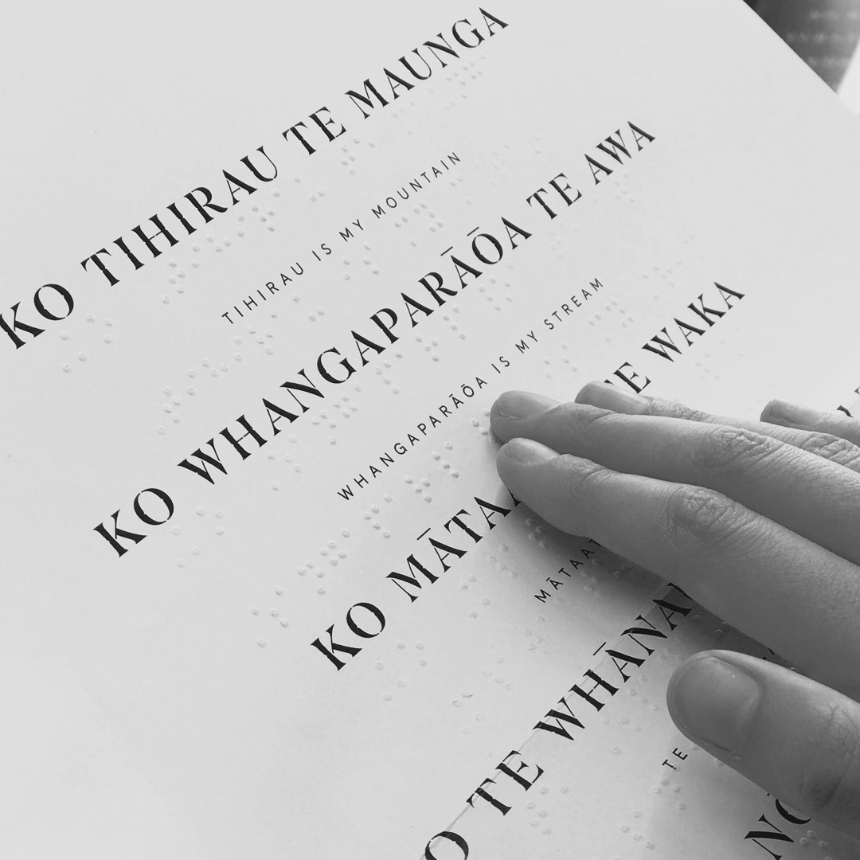

Follow instructions carefully.

- Go to the Pepeha creator, linked here https://pepeha.nz/create-pepeha
- Follow the instructions - try to be as accurate as you can. For example: if there isn’t a body of water on the map that you feel close to, use a beach or a river you feel represents your background. Additionally, if you are from overseas, try use those locations instead: the map defaults to New Zealand locations but allows you to put any location you want.

- When finished you should see a black + white page resembling the image below. That image is not the full screenshot, but most of it. Please make sure you see the full text of your pepeha.
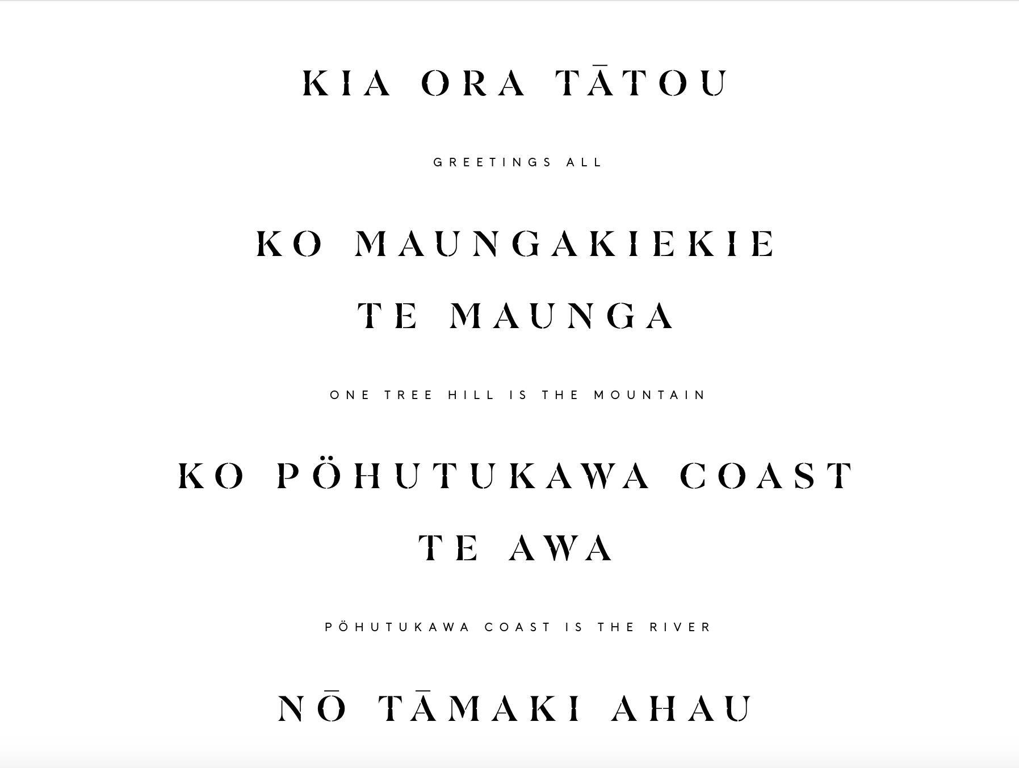

- Read carefully. Look at the completed pepeha image on your screen, and imagine that image copy + pasted onto a sheet of paper. You want your sheet to look like that. Using either white paper or coloured paper, write out your pepeha. Follow the style laid out in the Pepeha Creator - Te Reo in large font, English (or your home language, if you prefer) in a smaller font. Space out the sentences so you make full use of the page’s length, but leave room for colouring in. Make sure it is readable as you will be using this in a later exercise.

- On the BACK of the sheet, the opposite side of where you wrote on, write your name. Now I will know whose sheet it is.

- Finally, using the colouring pencils, you can now illustrate your sheet. You need to incorporate four things onto your drawing.
A) Draw a mountain (maunga) on your sheet.
B) Either draw a river/beach/body of water, or use the colour blue in a pretty way to showcase the connection to water. Your decision.
C) Draw either a) a famous landmark from your home town/city, or b) a symbol that represents your home country.
D) Finally, choose a native bird that you feel closest to, and draw that. Alternatively, a bird from your home country (such as the Peacock if you are from India) that you respect is also an option.
- When finished, give to the teacher to collect.

