Mr Bartholomew Week of May 1 to 7, 2023
Global Studies Year 8

Survival
Week 2 Lesson 1

Volcano!
Aotearoa New Zealand’s Greatest Volcanic Disasters & How to Survive Them

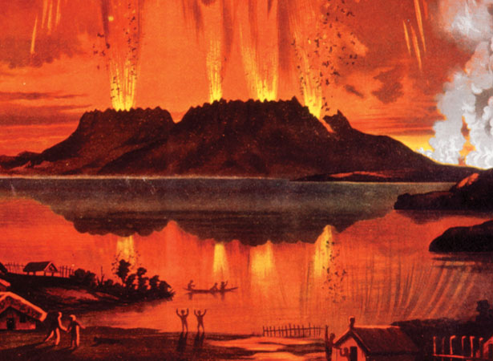
Success Criteria: Students will become familiar the major volcanic eruptions in recent memory and be about to recount the steps one can take to survive such an event.

Read the following summary below the Mt Tarawera eruption of June 10, 1886.

Task 1: One your Red Books to two blank pages and at the top of the 1st page write in large letters the Unit Title “New Zealand Disasters & How to Survive Them.”

Next write: ‘Week 2: Lesson 1 – Volcano!’

Task 1: We will read the summary below as a class, on the eruption of Mt Tarawera in 1886. Prior to the eruption, many tourists would tavel to the area to see one of the country’s most famous attractions – the famous hot springs known as the Pink and White Terraces which were made up mostly of hard sandstone rocks. See below:
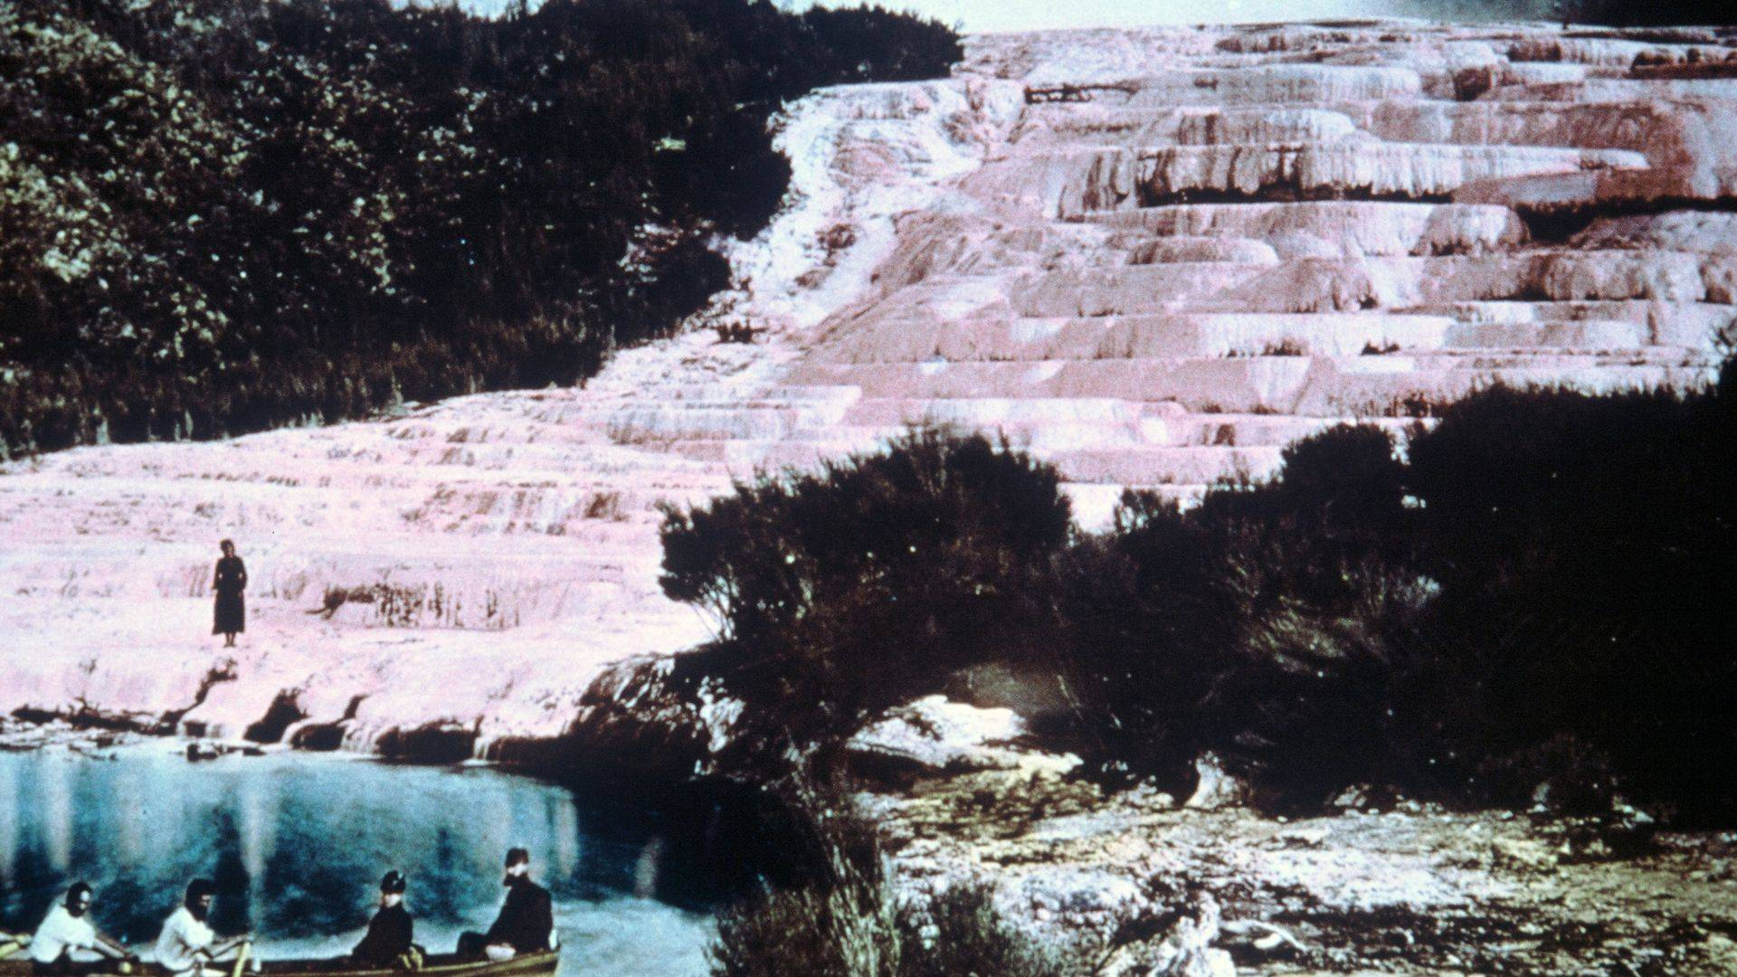

People travelled from all over the world to visit the Terrances and bath there. All around the area was geothermal stream. It was a spectacular sight. A few years before the erupt, people bathed at the Terraces. Below is a black & white photo taken in the 1860s.

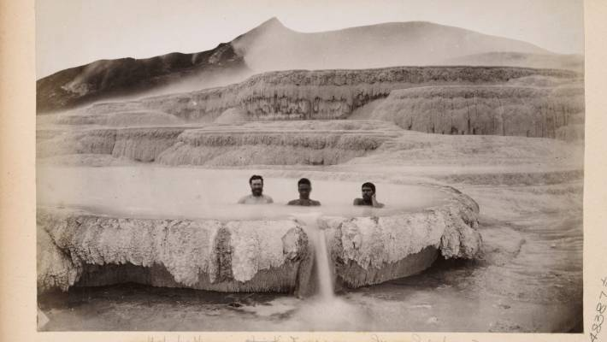

The eruption lasted six hours and caused massive destruction. It destroyed several villages, along with About 120 people, nearly all Māori, died.

In the early hours of 10 June, locals awoke to earthquakes, lightning, fountains of molten rock, and columns of smoke and ash up to 10 km high. People as far away as Blenheim heard the eruption. Some thought it was an attack by a Russian warship.

A 17-km-long rift split Mt Tarawera and extended as far south as Waimangu. The eruption covered land with millions of tonnes of ash and debris, transformed lakes, and flattened bush. It was over by dawn, though ash made day as dark as night. Men from Rotorua and Ōhinemutu formed rescue parties and began digging out survivors and casualties. Settlements at Te Tapahoro, Moura, Te Ariki, Totarariki, Waingongongo and Te Wairoa were destroyed or buried. Te Wairoa, now known as ‘The Buried Village’, later became a tourist attraction. Also gone were The Terraces which has been pushed under the ocean.

Task 2: Watch the video clip on the disaster, the Eruption of Tarawera (2000) Part 2 at: https://www.youtube.com/watch?v=KJssGS9I4MM

List the strange things that were reported in the months just prior to the eruption.

2:54 sec. May 1886

4:00 sec. What did the local think the illnesses indicated?

6:10 sec. curse & prediction

8:00 sec. what strange thing happened to the water

8:57 sec. people saw a strange sight. What was it?

Class Discussion: Do you think that these strange happenings shortly before the eruption, could be explained by science.

Week 2 Lesson 2:

The White Island Disaster & Could It Have Been Avoid?

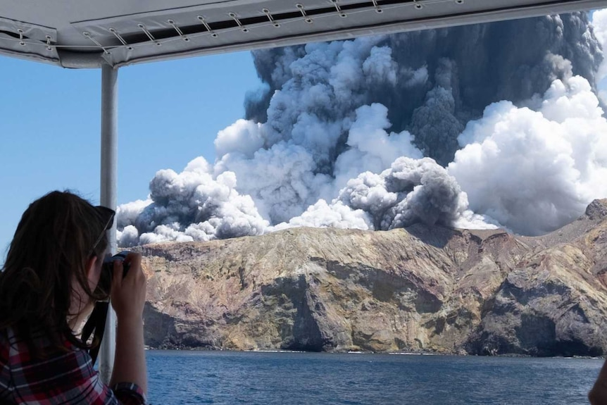

The Incredible Story of Survival on New Zealand’s White Island

Stephanie Browitt's Incredible Story

of Survival on White Island

Watch the video clip: Survivors of White Island Disaster say they felt abandoned after eruption at: https://www.youtube.com/watch?v=5nGnXthjVgc

Section 1: Watch to the 20:00 sec. mark paying close attention to the events at 15:10 sec. to 20:00 sec. Why were rescues helicopters not sent to the island? Do you think this was the correct decision? Why? Why Not. Write a summary below:

Write Section 1 Summary Here

Section 2: Watch from the 31:00 sec mark. 31:00 mark. How was the volcanic eruption predictable and not just a chance event that no one could have foreseen? List this information below in the form of key dot-points:

⚫

⚫

⚫

⚫

⚫

⚫

⚫

⚫

⚫

Week 2 Lesson 3

Could the White Island Deaths have been Prevented?

Task 1: Go to the site: https://www.geonet.org.nz/about/volcano/whiteisland

Create a timeline of significant volcanic eruptions on White Island over the past 150 years.

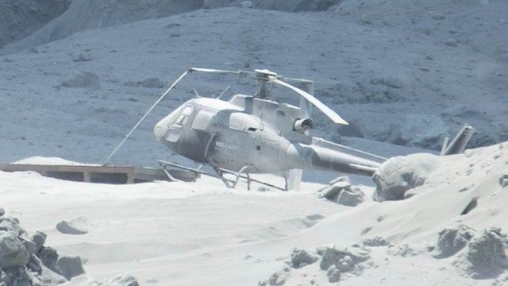

Basic Steps in Creating a Simple Timeline

Set the timeline's scale: Using a ruler, help the students draw a horizontal line across their paper. This line represents the timeline. At the beginning of the line, write the starting year or date of the events. At the end of the line, write the ending year or date of the events. Make sure the timeline is drawn to scale, so each section of the line represents the same amount of time.
Add events: On the timeline, have the students write down the events they want to include in chronological order. Each event should be labeled with a brief description and the year or date it occurred. Encourage them to use different colors or symbols to make the timeline more visually appealing.
Review and edit: Have the students review their timeline and make any necessary edits. They should check to make sure the events are in the correct order, the timeline is drawn to scale, and the descriptions are clear and accurate.

Extension Exercise (option)

Newspaper Editorial

Read the article in The Guardian, December 10, 2019 at:

https://www.theguardian.com/world/2019/dec/10/whakaari-eruption-on-private-island-was-disaster-waiting-to-happen-says-expert i

Armed with this knowledge from the website, write a paragraph in which you give your opinion as to why authorities should have been more careful in letting tourists visit the site. I have begun with a sentence starter:

There are many warning signs that were ignored prior to the volcanic eruption on White Island in 2019. …

