Week 4: Women & Inequality in North Africa
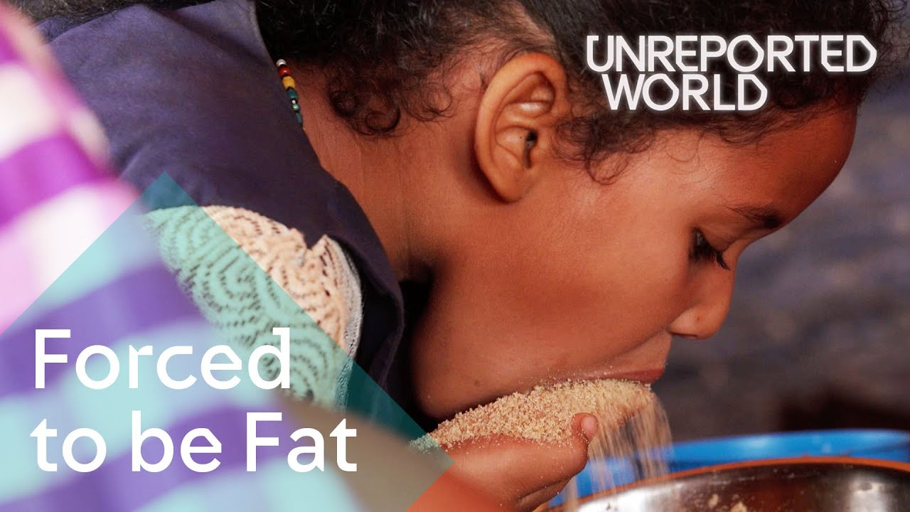
Success Criteria:

Students will be able to describe the forced feeding and forced marriage of young girls in North Africa, explain why these are considered to be human rights violations, and be able to identify which human rights are being violated.

Lessons 1 & 2: Force-fed for Marriage in Mauritania

This week we are going to look at cultural practices that reinforce inequality. One occurs in North Africa in the country of Mauritania where young girls are force fed to be fat: Some Mauritania communities believe that the fatter girls look the wealthier and more attractive they appear to men. Families force feed their young girls a 9,000 calorie-a-day diet during a brutal "feeding season" in Mauritania. Growing up in a poor country, that's going through a devastating drought, means that marrying well is crucial and mothers believe getting fat will increase the chances of a happy union.

Task: Read the article below – you have 10 minutes:

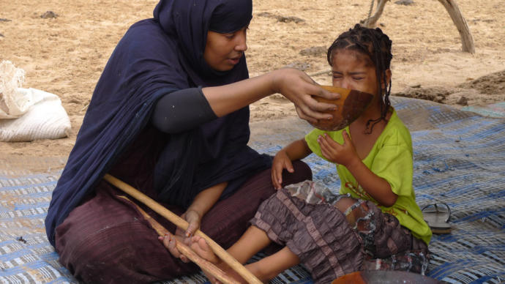

This Country Force-Feeds Young Girls

to Fatten Them For Marriage
Jasmine Osby
Yahoo News, September 16, 2022·

For as long as I can remember, I’ve felt pressure to be thin. From early years playing with Barbie dolls to the unavoidable advertisement parading slim bodies at every turn, it was clear that skinny was in.
Being fat was definitely not in style. Although my mom was overweight, I watched the torment obese kids endured on the playground. They were taunted, bullied, and name-called. They were exiles who sat alone isolated from the crowd. Other kids called them losers all because of their size.
As an adult, life outside of the playground didn’t get much better for my larger friends. I’ve watched them struggle in dating, the workforce, and in intimate relationships because their physical weight is frowned upon. While fat-phobic and fat-shaming culture seems to have improved, a lot of my plus-size friends and family still feel an overwhelming pressure to be thin to fit in.
However, while the West may identify being skinny with being beautiful, the locals in Mauritania disagree.
Located in Northwest Africa, Mauritania customs believe that being obese is a symbol of great wealth and status. Due to this tradition, families begin force-feeding girls at a young age. Their hope is that by 12 years old the girl will weigh at least 200 pounds. This will enhance her chances of getting a suitable husband.
After feeling the pressures of being slim and fit since birth as an American girl, I found the situation in Mauritania unusual. A different culture all the way on the other side of the world, this country praised a figure shunned by the Western world. However, while the tradition is embedded into the fabric of their society, it comes at the detriment of the women who live there.

An Age Old Tradition
Known as leblouh, the age-old tradition of fattening young girls has been a Mauritanian custom for centuries. The complete opposite of US culture, women in Mauritania begin feeling the pressure to be overweight at an extremely young age.
The people in Mauritania have long felt that having larger wives meant they were wealthier and more capable of feeding their families. Living in desert terrain, wealth and status were important in ancient culture.
Now, young girls are groomed for marriage as infants to ensure they are a perfect image of wealth. In an RT Documentary posted on Facebook, filmmakers interviewed multiple families in the countryside of Mauritania who still practice the ancient custom of leblouh. Elders can be seen encouraging girls as young as 3 years old to drink copious amounts of goat’s milk and gruel so they can gain weight faster.
Slimmer women are frowned upon and considered impoverished. Families in the country believe their daughters will not attract decent, wealthy husbands if they are not at least 220 pounds by marriageable age. Fatimetou Lelhamel, a grandmother and leblouh expert, described to the filmmakers how they force-feed female children early.
“This is how we fatten up women,” Lelhamel said. “She drinks milk until the afternoon. We prepare couscous and she eats it, too. For breakfast, we prepare special milk, called ‘amzik.’ We churn the milk until butter starts to appear. Then we mix that with fresh milk.”
Based on US standards, the National Institutes of Health suggest a girl between the age of 9 and 13 consumes 1,6000 to 2,000 calories each day. For those who practice leblouh in Mauritania, young girls are forced to consume 14,000 to 16,000 per day. Many follow this custom while sacrificing the health of their daughters. However, an entire industry built around fattening young girls has emerged in the country due to the need to be obese for marriage.
Although leblouh is becoming less appealing to younger people, some women in rural areas are resorting to desperate measures to gain weight. With recent food droughts in the country, some have started taking animal hormones and steroids to be bigger.

Task 2:

Watch the short documentary: “Young girls in Mauritania are force fed to look older and wealthier for marriage.” From SBS Australia at:
https://www.youtube.com/watch?v=N24CZ_Gf0uw

Task 3: What are the health problems associated with force-feeding children? List them below:
Consult the following websites:
1. https://rightforeducation.org/2022/05/23/the-human-right-to-dignity/
2. https://parenting.firstcry.com/articles/harmful-effects-of-force-feeding-children/?ref=interlink

List of Health Problems Associated with Force-Feeding:
1.
2.
3.
4.
5.
6
7.
8.

Task 4:

Watch the video on the United Nations Universal Declaration of Human Rights: https://www.youtube.com/watch?v=hTlrSYbCbHE

Task 5: Now look at the List of Human Rights under the United Nations Declaration:
https://www.un.org/en/about-us/universal-declaration-of-human-rights

List those rights that are being violated in Mauritania when young girls are forced into marriage and forced to be overweight as it is seen as attractive in their culture. Summarize each Article that is being violated in a single sentence, and in a second sentence, tell me why it is a violation.

For example:

1. Article 5: “No one shall be subjected to torture or to cruel, inhuman or degrading treatment or punishment.” This is a violation because it is a form of torture to force-feed a child.

List at least 4 more Article here -------------------------

Week 4 Lesson 3:

Current Event Analysis

Food & Culture

Advanced

Meet the Town that Drinks the
Most Coca-Cola in the World –
Are they Healthy?

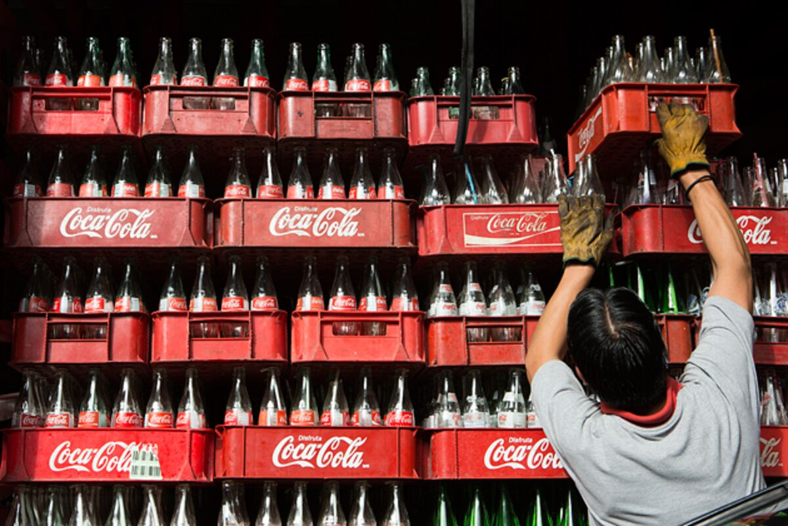

Success Criteria
Students will gain an understanding of the health consequences of consuming fizzy drinks, specifically Coca-Cola. While eating or drinking most foods/drinks in small quantities is usually not harmful, overdoing it can cause major health problems – even in young people. By the end of the lesson students will be able to list the major health consequences of drinking too sugar-based fizzy drinks.

KEY POINTS

- Nobody in the world drinks more Coca-Cola and other fizzy drinks than the residents of Chiapas, Mexico.

- Their obsession with the fizzy drinks is having dire health consequences.

Coca-Cola is Everywhere

in this Mexican Town –

So Is Diabetes

A religious ceremony in Mexico involving bottles of Coca-Cola

Class Discussion – how much Coke do students drink? What about soda in general? What impact do you think it can have on your health?

Task 1: Watch the video clip:

“Coca-Cola is Killing Thousands in This Mexican Town.”
https://www.youtube.com/watch?v=OuF19EAP9E0

1. Chiapas is Mexico’s _____________ most state and one of the p - - - - - -.

2. How much Coca-Cola does the average person in Chiapas drink per day? How does this compare to people in America?

3. For the Tzotzil people of Southern Mexico, how have they brought Coca-Cola into their religious practices?

4. As a result of drinking so much Coke, diabetes has become a major health problem.

Task: Research the link between drinking sugary soda drinks and diabetes by reading the article below from Medical News Today:

Go to: https://www.medicalnewstoday.com/articles/259604#takeaway

How to prevent Type 2 Diabetes in
Children & Teens

While Type 1 Diabetes is not preventable, a person can take steps to reduce the more common type 2 diabetes.
Factors that can raise the prevalence for type 2 diabetes include:¹
- Above weight or obesity
- Sedentary lifestyle (not having much physical activity)
- Hormonal changes in puberty
- Family history of type 2 diabetes
- Your birth parent having gestational diabetes (diabetes during pregnancy)

Foods to Eat and Avoid
To help prevent type 2 diabetes, incorporate the following foods into your child's diet:
- Fruits
- Non-starchy vegetables like peppers, broccoli, asparagus, and spinach
- Whole grains like brown rice, steel-cut oatmeal, and quinoa
- Lean cuts of meat
- Low-fat or fat-free dairy products
- Low-salt foods

What to Avoid
Foods that create sudden changes to blood sugar levels should be avoided or limited. These food items include:
- Highly processed foods, including baked goods, fried foods, and processed snack bars
- Sugary foods and beverages, including fruit juice
- High-fat foods such as full-fat dairy (milk products) and fatty meats
- Simple carbohydrates like white bread or flour
- Takeout or convenience meal items
Get Active
Experts recommend that every child participate in at least 60 minutes of physical activity a day.¹ This can be accomplished in several smaller sessions or all at once by participating in activities.
Task: Create a poster in a single page of your Red Books on what children & teens can do to prevent getting diabetes.

Current Event Analysis #2
Basic – Week 4 Lesson 3

The New Study that Shows Napping
can be Good for You – But Don’t Overdo it!

Success Criteria
Students will gain a basic understanding of the health benefits from taking a nap and by the end of the lesson will be able to recall the positive impact it has on the human brain.

Read the article below and answer the questions.
Reading: Banbury, Shem (2023). Kiwi Kids News, June 27.

New STudy:

NAPS CAN BE GOOD FOR YOU
Above photo – hopefully this is NOT you in class!
Taking regular naps has been found to have benefits for our brains and can help keep them healthy for longer, according to researchers from University College London. The study revealed that people who took naps had brains that were 15 cubic centimeters larger than those who didn’t nap, which is equivalent to delaying the aging process by three to six years.
However, the scientists recommend keeping naps to less than half an hour. Unfortunately, daytime sleep can be challenging for many people due to work culture and the disapproval of napping in many careers.
Dr. Victoria Garfield, one of the researchers, emphasized that everyone could potentially benefit from napping and described the findings as exciting and novel. She also highlighted that napping was a simple activity compared to weight loss or exercise, which can be difficult for many individuals.
Napping is more common in babies for their development, becomes less frequent as we grow older, and regains popularity after retirement, with around 27 percent of people over 65 reporting daytime naps.
While napping has shown positive effects on brain health, further research is needed to determine if it can help prevent diseases like Alzheimer’s. Maintaining overall brain health is crucial for protecting against dementia, and there is a link between disturbed sleep and the condition.
The researchers suggest that poor sleep damages the brain over time by causing inflammation and affecting the connections between brain cells. They propose that regular napping could compensate for deficient sleep and potentially protect against neurodegeneration.
However, Dr. Garfield mentioned that she prefers other methods of brain care, such as exercising for 30 minutes, rather than napping. Each individual can find what works best for them.
Key words to look up the definitions of: Alzheimer’s, dementia
Questions:
1. What effect do short daytime naps have on our brains?
2. If you are planning to take a nap, how long is recommended?
3. What percentage of people over the age of 65 take a daytime nap?
4. What is a health problem associated with poor sleep?
5. What is another way of helping your brain besides taking a nap?

