Week 7

Assessment on
New Zealand Political Party Platforms
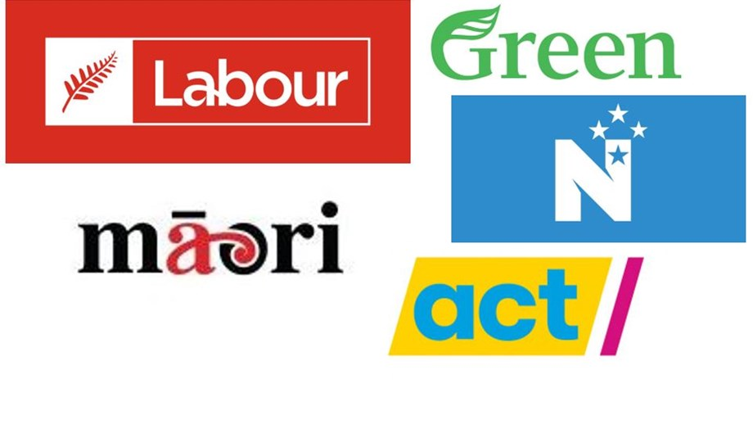
Success Criteria: To become familiar with and be able to identify and recount one major stance (plank) in the platform of one of New Zealand’s major political parties.

- New Zealand Labour Party (Labour): The Labour Party has historically been one of the major parties in New Zealand and is currently in power.

- New Zealand National Party (National): The National Party is the main opposition party in New Zealand and has also held the government in the past.

- Green Party of Aotearoa New Zealand (Greens): The Green Party is known for its focus on environmental and social justice issues.

- ACT New Zealand (ACT): ACT is a right-leaning political party that advocates for free-market policies and individual freedoms.

- Māori Party: The Māori Party represents the interests of the indigenous Māori population in New Zealand and focuses on Māori rights, culture, and issues.

- New Zealand First Party (NZ First): NZ First is a party that was founded by Winston Peters and has held a significant number of seats in Parliament in the past.

Information on the major party platforms can be accessed at:

1. The Labour Party Platform
https://www.labour.org.nz/our-plan

2. The National Party Platform
https://www.national.org.nz/plan

3. The ACT Party Platform
https://www.act.org.nz/

4. The Green Party Platform
https://www.greens.org.nz/

5. The Maori Party
https://www.maoriparty.org.nz/

6. The New Zealand First Party
https://www.nzfirst.nz/

The assessment is on Google Classroom as a separate file. It must be completed on a Google Doc. See instructions.
Mr Bartholomew

