Week 8

The Gender Pay Gap in New Zealand

& Other Issues Facing Kiwi Women

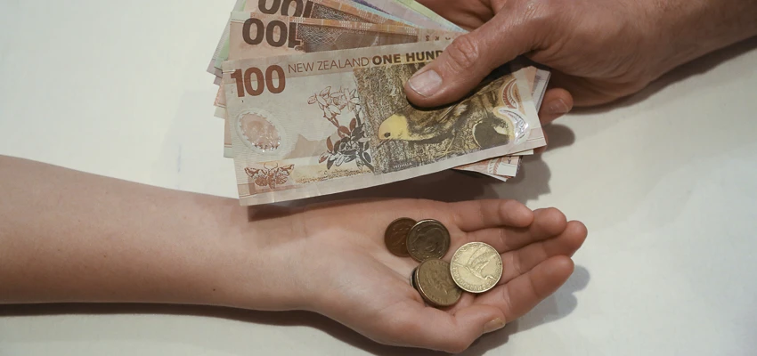

Success Criteria: To be able to identify and recount key information and statistics pertaining to the gender pay gap in New Zealand and equality issues facing Maori women.

Class Discussion: Is there a gender pay gap in New Zealand – and if so – how serious is it?

Task: Watch as a TV1 Story on the Gender Pay Gap in New Zealand at: https://www.youtube.com/watch?v=0nzoOGYO4XU (5:36 sec.)

Group Work: Students are to break into groups of between 4 and 6 – in which they will access and read the article below on the gender pay gap:

https://women.govt.nz/women-and-work/gender-pay-gap

Task 1: Write down key dot-points on how serious the problem is in New Zealand (30 minutes)

Task 2: With 15 minutes to go, I will call on the different groups and write down the key points from each group – on the white board. Key points that you have not already written down – need to be added to your Red Book.
Week 8: Lesson 2

Inequality and Maori Women

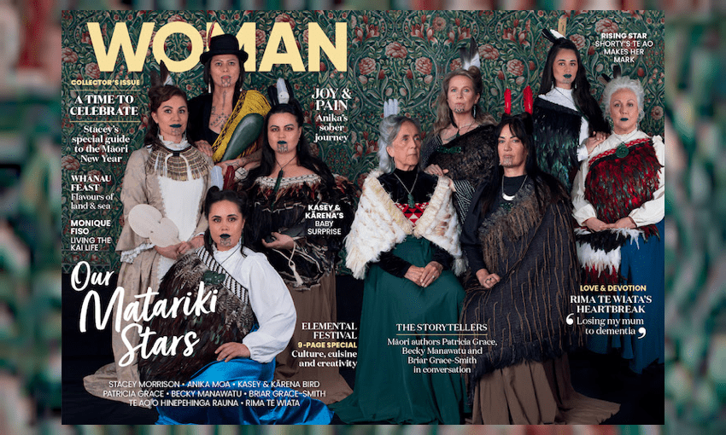

In this lesson we will look at the different challenges faced by Maori women. It is a continuation of yesterday’s lesson. We will go back to our groups and begin by discussing the reading below:

Once we have read the article as a class – you will summarise 3 major issues facing Maori women and 3 solutions (ways these issues can be addressed by the government).

With 15-minutes to go – we will call on the various groups and they will write their ideas on the whiteboard. Students will then write the information into their books.

Reading:

New Zealand’s Māori women have more to contend with than ordinary sexism
Tina Ngata
This article is more than 2 years old
Colonisation has had a particular effect on Maori women and disadvantages them to this day
Friday 5 Feb 2021

Hearings will begin this week, investigating claims regarding the specific violations of the crown (the New Zealand Government) that have led to injustice against wahine (female) Māori in many areas of life.

Maori women who are at once recognised globally for their leadership at University and as teachers, are also significantly underpaid for their work, experience numerous barriers to adequate healthcare and social assistance, and suffer one of the highest prison rates for women in the world. In order to understand the role of the crown in the injustices faced by wahine Māori, we must first understand the roles they held prior to European contact.

New Zealand is often looked upon as a global leader in women’s rights, praise which is usually rooted in our parliament securing the women’s vote before other nations, in 1893. What is so often missed in this situation is the fact that Māori women, under the British years ago, suffered. Before the British arrived in New Zealand, Māori women were landowners, spiritual and political leaders, fighters and navigators. While getting the right to vote was a positive step, Māori women struggled, and still struggle, to recover their rights.
In fact, even with the right to vote, Māori women were oppressed, having to sign agreements that they would never take on their ancestral sacred markings (tatoos) if they wished to join the Women’s Christian Temperance Union, which spearheaded the right to vote. The Temperance Union wanted to ban the drinking of alcohol in New Zealand.

While Māori female elders were holders of sacred knowledge before the British settlers arrived, women were restricted from even attending school in Britain and Europe. And even though women were significant landholders and political leaders at the time of the treaty, they were in many cases disallowed or discouraged from signing by the men who were charged with collecting signatures.

Much of the discussion around the roles and respect for Māori women prior to European contact have been misrepresented, or simply erased altogether the presence and importance of Māori women. As scholar Aroha Yates Smith has noted: These early anthropologists predominantly focussed upon – male gods – and Maori males and ignored the contribution of Maori women.
Anthropologist Elsdon Best – who provided much of the written material upon which we would come to base our understandings of precolonial Māori – literally referred to our most sacred centre thus: “This ‘house’ of misfortune, of ominous inferiority, is represented by this world, by the earth, by the female sex, and by the female organ of generation, which holds dread powers of destruction and pollution.”
The trauma of war was then visited upon the women and children at home. The ensuing cycles of addiction, violence and assault have been intergenerational for Māori whanau, and compounded by a state system that, alongside the absence of effective support, is significantly more likely to remove Māori children than non-Māori children from their family’s care, and subsequently significantly more likely to visit further abuse upon those children whilst they are wards of the state.

All of this must be taken into account when considering the specific ways in which the crown has affected wahine Māori. The care and wellbeing of mothers, in particular, is termed a “circuit breaker” in intergenerational patterns of harm precisely because of the role they play in the wellbeing of families. Tiriti justice cannot be achieved for Māori families without tiriti justice for women, and the imminent hearings, while overdue, will carry painful and powerful histories to the surface. Like all treaty issues, these truths, once heard, must be responded to with actions that will restore justice. Only then can we hold our heads high as a progressive nation for women’s rights.

Week 8 Lesson 3

Human Cultural Diversity -
The Cousin Debate:

Why Marrying Your Cousin
is Legal in New Zealand!

While I am not encouraging people to marry their cousin, up until recently it was the norm because people living as hunter-gatherers in small groups, didn’t have a lot of choice. In many cultures people marry their cousins – and the scientific research is clear – there is nothing particularly harmful with doing it.

Class discussion: How common is this practice?

There is a common belief in Western countries like New Zealand that marrying your cousin is wrong and will cause serious genetic problems. This is a myth. Cousin marriage is common around the world.

Task 1: As a class we will read the article on the University of Otago scientist who has studied this topic:
https://www.odt.co.nz/news/dunedin/its-ok-date-your-cousin-says-otago-professor

Class Discussion: What do you think?

Task 2: Now watch the video on diversity in human marriage:
https://www.youtube.com/watch?v=ZbzFHr3nM8U
Begin at 9:11 sec. mark to the 52:00 sec. Mark

Task: After watching the video – write a paragraph summarizing at least 3 key points discussed in the video and in class.

